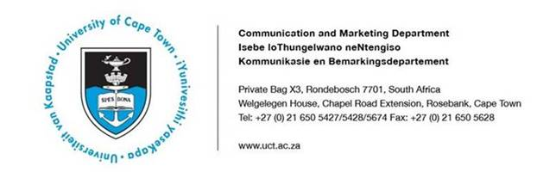

**23 August 2019**

**UCT invests in women academics**

The University of Cape Town (UCT) has kept to its commitment to create more opportunities for women by offering a total of R22.5 million in individual grants over [five years](https://www.news.uct.ac.za/article/-2019-02-11-five-winners-advancing-womxn-awards).

**Five substantial grants have been awarded to women researchers to make space for more women’s voices to be heard – both for their own advancement and for the advancement of others. These are a**imed at postgraduate students and postdoctoral research fellows.

Vice-Chancellor Professor Mamokgethi Phakeng said: “The leadership at UCT is committed to honouring women. The university can show the way raising up African women academics. While the target in these grants is human capital development, the projects would also help us rethink our views of gender in South Africa and give us new insights into ourselves and others in different communities”.

The winning research projects are:

**Dr Katye Altieri: enabling South Africa’s black oceanographers**

Along with three co-investigators, Altieri from the Department of Oceanography aims to enable a cohort of postgraduate black women and transgender oceanographers to become the leaders of oceanography in South Africa – and the global south. Through her project, Boonzaier – from the Department of Psychology – aims to shift the ways of thinking about and doing research on gender-based violence.

**Professor Floretta Boonzaier: unsettling research on gendered and sexual violence**

Through her project, Boonzaier – from the Department of Psychology – aims to shift the ways of thinking about and doing research on gender-based violence. She asks, what does it mean to think differently about research on gender-based violence? The work aims to impact not only the ways we teach approaches to research, but also the ways we think about the purpose of research itself and the benefits that might be derived from it.

**Professor Janet Hapgood: informed choices for women’s contraception**

Women in sub-Saharan Africa are at high risk of being infected with HIV. They also need access to effective, safe and affordable contraception. However, the hormonal contraceptive that’s most widely used in the region has a potential side-effect: it may increase the risk of HIV infection by about 40%. Sub-Saharan Africa is also the region with the highest use of this injectable contraceptive – called depo-medroxyprogesterone acetate or Depo-Provera – and the highest prevalence of HIV.

**Dr Robyn Pickering: transforming the field of paleoanthropology**

South Africa has a rich record of human evolution spanning fossils of our early ancestors through to more recent evidence for the emergence of modern humans and their complex behaviours. Research into human evolution in South Africa has been substantial and has received international attention for nearly 100 years. However, the leading researchers in South Africa have always been men: women are under-represented and black women are virtually absent. Pickering and her co-investigators, Professor Rebecca Ackermann and Dr Jayne Wilkins, want to take the first step towards transforming the field of paleoanthropology. They plan to build up the Human Evolution Research Institute (HERI) at UCT to make it a world-class and enabling research environment where excellence shines and the next generation of great South African black women palaeoanthropologists can thrive.

**Professor Patricia Kooyman: building fuel cells, better**

Professor Kooyman will explore ways to remove carbon monoxide gas from hydrogen gas with the goal of improving methods for preparing fuel for fuel cells. Providing cheap, easy-to-use and -maintain, stand-alone fuel cells may contribute to the economic empowerment of people who are socially disadvantaged. As part of her project, Professor Kooyman will train a cohort of black female or trans postgraduate researchers in critical skills in chemical engineering, catalysis research and transmission electron microscopy – areas in which men still dominate.

**The winners of the grants** will receive funding of R1 million per year for five years, and the meritorious awards to the value of R750 000 a year for five years.

Deputy Vice-Chancellor: Transformation Professor Loretta Feris commented: “These women will not only be conducting leading-edge research in fields where women are under-represented, and into women’s issues, but they will also be advancing the next generation of women and non-conforming gender transgender researchers.”

***ENDS***

***Issued by: UCT Communication and Marketing Department***

**Thami Nkwanyane**

**Media Liaison and Monitoring Officer**

Communication and Marketing Department

University of Cape Town

Rondebosch

Tel: (021) 650 5672

Cell: (072) 563 9500

Email: [thami.nkwanyane@uct.ac.za](mailto:thami.nkwanyane@uct.ac.za)   
Website: [www.uct.ac.za](http://www.uct.ac.za/)