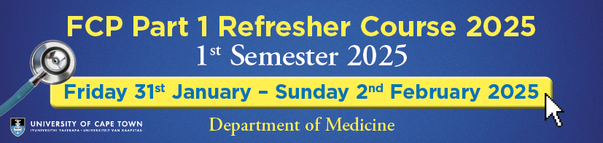

FCP Pt 1 REFRESHER COURSE – UCT/GSH
1st SEMESTER 2025

TERMS AND CONDITIONS FOR APPLICATION AND REGISTRATION

Purpose of the FCP Part 1 Refresher Course

A self-guided learning preparatory programme culminating in the essence of the Course – which is 3 days of interacting with clinicians with mock MCQ’s based on the CMSA FCP Part 1 curriculum.

The format of the Course is as follows:

- Access online to recorded lectures in preparation for the 3-day ZOOM section., commencing 2nd January 2025.
- Participation in the 3-day LIVE Zoom Inter-active mock MCQ engagement with the clinicians, most of whom presented the recorded lectures. This takes place 31st January – 2nd February 2025 and is compulsory to attend.
- Access to the lectures (PLUS the recordings of the ZOOM sessions) from 2nd January – Monday 17th February (the day of the examination) for those who attended the 3-day ZOOM course.

NB NB Please note that access to the recorded lectures will terminate after 2nd February 2025 if candidates do not attend and participate in the 3-day ZOOM online event, 31st January – 2nd February 2025.

Please ensure that you are available for 3 full days on Friday 31st January – Sunday 2nd February 2025 before registering for the FCP Pt 1 Refresher Course.

If you wish to discuss any aspect of these T&C’s, please email leadingwithexcellence@uct.ac.za

I accept and understand the Terms and Conditions as outlined above.

Name…………………………..Surname………………………………………

Signed ……………………………………………………Date ………………………….
Please return this form to leadingwithexcellence@uct.ac.za

October 1st 2024

