POISONS INFORMATION CENTRE – RED CROSS CHILDREN’S HOSPITAL

HOME
Our poisons centre provides advice on the prevention, diagnosis and management of poisoning in both adults and children.

The centre is part of the UCT Department of Paediatrics and Child Health and is situated in the Institute of Child Health at Red Cross War Memorial Children’s Hospital.

We produce the database AfriTox® which is available to doctors throughout Southern Africa to manage poisoning cases.

Our telephone service is available 24 hours a day, both to the public and to medical professionals. It allows fast access to accurate information immediately after poisoning is suspected or confirmed so that a patient can be treated appropriately and effectively.

Poisons Emergency Telephone Service +27 21 689 5227

To contact us (and for enquiries about AfriTox®):

Poisons Information Centre +27 21 658 5308 (8am-4pm)

e-mail poisonsinformation@uct.ac.za

ABOUT US
The Poisons Information Centre at Red Cross Children’s Hospital has over 30 years compiled, collated and researched information on the diagnosis and treatment of potentially poisonous substances, animals and plants.

This information is packaged as the database AfriTox® which is designed to help medical professionals throughout Southern Africa diagnose and treat poisoned adults and children. AfriTox® is widely distributed to doctors and treatment facilities and it underpins the Poisons Emergency Telephone Service.

The Poisons Information Centre is staffed by medical doctors and specially trained pharmacists and is dedicated to providing up-to-date, well-researched and peer-reviewed information on a wide spectrum of toxins, including locally available commercial products and South African poisonous plants and animals.

The running costs of the Red Cross Children’s Hospital Poisons Information Centre are partly supported by the Western Cape Department of Health and partly by private donations through the Children’s Hospital Trust.

The services we offer:

Poisons Emergency Telephone Service. Available 24 hours a day to the public and health care workers, provided by the staff of the Poisons Centre from 08:00 – 16:00 on weekdays.
After-hours calls are answered by the staff of the Department of Emergency Paediatrics at Red Cross Children’s Hospital.

Information on managing poisoning by substances including
- Medicines and drugs
- Chemicals
- Pesticides
- Household products
- Plants and animals

Help with poisonings caused by unidentified toxins

AfriTox® poisons information database. There are 2 versions available to healthcare practitioners:

- AfriTox® ONLINE : for a single user with continuous internet access who can use it on their smart phones, laptops or PCs

- AfriTox® OFFLINE : gives everyone who works in a clinical unit (eg an Emergency Room) access to AfriTox. It downloads all the information in AfriTox onto a computer. It can be used at any time and works fine with only intermittent internet access.

The intellectual property rights to AfriTox® belong to UCT.

Teaching and education.

- Education of health care professionals in an approach to poisoning
- Teaching of medical students
- Public education in prevention of poisoning through the media, talks to interest groups.

Poisons Information Centre staff

Our staff members have highly specialized knowledge in toxicology and apply meticulous attention to detail in order to meet the unusual demands of sustaining a poisons information system.
Our staff consists of two part-time medical officers, one full-time pharmacist and one part-time pharmacist. All are trained to answer calls from the public and to discuss details of patient management with health professionals.

(see pic below)
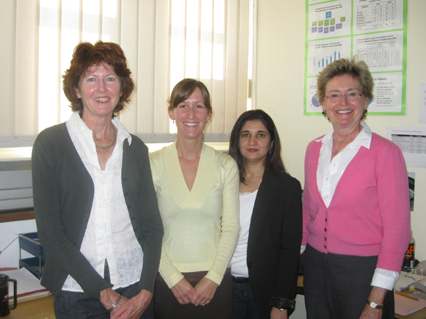
From left: Linda Curling, Dr Kate Balme, Farahnaz Mohamed, Dr Clare Roberts (Director)

