Hello 😊

I am Corona!



I am a virus and I love everyone! 

My real name is Coronavirus

I travel all over the world

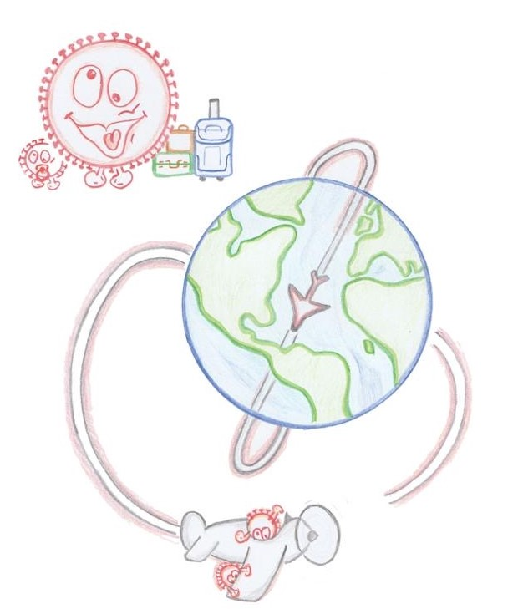

And I want to get to know everyone!

You don’t see me but I am there 😉

I fly out of someone’s nose or jump from hand to hand

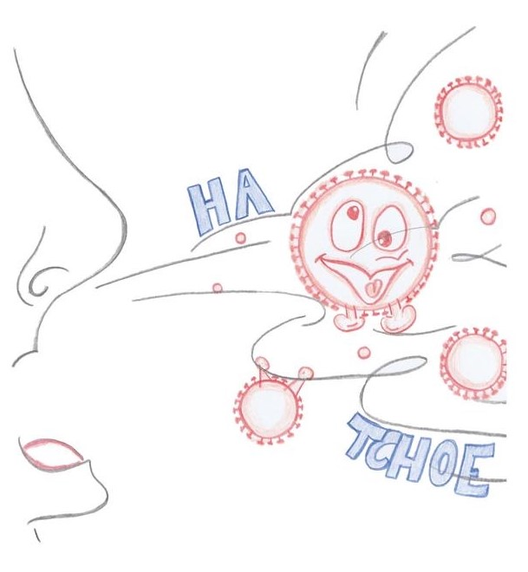

That’s how I make everyone sick

When I am in someone’s body, I cause a fever, cough and difficulty breathing



I love everyone, young and old

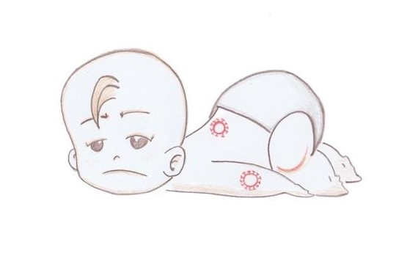



But nobody likes me☹

Luckily for you, I won’t stay long

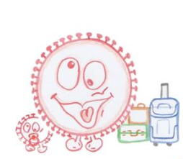

Most people can fight me succesfully and then I leave again!

If you don’t want me to visit you, there are plenty of things you can do by yourself



Stay at home!

Stay at home Wash your hands

 

So I can’t get in! With soap and water!

 

Throw paper tissues sneeze and cough in

into the bin! your elbow!

The more everyone tries to do their best, the fewer friends I can make

Doctors do everything they can to destroy me as quickly as possible



But I will stay for a while…

If you are scared of me, tell your parents

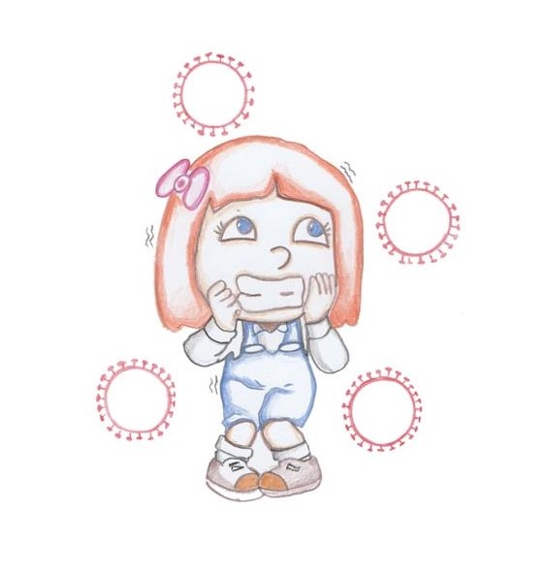

They will do everything to take good care of you!

And then I will disappear as soon as possible😊



Goodbye!

How did you feel when you heard about me? Colorize the face, you can choose more then one:



Happy Scared Angry



Sad Curious Confused

What do you think about me?

Write it down in the clouds:

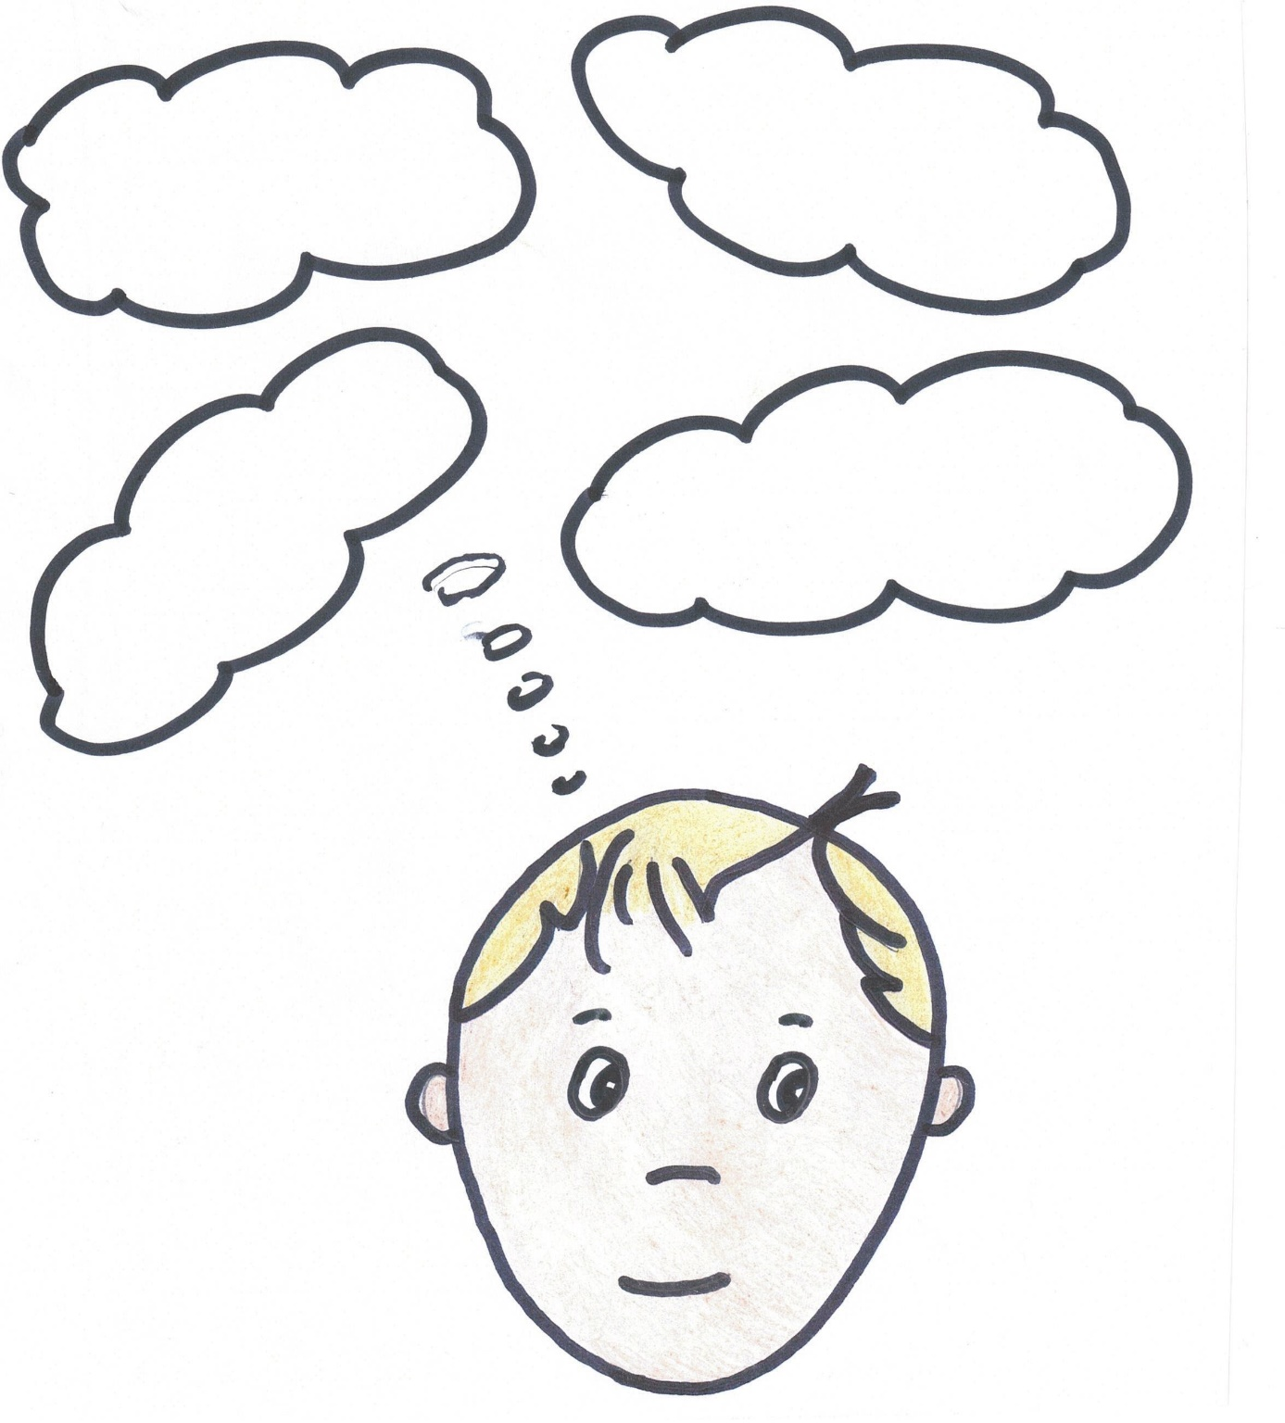

What questions do you have about me?

Write it down in the question marks:

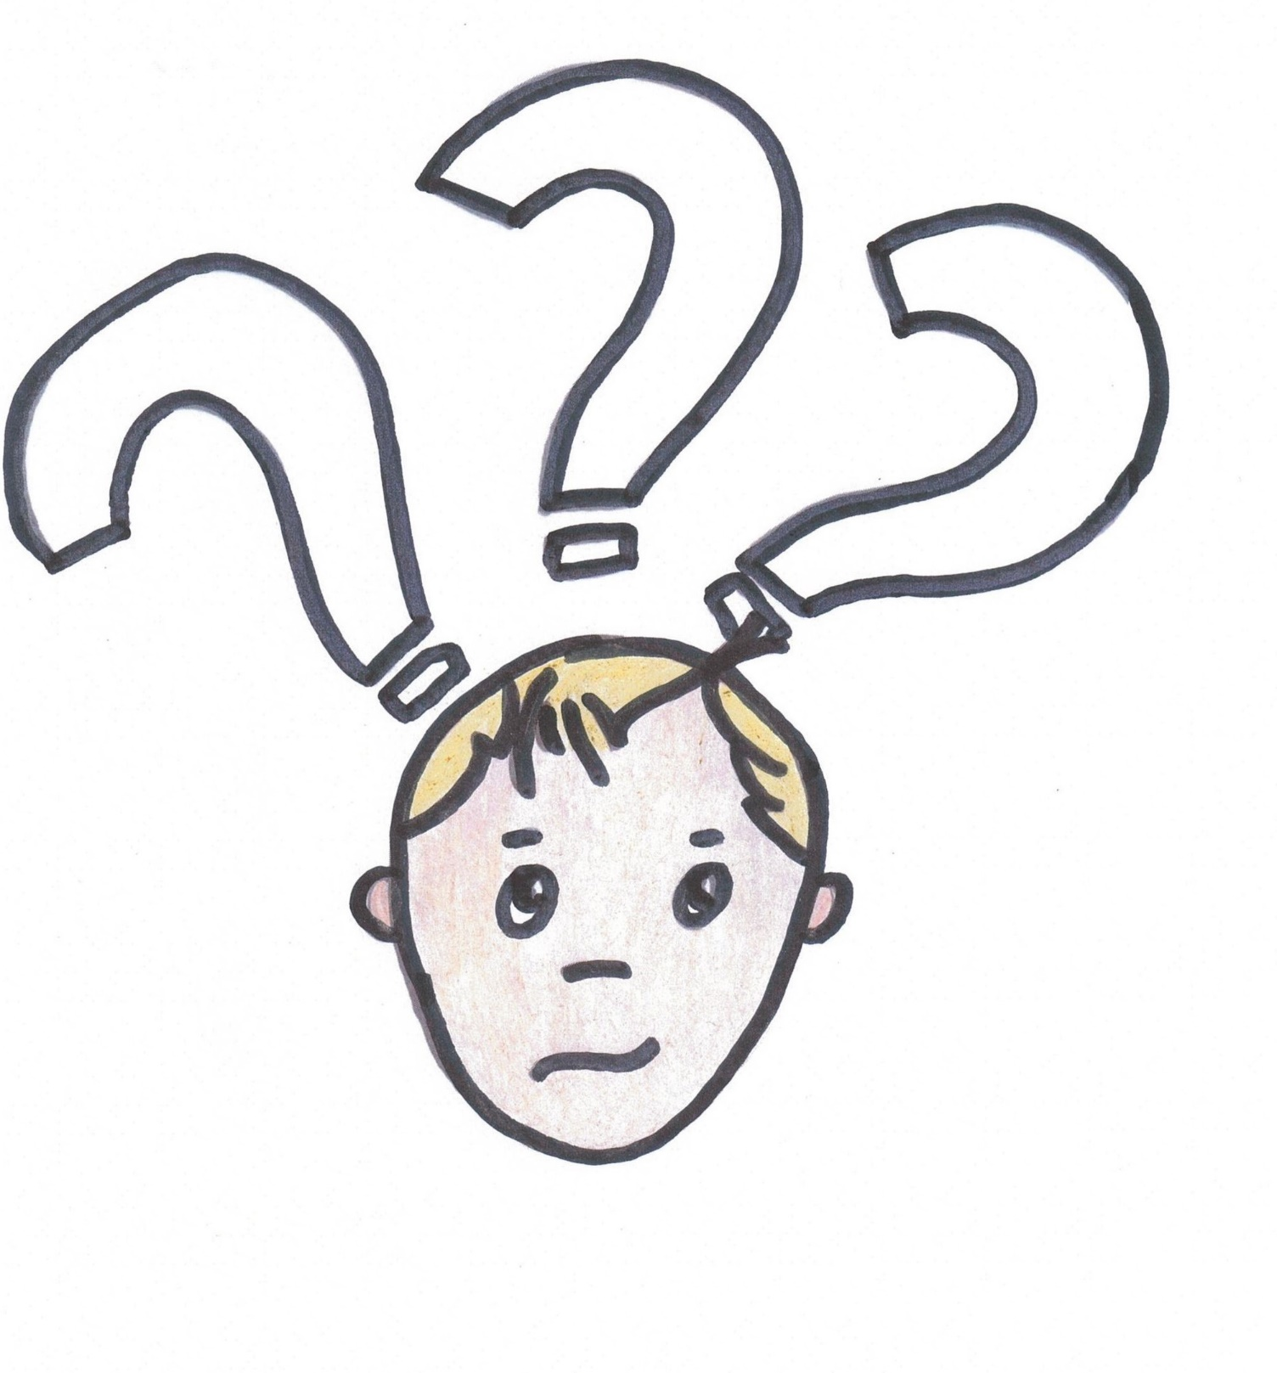

Why are you afraid of me?

Write it down in the ghosts:

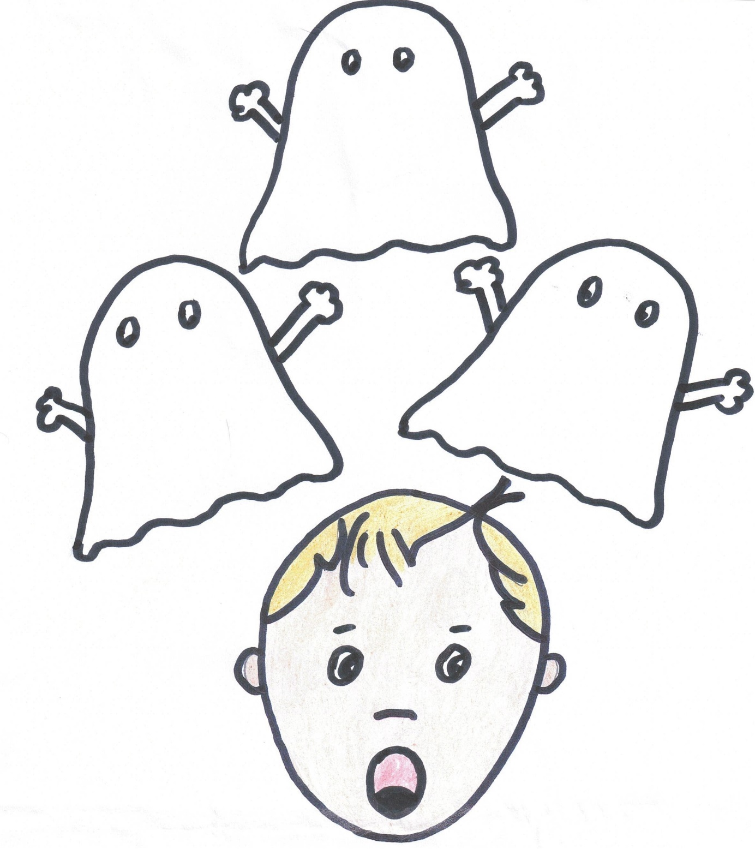

Why are you mad at me?

Write it down in the lightnings:

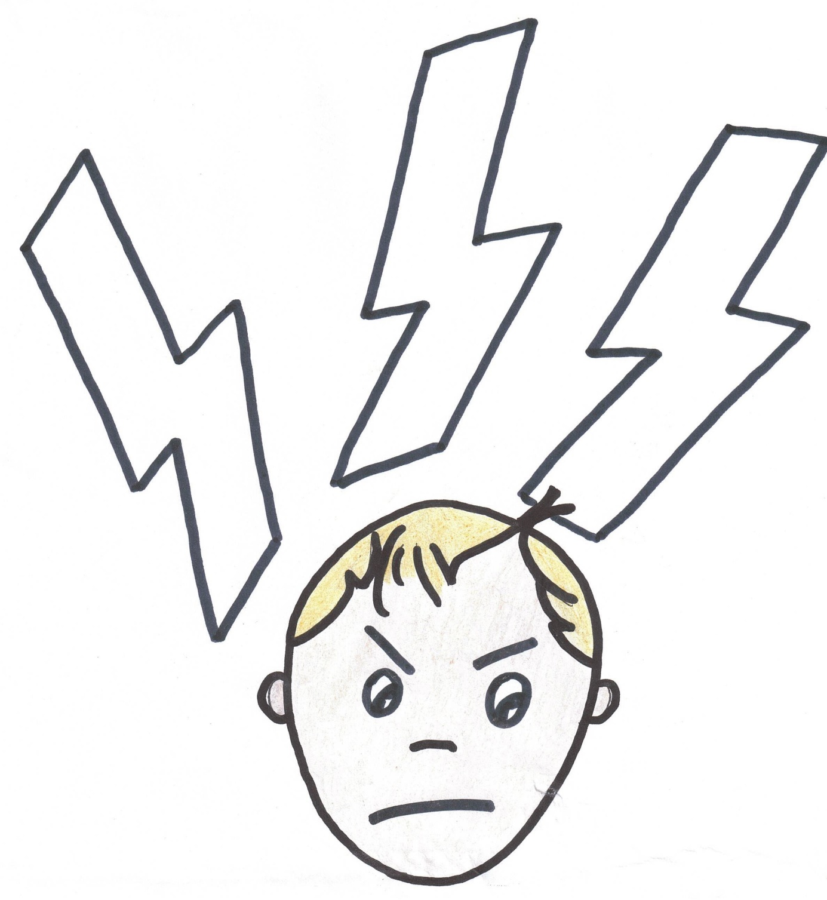

What do you want to say to me?

Write it down in the speech bubbles:

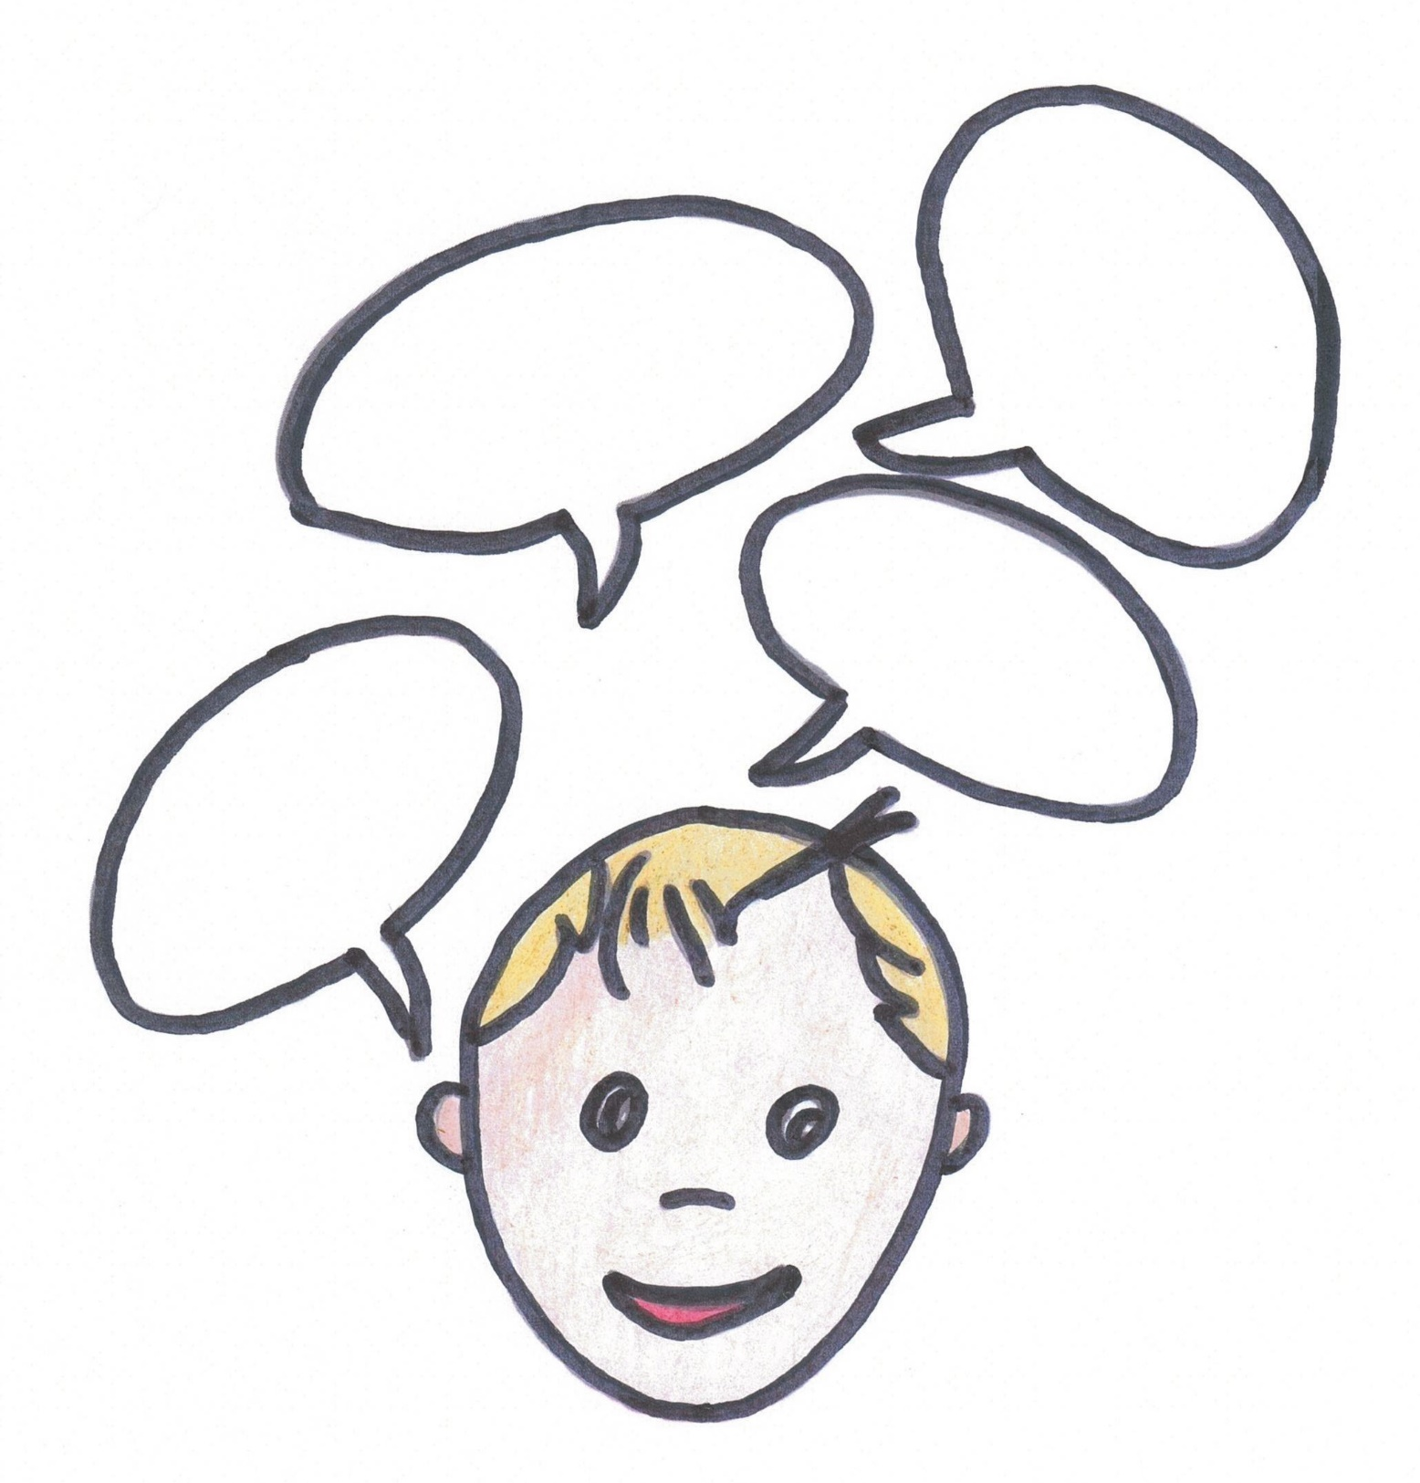

Make a drawing of me here:

Come up with all kinds of tools that can help you when you are afraid and put them in your ‘First Aid For Anxiety’-box. You can write it down in this box or you can take a shoebox and put everything in there:

FAFA

Come up with all kinds of tools that can help you when you are angry and put them in your ‘First Aid For Anger’-box. You can write it down in this box or you can take a shoebox and put everything in there:

FAFA

Come up with all kinds of tools that can help you when you are sad and put them in your ‘First Aid For Sadness’-box. You can write it down in this box or you can take a shoebox and put everything in there:

FAFS

Think of all kinds of things that make you happy 😊 Write them down, in and around the smiley:



The end 😊

Download this PDF on:

[www.dewegwijzer.org](http://www.dewegwijzer.org)/nieuws

Author: Lies Scaut

liesscaut@gmail.com

Illustrator: Steven De Soir

Copyright © 2020 by Lies Scaut