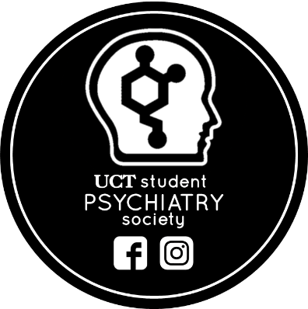
UCT STUDENT PSYCHIATRY SOCIETY

Logos:

Mission:

Description of society:
Welcome to the new year! The Student Psychiatry Society aims to foster interest and learning within the field of psychiatry through collaboration with other societies and with members of the discipline. The society strives to contribute towards the professional growth of students, whether they have a particular interest in psychiatry, or would simply like to improve their skills as a holistic practitioner. The society is completely FREE to join (there is no membership fee) and hosts the following activities:
- Panel discussions involving various health professionals & disciplines within/related to psychiatry
- Special interest talks on past, contemporary and emerging issues in psychiatry and related fields
- Movie screenings of movies centered on issues in psychiatry that foster discussion and empathy in psychiatry-related topics
- Facilitating engagement in research or elective opportunities, as well as mentorship, at a level appropriate and accessible to students
- Social media engagement and informative updates on research in psychiatry, other special interest events.
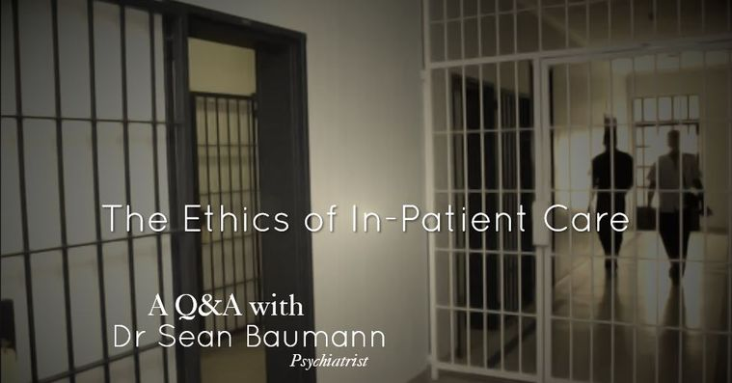
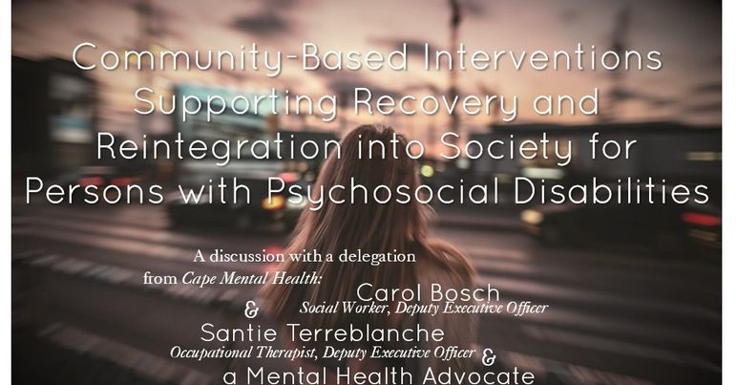
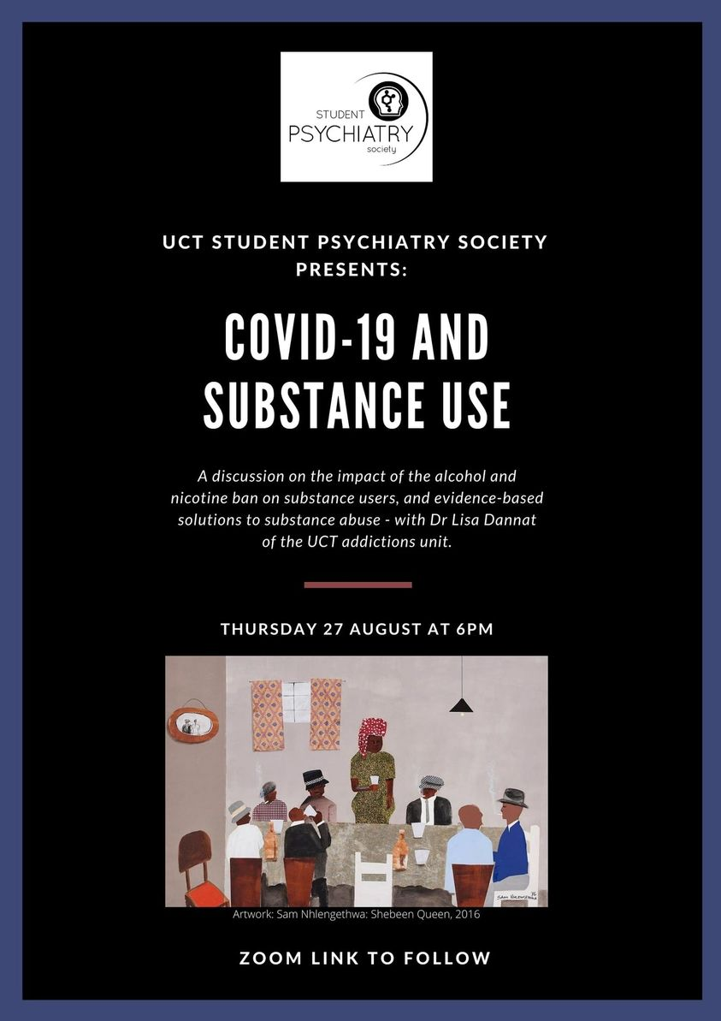
Some examples of events:

