 | University of Cape Town  Department of Psychiatry and Mental Health  Invites you to attend a  Zoom  Departmental Social Responsiveness Lunch-time Lecture  on Tuesday, 2 August 2022 @ 12h30 | 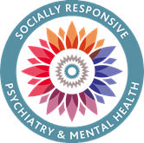

Speaker: Dr Jill Ryan
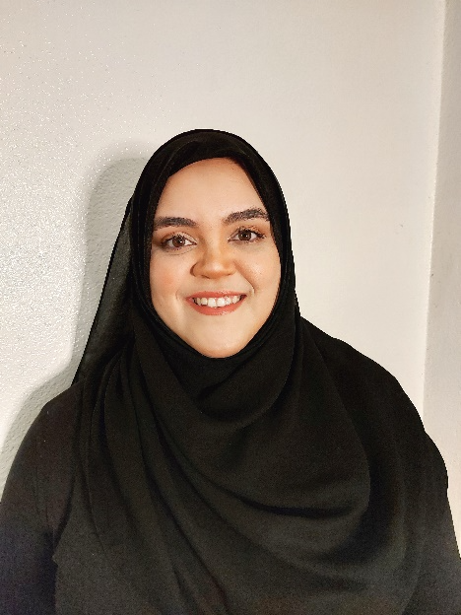

Biography:

“Dr. Jill Ryan is Stellenbosch University’s coordinator for gender non-violence at the Equality Unit, under Learning and Teaching. She holds a bachelor’s degree in Psychology, with her postgraduate education completed through the Centre for Interdisciplinary Studies of Children, Family, and Society (formerly Child and Family studies), all of which were based at the University of the Western Cape. Her research background focused on family violence and intergenerational transmission of domestic violence, with other projects including health promotion, health decision-making, vaccine hesitancy, and family well-being. Due to her advocacy and research on family centric interventions for violence, she has had the opportunity in participating in various family service and violence prevention forums and committees at national and provincial level; having also provided training on theory and practice regarding violence intervention research, at student and professional level. Furthermore, she has lectured and still currently supervises postgraduate students on topics about intimate partner violence and has authored and co-authored articles across diverse topics such as violence prevention, health promotion, and family well-being; also, having contributed and co-edited a book on Family Violence. In 2021, Jill was selected as one of the winners in the category of ‘Health’ in the Mail & Guardian Top 200 young South Africans.”

