**BCL MEDICAL WASTE MANAGEMENT**

**STANDARD OPERATING PROCEDURE (SOP)**

**MANAGEMENT OF COVID-19 WASTE.**

**1. Purpose**

This Procedure will apply for the containment, transport / delivery and treatment of the Covid- 19 waste stream. In light of growing concerns around the spread of COVID-19 (Coronavirus), BCL is committed to acting in the best interest of all employees, clients, suppliers and contractors

**2. Description**

Coronavirus is a group of viruses named for the way they look under a microscope (“corona” meaning “crown”). The novel (or new) coronavirus, identified in 2019 during an investigation into an outbreak in Wuhan, China, causes the coronavirus disease 2019 (COVID-19).

In the medical fraternity, COVID-19 may contaminate sharps, material containing body fluids (like tissue, gauze, gloves or gowns) and pathological waste. Such waste will be accepted for treatment at the BCL licensed incineration facility.

**3. BCL Procedure for Collection / Delivery and Treatment of Covid-19 Waste**

* So as to comply with the Department of Employment and Labour Government Notice No. 479, the BCL Environmental Compliance Manager (ECM) has been appointed the designated person responsible to oversee the management of the Covid-19 waste stream.

|  |  |  |
| --- | --- | --- |
| **Contact Person** | **Designation** | **Contact nr.** |
| BCL Office | Receptionist | 021- 955 2447 (office hours: 8h00 till 16h00) |
| Agnetha Poggenpoel | Environmental Compliance Manager | 071 4211270 |
| Marco Stemmet | Operations Manager | 082 8890460  (after hours emergency contact person) |

* Trained BCL drivers are responsible for the collection of the Covid – 19 waste at Healthcare Facilities (generator).
* The generator is responsible to ensure the waste is securely packaged in the following manner prior to the collection or delivery to the BCL facility for incineration.
* red liner to be placed in the box and sealed with a cable tie once the box is ¾ full.

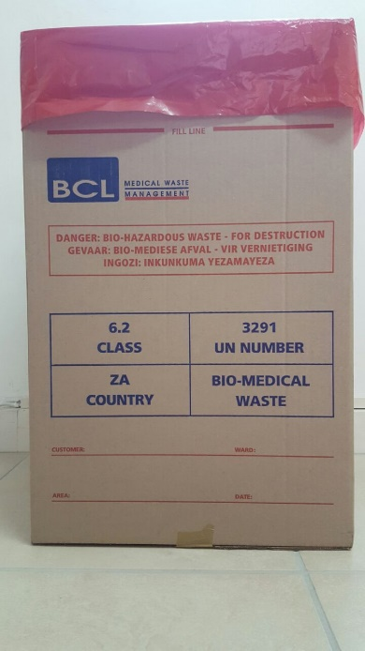

* Seal lid of the box adequately and securely with the bio-hazardous tape.

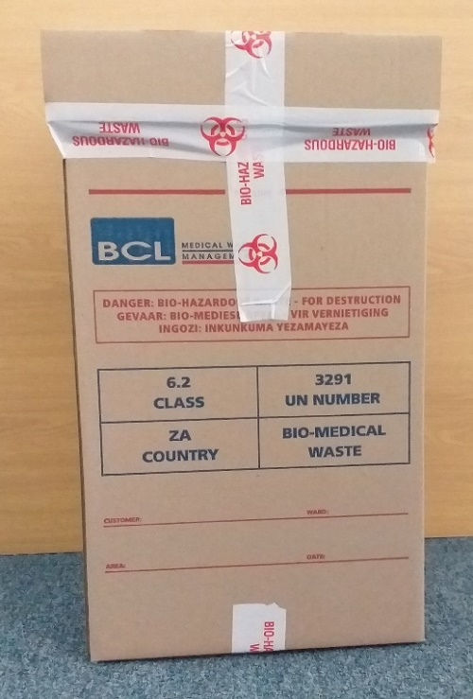

* The box to be placed in a 90lt red liner and sealed with a cable tie.
* The Covid-19 sticker to be placed on the outer red liner to identify the waste stream.

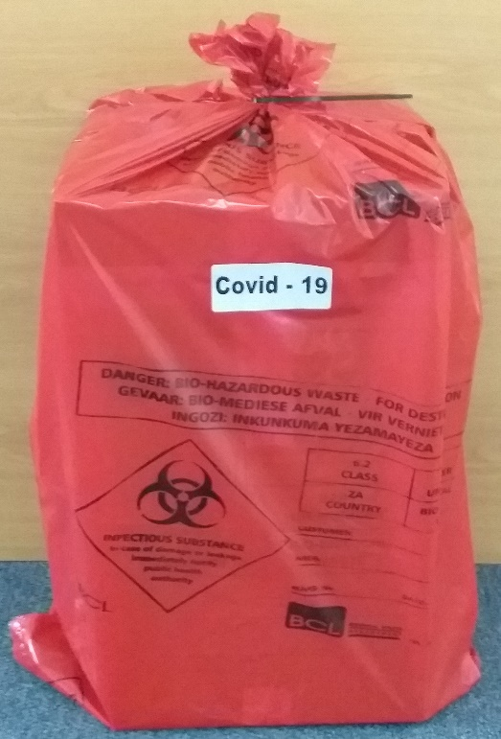

* In line with the Department of Health SA Guidelines on the Management of Coronavirus health care waste, the Covid-19 waste stream will be collected with the normal HCRW from the dedicated waste areas.
* The BCL driver will log the Covid-19 waste collected on a separate BCL manifest document signed by both himself and the generator.
* All BCL vehicles are monitored by the Radio Operator on a live tracking system until the vehicles have completed their routes and returned to the BCL premises.
* Once at the BCL premises, the Incineration staff off-load the waste which is taken directly to the infeed Hopper (wheelie bin) of the incinerator facility.
* The BCL staff continue to be equipped with the legislated PPE during the handling of the Covid-19 Waste.
* This waste stream will take priority for incineration from the other health care risk waste.
* As per the established BCL protocols:
* The Incinerator Supervisor will sign off the Safe Disposal Certificate upon completion of the incineration process.
* As proof of destruction the safe disposal certificate will be returned to generator of the Covid-19 waste for their records.
* The residual ash from the incinerator is contained in metal lidded skips and transported to the Vissershok Class-A Waste Management landfill site for final disposal.
* The ECM will monitor all BCL staff members by taking daily temperature readings.

Below please find the relevant legislated guidelines and references which BCL will adhere to at all times.

References :

* March 2020 - Department of Health SA March 2020

Guidelines on Management of Coronavirus or COVID-19 health care waste

* 08 April 2020 - Department of Health Government Notices No. 457

Directions issued in terms of regulation 10(1)(a) of the regulations made under section 27(2) of the Disaster Management Act, 2002 (Act No. 57 of 2002) : Measures to address, prevent and combat the spread of Covid-19

* 29 April 2020 – Government Gazette, Republic of South Africa, Volume 658, No. 43257