

**INFORMED CONSENT FORM TO PARTICIPATE IN A RESEARCH STUDY**

**STUDY NO: INITIALS: DOB: (DD-MM-YYYY)**  ⬜⬜⬜⬜⬜ ⬜⬜⬜ ⬜⬜-⬜⬜-⬜⬜⬜⬜

**TITLE OF RESEARCH**

**Evaluation of the safety and efficacy of a novel tongue anchorage device in continuous positive airways pressure non-compliant patients with obstructive sleep apnoea**

**Principal Investigator:** Dr Rushdi Hendricks

**A. PURPOSE OF THE STUDY**

You have been asked to volunteer for a research study, because you are diagnosed with a condition called obstructive sleep apnoea (OSA). This means that while you are asleep your airway becomes obstructed for various reasons. The most common reason being that your tongue relaxes during sleep and falls back blocking your airway. Rarely, a patient’s airway becomes blocked because of other reasons like bone abnormalities or growths. As the airway becomes progressively blocked you snore but eventually you stop breathing and are startled awake when you choke or stop breathing. Sometimes you are unaware of this happening and your partner wakes you up. OSA is associated with high blood sugar, high blood pressure and high cholesterol levels.

Currently the recommended therapy for obstructive sleep apnoea is using a continuous positive airway pressure (CPAP) machine for at least 4 hours a night. A CPAP machine works by generating pressure with air, to keep your airway open. Unfortunately, we know that many patients find this equipment uncomfortable and difficult to use as is needed for effective treatment of OSA.

The purpose of this study is to assess the safety and effectiveness of a new device designed to anchor your tongue to the lower jaw, thus preventing it from falling back into the throat. To do this, we will need 3 groups of participants as described below. We will then compare which group of individuals improve most over a period of nine months.

**B. SUMMARY OF THE STUDY**

120 adult participants will be screened to see if they are eligible to partake in the study.

To take part, you must have moderate to severe sleep apnoea with the main cause being at the level of your tongue. If you have other airway problems, you will be referred to an ear, nose and throat specialist to treat that first, before you can be part of our study. You will not be allowed to be part of the study if you are pregnant, if your body mass index (BMI) is above 45 or if you have a significant medical condition that your doctor, usually a specialist in medicine, believes will make it unsafe for you to be in the study.

Once it has been identified that you have moderate to severe OSA, you will receive CPAP for 2 months. During this time, we will give you a new CPAP machine and do our best to help you to use it well. We will make sure that the mask fits comfortably and that the machine is set up correctly. You will need to use this machine every night when you are asleep for at least 4 hours during the night.

We will then identify 90 participants, 30 of whom cope well with CPAP and 60 who are unable to tolerate the CPAP machine. In the group unable to tolerate CPAP, thirty of these participants will be randomly allocated (like flipping a coin) to undergo surgery in the form of implantation of the new tongue anchoring device. We hope to prove that the device is better at improving your OSA than you not using your CPAP correctly.

As you can see below, 90 participants will be divided into three groups:

1. Surgical group (30 participants) – The group that will be offered surgery with the new tongue anchorage device

2. Non-surgical group (30 participants) – The group of patients that cannot use CPAP, but are not selected for surgery on this study.

3. CPAP compliant group (30 participants) – The group of patients that can use the new CPAP machine well after they are trained, the mask is properly fitted and the machine adjusted appropriately.

All 90 participants will be assessed and followed up for 12 months, by a pulmonologist and maxillo-facial surgeon as well as undergo investigations designed to compare the outcomes of CPAP and the surgical intervention.

**C. DESCRIPTION OF THE RESEARCH:**

To diagnose OSA, all patients will undergo a standardised sleep study. After the initial visit, you will receive a new CPAP machine for 2 months with all the required support as described above. After this period, we will assess you to see into which group of participants you will fall.

If you are compliant on CPAP we will continue your care as the current international standard of care. We will ask you to attend follow up visits and special tests for 12 months, that are essential to objectively prove which therapy for OSA is most effective with minimal risk.

If you are unable to use CPAP, you will randomly (like flipping a coin) be assigned to the surgical group or the non-surgical group.

If you are **not** randomly selected for the operation, you can continue with CPAP and will receive the recommended international standard of same care as other patients with your condition. We will ask you to come back for follow up visits and special tests for 9 months, that are essential to objectively prove which therapy for OSA is most effective with minimal risk.

If you are randomly selected for surgery you will be assessed for surgery (*more detail below in the consent form*) and will undergo the operation. You will then also be followed up with special tests for 12 months to look for any improvement in your condition and to make sure that you do not develop side effects.

As a participant in the study we will ask you to be involved in the following investigations initially and subsequently at various time points during the study:

1. *Questionnaires regarding how sleepy you feel* *and your quality of life.*

This involves answering a list of questions either to assess your degree of daytime sleepiness as well as your quality of life.

1. *Sleep Study*

The purpose of the sleep study is to diagnose obstructive sleep apnoea, exclude any other sleep disorders and monitor progress on therapy.

During this study, you will be required to sleep for a night in a sleep laboratory where you will be connected to certain monitors to measure your blood pressure, heart rate, blood oxygen levels, snoring and movement during sleep. In addition, we will monitor your brain activity to assess whether you wake up during the night.

There will be a nearby central monitoring location room where the sleep technicians ensure the quality of the sleep studies.

The placement of numerous wires and sensors can be a little intimidating, but most people manage the procedure well. If, however, you do not, a sleeping pill can be used, without changing the results of the testing, to ensure that adequate sleep occurs.

1. *Blood and urine sampling*:

We will collect 20 ml (4 teaspoons) of blood to run tests looking at your heart function and levels of inflammation in your body at each visit for all groups of participants. If you are selected to undergo surgery additional blood tests will be done to confirm that you are healthy enough to undergo the operation. This is done by inserting a needle into a blood vessel by a trained professional and removing the required amount of blood. We will also collect 50ml (10 teaspoons) of urine to test for sugar and protein levels.

1. *Drug Induced Sleep Endoscopy (DISE)*

If you are unable to tolerate CPAP, despite training and addressing all the adjustable components of your machine, we need to specifically identify where the snoring and blockage in breathing is occurring. In that way, we can plan for the best treatment for you. DISE is a procedure where we will give you sedating drugs to help you sleep. While you are asleep, the doctor will look inside your throat with a flexible camera pipe (fibre-optic endoscope). You will still breathe on your own during this procedure. The camera will be inserted into your nose down the back of your throat to determine the level at which your breathing during sleep is blocked.

You should have no pain after this procedure, and no pain medications will be prescribed, unless it is necessary. Since you will have received medications to make you sleep, you should not drive or operate heavy machinery on the day of the procedure. We will discuss the findings with you at a follow-up visit, and depending on the abnormality found you will either continue in the study or be referred to another doctor for the best treatment for the condition identified. A separate consent form will need to be filled on the day of the procedure.

1. *Magnetic Resonance Imaging*

This is a special scan that uses magnetism to get very clear images, to see the shape and function of the tongue and airway before and after surgery. It will also be very helpful to identify the biological tendon in your tongue if you were selected for the tongue anchorage surgery.

6 *Cone Beam Volumetric Airway Analysis*

This is a special computerized scan (CT) which will allow the doctor to calculate how your airway has changed after surgery and CPAP usage. It is very accurate and exposes you to only one tenth of the usual X-ray radiation of a conventional CT scan. A separate consent form will need to be filled on the day of the procedure.

In the group of participants that are selected to undergo surgery, we will need to ensure that you do not have any medical problems that would make surgery unsafe. This will be done by examining you and drawing blood as described above. If further tests are requested by your doctor or the anaesthesiologist, they will be explained to you, before they are done.

You will then be given a general anaesthetic (that will make you sleep and render you pain-free) for about 2 hours by an anaesthesiologist. An endotracheal tube (breathing pipe) will be put into your throat to ensure that you are breathing well throughout the procedure.

During this time, the surgeon will make a cut into your tongue to insert the device. The wound is closed with a suture that disappears after a few weeks. A second cut is made on the inside of your lower lip and a small hole is made into the inside of your chin. The implanted device is pulled into your chin and the tongue is secured in a forward position. By doing this, we aim to open the obstruction at the back of your throat.

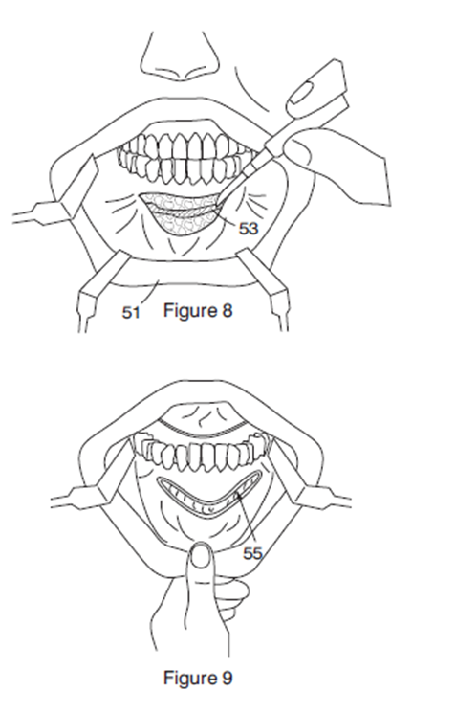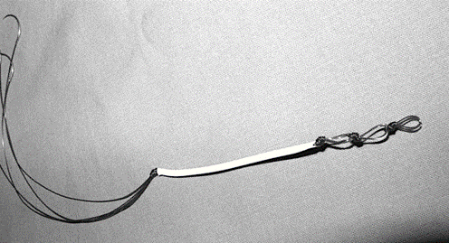

*Figure 1: A picture describing the surgery* *Figure 2: A picture of the device*

Immediately after the procedure you will be woken up and transferred to an intensive care unit (ICU). This is a precaution to ensure that there are no complications after the procedure that will affect your breathing. You will most likely stay in ICU for 24 hours. This stay will be extended if any medical problems arise. Thereafter you will be moved to a ward, where we will ensure that you are able to breath eat, drink and walk around pain free before being discharged home. After 8 months, this device will disappear/dissolve and in its place, will grow a natural tendon to support your tongue. If you undergo the operation, your doctor will discuss the procedure with you again when you are admitted to the hospital and will ask you to sign a separate consent form.

If you undergo the operation, you will also be reviewed regularly to see that you remain stable after the procedure and to deal with any issues you may have. The follow-up periods are usually 1 week and 1 month after the operation, and then every three months. However, you are free to see the Primary Investigator, Dr Rushdi Hendricks, at any time during this study if you have a concern. His contact number is 0832618472, all hours.

So, to summarise the study design is as follows:

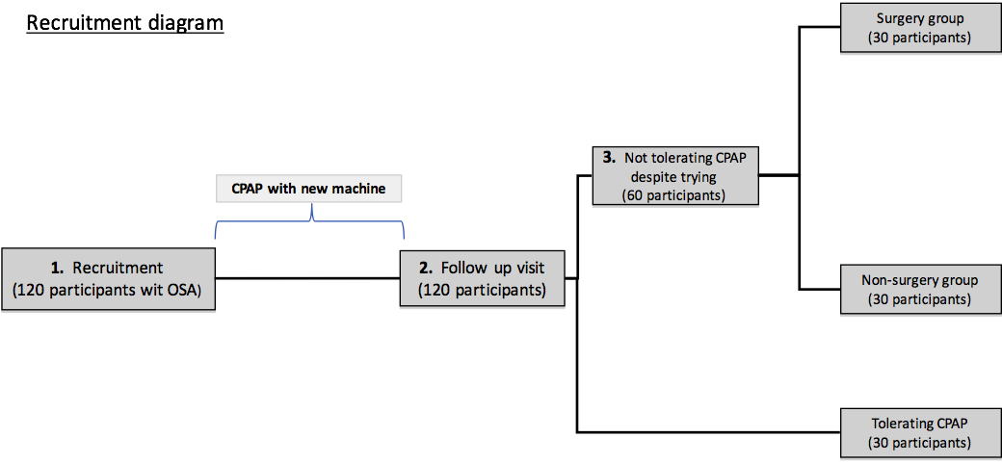



**D. POTENTIAL RISKS AND DISCOMFORTS**

The following are risks and discomforts that you may experience during your participation in this research study:

**DISE**: **Allergic reaction**

If you are allergic to anything, and especially egg products, soy, or glycerol, you should discuss this with your doctor.  The sedative medication used in DISE is Propofol, which contains egg lecithin, soybean oil, and glycerol, so there is a risk of an allergic reaction.

**DISE: Apnoea (Stopping breathing)**

Sedative medications relax the muscles around the throat and can slow down your breathing. To reduce the risk of this complication, the procedure is performed in the operating room and you will be closely monitored by your doctors throughout the procedure.

The medication is given very slowly, to give just enough for you to fall asleep and start the process of snoring and blockage of breathing that has been shown on the sleep study without sedation. It is uncommon for too much muscle relaxation or stoppage of breathing to occur, but there are many simple treatments that can be performed such as stopping the medication (it takes effect quickly and wears off quickly), lifting the lower jaw, or having one of the doctors in the operating room use a mask to help with breathing. Alternatively, if these and other measures do not resolve the problem, a breathing tube can be placed through the mouth, or a tracheotomy (breathing tube directly through the neck into the windpipe) can be performed.

**Sleep study:**

This is a non-invasive, painless test, and complications are rare. The most common side effect is skin irritation caused by the stickers used to attach test sensors to your skin. Napping the afternoon before the sleep study is usually discouraged.

### MRI scan:

An MRI scan is a painless scan that has the advantage of avoiding x-ray radiation exposure. There are no known side effects of an MRI scan. The benefits of an MRI scan are that it gives very clear images and can show structural abnormalities of the body.

Patients who have any metallic materials within the body must notify their doctor before the scan or inform the MRI staff. Metallic chips, materials, surgical clips, or foreign material (artificial joints, metallic bone plates, or prosthetic devices, etc.) can decrease the quality of the images obtained by the MRI scanner. Patients who have heart pacemakers, metal implants, or metal chips or clips in or around the eye, [artificial heart](http://www.medicinenet.com/heart_disease_pictures_slideshow_visual_guide/article.htm) valves, metallic ear implants, bullet fragments, and [chemotherapy](http://www.medicinenet.com/chemotherapy/article.htm) or [insulin](http://www.medicinenet.com/insulin/article.htm) pumps, cannot be scanned with an MRI because of the risk that the magnet may move the metal in these areas.

During the MRI scan, patient lies in a closed area inside the magnetic tube. Some patients can experience a claustrophobic feeling during the procedure. If you struggle with a fear of small spaces, you should tell your doctor and the radiology staff. A mild sedative can be given prior to the MRI scan to help ease this feeling. MRI staff will be nearby during your scan and can stop it at any time. There will be a way to communicate with the staff (such as a buzzer), which can be used at any time if you do not wish to continue with the scan.

**Drawing of blood:**

This test involves drawing blood from a vein in your arm, using a needle. It is known to be a safe procedure, with only minimal risk of complications. There can be minimal discomfort during procedure. Other occasional complications include bruising and local infection.

**Surgery:**

As mentioned above, if you get allocated to undergo surgery, this will be explained to you in more detail before the operation by the doctor who will do the operation. You will then also be asked to sign a consent form for the operation.

The following side effects are rare, but could be experienced during and after the operation:

You may have difficulty breathing after the surgery. This could be due to bleeding, swelling or blockage of the airway. To limit any danger to you, you will be admitted into an ICU where you will be taken care of by a doctor who specialises in patients who need intensive care (an intensivist). If the need arises they will be able to re-insert the breathing tube. If this is not possible they will be able to create an airway through your neck (tracheostomy), thus ensuring that you are breathing. This will be removed when it is safe to do so.

Other complications that you should be aware of are bleeding which usually can be stopped with pressure, and temporary numbness of the lower lip.

In the future, you may develop a scar along the device that may impair taste, speech and swallowing.

There is a chance that the device will not improve your airway and you will still require CPAP.

**E. WHAT IF SOMETHING GOES WRONG?**

This research study is covered by an insurance policy taken out by the University of Cape Town if you suffer a bodily injury because you are taking part in the study.

The insurer will pay for all reasonable medical costs required to treat your bodily injury, according to the SA Good Clinical Practice Guidelines 2006 (or latest version), which are based on the Association of the British Pharmaceutical Industry Guidelines. The insurer will pay without you having to prove that the research was responsible for your bodily injury. You may ask the study doctor for a copy of these guidelines.

The insurer will not pay for harm if, during the study, you:

• Use medicines or other substances that are not allowed

• Do not follow the study doctor’s instructions

• Do not tell the study doctor that you have a bad side effect from the study medicine

• Do not take reasonable care of yourself and your study medicine

If you are harmed and the insurer pays for the necessary medical costs, usually you will be asked to accept that insurance payment as full settlement of the claim for medical costs. However, accepting this offer of insurance cover does not mean you give up your right to make a separate claim for other losses based on negligence, in a South African court.

It is important to follow the study doctor’s instructions and to report straightaway if you have a side effect from the study or operation.

**F. POTENTIAL BENEFITS**

If the device is proven to be a safe and effective way to treat sleep apnoea, you and the global community may benefit from partaking in this study.

The main problem with Obstructive Sleep Apnoea (OSA), as you know, is the difficulty in sleeping while attached to a mask and CPAP machine. Participation in this study, will hopefully ultimately benefit all OSA sufferers soon, by adding an alternative treatment for the condition.

**G. ALTERNATIVES TO PARTICIPATING IN THE STUDY**

There is no obligation to participate in the study. If you decide not to take part in this study it will not affect the care you receive in any way.

**H. CONFIDENTIALITY**

Private information about you will be collected and used by the study team. This section of the consent/authorization form describes how your information will be used and shared in this research, and the ways in which the University of Cape Town safeguard your privacy and confidentiality.

The results of the tests performed during this study will be kept in your file and will be included in reports of the research. This will include sending them to the sponsor of some of this research at the Technology and Innovation Agency of South Africa and UCT.

**Confidentiality of Your Medical Records**

Your medical records will be kept in accordance within the laws concerning the privacy and confidentiality of medical information.

**Confidentiality of Your Study Information**

The results of all the details and tests collected by researchers will be transferred to a computer, but your name will not be included, and a coded number will identify you. No information about individual persons will be released to any other parties apart from the research team, except if we refer you to a clinic or doctor for treatment, or letters are written to other persons, or your close contacts, with your permission. When the results of research are published (for example, in medical journals), no personal details that could identify individuals, or individual households will be included. Completed results of the sleep studies and all other study-related paper or electronic records will be stored in a secure place.

**I. COMPENSATION/TREATMENT IN THE EVENT OF INJURY**

All forms of medical (or mental health) diagnosis and treatment – whether routine or experimental – involve some risk of injury. In addition, there may be risks associated with this study that we do not know about. Despite all precautions, you might develop medical complications from being in this study. If you sustain any injury during the research or experience any side-effect to a procedure, please contact Dr Rushdi Hendricks, on 0832618472

If such complications arise, the study doctor will assist you in obtaining appropriate medical treatment. You do not give up any rights to seek payment for personal injury by signing this form. Please note that all participants in this trial will be covered by the University of Cape Town no-fault insurance policy. This policy will be effective in the event of any injury during the research that is found to be a result of the research and that should result in a claim for compensation.

Your decision to take part in this study is completely voluntary (of your free will). If you decide not to take part in this study it will not affect the care you receive and will not result in any loss of benefits to which you are otherwise entitled.

You will be informed of any significant new findings during the research that may influence your willingness to continue to participate in the research.

**J. SPECIMEN STORAGE**

If you want to participate in this study, you will be asked to agree to have your blood and urine stored. The specimens that are stored will only be used to do retrospective testing for associated medical conditions linked to OSA and not for any other purpose.

Any leftovers of these samples will be destroyed. None of your personal details will be linked to your samples.

Your samples will be held in reserve for up to 10 years. If you decide that you don’t want your samples and information to be used for future research, you can tell us at any time and we will destroy them.

⬜ I agree to have my blood and urine samples stored for future use in this line of study work

⬜ I refuse to have my blood and urine samples stored for future use in this line of study work

**K. COSTS/REIMBURSEMENTS**

For each of the visits which you will attend during the study period, you will be receive R200.00, as compensation.

If you are to undergo the operation, you will be reimbursed with R1000.00 per day while in hospital.

If you are to undergo drug induced sleep endoscopy (DISE), you will receive R500.00 per session.

This will be as compensation for your time, inconvenience or discomfort, transport costs and time off work.

There will be no costs to you for your participation in the study.

**L. WITHDRAWAL FROM THE STUDY AND/OR WITHDRAWAL OF AUTHORIZATION**

If you decide to take part in the study, you may withdraw from participation at any time without penalty or loss of benefits to which you would otherwise be entitled. You may also withdraw your authorization for us to use or disclose your protected health information for the study and to store your specimens.

If you decide to withdraw your consent, please inform Dr Rushdi Hendricks. His telephone contact number is listed above and his mailing address is: Lung Infection and Immunity Unit, H46.41 Old Main Building, Groote Schuur Hospital, Observatory, 7925, South Africa.

The Principal Investigator or another member of the study team will discuss with you any matters that arise from withdrawing from the study.

If you have questions related to this trial that are not answered to your satisfaction by the study doctors, you may approach the Chair of the Human Research Ethics Committee of the Faculty of Health Sciences of the University of Cape Town:

Professor Mark Blockman: Research Ethics Committee

University of Cape Town

Faculty of Health Sciences,

E52 – 23 Old Main Building

Groote Schuur Hospital

Observatory, 7925

Tel: (021) 406 6492

Fax: (021) 406 6411

**AGREEMENT TO PARTICIPATE**

**Evaluation of the safety and efficacy of a novel tongue anchorage device in continuous positive airways pressure non-compliant patients with obstructive sleep apnoea**

**STUDY NO: INITIALS: DOB: (DD-MM-YYYY)**

⬜⬜⬜⬜⬜ ⬜⬜⬜ ⬜⬜-⬜⬜⬜⬜⬜

I have read this consent form,

[or it was read to me by: ______________________________________].

Any questions I had were answered by: ____________________________________.

All the above was explained to me in a language I understand and I had adequate time to consider my participation and discuss it with my family/ friends.

* I *am / am not* (circle one) participating in another research project at this time.
* I voluntarily agree to this research program as conducted by:

Lung Infection and Immunity Unit, H46.41 Old Main Building, Groote Schuur Hospital, Observatory, 7925, South Africa.

I will receive a copy of this Consent Form.

**Print Name of Participant or**

**Legal Representative/Guardian ________________________________________**

**Signature of Participant or**

**Legal Representative/Guardian ________________________ Date_______________** (dd/mm/yyyy)

**Print Name of Person**

**Obtaining Consent ___________________________________________________**

**Signature of Person**

**Obtaining Consent _______________________________ Date__________________**

(dd/mm/yyyy)

**If the Participant is illiterate**

A literate witness must sign (if possible, this person should be selected by the participant and should have no connection to the research team). Participants who are illiterate should include their thumb-print as well.

**I have witnessed the accurate reading of the consent form to the potential participant, and the individual has had the opportunity to ask questions. I confirm that the individual has given consent freely.**

**Print Name of Witness ______________________________**

**Signature of Witness ___________________________ Date ____________________**

(dd/mm/yyyy)

**AND Right Thumb Print of Participant**