

Evaluation of the safety and efficacy of a novel tongue anchorage device in continuous positive airways pressure non-compliant patients with obstructive sleep apnoea

Protocol version no 1
25 May 2017

Author(s): Rushdi Hendricks
Sponsor(s): UCT
Funder(s): TIA

Investigator Signature Page
I have read the protocol and agree it contains necessary details for carrying out the trial as described. I will conduct this trial as outlined making a reasonable effort to complete the trial within the timeline.
I agree to personally conduct or supervise the trial.
I agree to inform all participants that the trial device is for investigational purposes and I will ensure that obtaining informed consent is in line with Good Clinical Practice (GCP) and specific local requirements.
I agree to report adverse events to the Sponsor in accordance with GCP and specific local requirements.
I have read and understand the information in the Investigator’s Brochure or equivalent product information, including potential risks.
I agree to report to the Ethics Committee (EC) problems involving risk to the participants and will not make changes to the protocol without the EC and Sponsor approval, except if necessary to eliminate immediate harm to participants.
I agree to maintain adequate records, making them available as per GCP requirements.
I agree to ensure that all staff working on this trial is aware of their obligations in meeting the above commitments.

Principal Investigator: Rushdi Hendricks _________________________
Date: __24 May 2017_______________________

ROLES
Sponsor: University of Cape Town
Principal Investigator: Dr Rushdi Hendricks
Study sites: Department Pulmonology
University of Cape Town
UCT Private Hospital
KEY PERSONNEL
Co-Primary Investigator: Prof Keertan Dheda (Senior Specialist Physician and Pulmonologist)
Head: Division of Pulmonology, University of Cape Town, Groote Schuur Hospital)
Sub- Investigators: Dr Richard Raine (Senior Specialist Physician and Pulmonologist),
University of Cape Town, Groote Schuur Hospital)
Dr Ali Esmail (Specialist Physician and Pulmonologist, Dept. of Pulmonology, University of Cape Town, Groote Schuur Hospital)
Dr. Lynelle Mottay (Specialist Physician and Pulmonologist, Dept. of Pulmonology, University of Cape Town, Groote Schuur Hospital)
Dr Greg Symons (Specialist Physician and Pulmonologist, Dept. of Pulmonology, University of Cape Town, Groote Schuur Hospital)
Dr Suzette Oelofse (Research Medical Officer, University of Cape Town)
Dr Azgar Karjiker (Otorhinolarygologist, Private Practice)
Dr Shabeer Ebrahiem (Otorhinolarygologist, Private Practice)
Overall Study Monitor: Dr Delva Shamley (Director: Clinical Research Committee, University of Cape Town)
Medical Monitor: Dr Richard Raine / Dr Ali Esmail

Table of Contents
1
Protocol Synopsis 6
1 Background 11
2 RATIONALE 17
3 HYPOTHESIS 19
4 AIMS AND OBJECTIVES 19
4.1 Aims 19
4.1.1 Primary Aim: Safety and efficacy 19
4.2 Objectives 19
4.2.1 Primary objective: 19
5 TRIAL DESIGN 23
6 STUDY SCHEDULE 24
7 Investigational Plan 26
8 Safety monitoring 27
8.1 General safety monitoring 27
8.2 Study Specific Safety Monitoring 28
8.2.1 Adverse Events (AEs) 28
8.2.2 Serious Adverse Events (SAE) Reporting 29
9 Population 29
9.1 Inclusion criteria 29
9.2 Exclusion criteria 30
9.3 Participant Recruitment 30
9.4 Participant identification 30
10 TONGUE ANCHORAGE DEVICE 31
10.1 Device supply 31
10.2 Receipt and storage 31
10.3 Treatment / Surgical Procedure 31
10.4 Discontinuation of treatment or withdrawal of participants from the trial 33
11 Data review and database management 33
11.1 Data collection 33
11.2 Monitoring for quality 33
11.3 Database management 33
12 Analysis 34
12.1 Sample size calculation 34
12.2 Statistical analysis plan 34
12.3 Safety data 34
13 Ethical considerations 35
13.1 Regulatory and ethical compliance 35
13.2 Informed consent 35
13.3 Participant compensation 36
13.4 Withdrawal 36
13.5 Insurance 36
13.6 Budget 36
14 APPENDICES 37
14.1 Appendix 1 37
14.1.1 SLEEP APNOEA SYMPTOM QUESTIONNAIRE 37
14.2 Appendix 2 38
14.2.1 Visual Analog Scale 38
14.3 APPENDIX 3: 39
14.3.1 Division of AIDS (DAIDS) Table for Grading the Severity of Adult and Paediatric Adverse Events 39
14.4 APPENDIX 4 40
14.4.1 Device before and after implantation into sheep model 40
14.5 APPENDIX 5 43
14.5.1 Implantation Technique [Figure numbers correspond to Patent document] 43
14.6 APPENDIX 6 47
14.6.1 Calgary Sleep Apnoea Quality of Life Index (Interviewer) 47
14.7 APPENDIX 7 56
14.8 APPENDIX 8: 58
14.8.1 SLEEP DISORDERED BREATHING 58
14.9 APPENDIX 9 66
14.9.1 DISE: DRUG INDUCED SLEEP ENDOSCOPY 66
15 REFERENCES 67
65. Kezirian EJ, Hohenhorst W, de Vries N, Drug-induced sleep endoscopy: the VOTE classification. 70

Protocol Synopsis
Title | Evaluation of the safety and efficacy of a novel tongue anchorage device in continuous positive airways pressure non-compliant patients with obstructive sleep apnoea
Sponsor | University of Cape Town
Principal Investigator | Dr Rushdi Hendricks  Department of Pulmonology  University of Cape Town
Purpose and objectives | Primary objective:  To demonstrate safety and efficacy of the tongue anchorage device in patients who are non-compliant on CPAP with moderate to severe OSA.  - (A) Safety  Safety pilot study:  Safety will be assessed in a pilot study. The aim of the pilot study will be to demonstrate safety of the tongue anchorage device in patients who are non-compliant on CPAP with moderate to severe OSA.  For this aspect of the study, 40 participants will be screened in order to randomise 20 participants who are truly non-compliant on CPAP. 10 Participants will be randomised to the surgical arm of the study. All other aspects will be the same as for the main study including follow up schedule. An early safety analysis will be conducted after randomising 10 participants (5 surgical participants), while the final safety analysis will be conducted after 10 surgeries have been performed.  After each of the safety analysis (early and final), the study will be paused, and an interim safety analysis will be conducted where data will be presented to an independent DSMB. The data will then be reviewed and the study will only proceed after pronouncement of safety from the DSMB. The safety analysis report will be presented to the Human Research Ethics Committee and to Surgical Departmental Research Committee.  All participants will be followed up as per the protocol and the primary safety outcome will be measured at 4 weeks post-surgery. All adverse events will be managed throughout the study period, and graded according to severity. For the primary safety endpoint, a focussed safety analysis will be conducted at the 4 week post-surgery visit. This will be measured by a composite of the number and severity of adverse events as defined by the GCP, length of stay in the hospital over the standard 3 days, re-intubation rates, airway obstruction, bleeding, swelling, difficulty in swallowing and death. See safety assessment for further details. Adverse events will be classified as significant if they require any form of intervention.  Our safety endpoint will be to show that the novel tongue anchorage device is safe in the pilot study.  - ( B ) Efficacy  To show anatomical and clinical efficacy of the novel tongue anchorage device in patients with moderate to severe obstructive sleep apnoea that are non-compliant to CPAP.
Trial design | A Randomised control study with interim safety analysis after recruitment of 6% (5 surgical procedures) of the cohort and again at 12%, will be conducted at the UCT Academic Hospital  MAIN TRIAL DESIGN  * Interim safety analysis will be conducted after recruitment of 6% and 12% of participants.
Sample size | 120 adult participants will be screened and undergo a run-in phase of 12 weeks. Compliance on CPAP will be assessed in the run-in phase of the study and causes of non-compliance will be addressed in each patient. Using block randomisation (blocks of 4), 30 participants found to be truly non-compliant will be randomised to surgical intervention in the form of implantation of the novel tongue anchoring device.
Inclusion Criteria | - Participants who are willing and able to give written informed consent prior to any trial procedures.  - Patients who are documented to be non-compliant on CPAP therapy or are unwilling to use CPAP.  - Male and female adults between 20 and 70 years of age (inclusive) with symptomatic, moderate OSA as determined by AHI >15 and ESS >14.  - Women must have a negative serum pregnancy test at screening.  - Body mass Index (BMI) between 30 and 45 kg/m², inclusive; and a total body weight ≤150kg.  - Clinical laboratory tests at screening judged to be “not clinically significant” by the Investigator.  - Fujita type III diagnosed on DISE.  - History of previous failed ENT surgery for clearance of the upper airway (level 1 and level 2)
Exclusion criteria | - The presence of pre-existing medical conditions judged to be clinically significant by the investigators that would put the patients’ safety at risk.  - Coexistence of sleep disorders other than OSA.  - Evidence of current or history of clinically significant oncologic, pulmonary, hepatic, cardiovascular, haematologic, metabolic, neurological, immunologic, nephrologic, endocrine, psychiatric disease, or clinically significant current infection.  - Fujita type I and II diagnosed on DISE  - Patients with Macroglossia defined by the tongue protruding beyond the teeth during natural posture (Except if the patient is willing to undergo a tongue reduction procedure).
Trial duration | 52 weeks
Investigational Product | The novel tongue anchoring device will be the Investigational Product
Safety assessments | Safety will be assessed in a pilot study as mentioned above. Adverse event and severe adverse events will be monitored post enrolment. Specific adverse events related to the procedure will be collected in addition. These will be graded according to severity. Safety will be evaluated throughout the study; however the specified safety evaluation visit will take place at 4 weeks post surgery/ post randomisation for all groups.  Intra-operative: Such as, but not limited to bleeding, anaesthetic complications, hypoxia, length of procedure, failure of device implantation, adverse drug reactions.  Peri-operative: Such as, but not limited to sublingual haematoma, upper airway obstruction, infection, pain, migration of the device, length of hospital stay and wound dehiscence.  Chronic: Such as, but not limited to fibrosis, migration of the device, failure of device to improve airway patency, failure of the device to induce tendon growth, infection.
Efficacy assessments | Drug Induced Sedation Endoscopy (DISE): To evaluate improvement in airway patency/ compliance: ENT/pulmonologist  Cone Beam Volumetric Analysis: To analyse the calibre of the Pharynx pre- and post-surgery via 3-D volume analysis of the airway using Cone Beam Computerized Tomography  Orthopantomogram: pre- and post-operative to evaluate bony anatomy  Daytime Sleepiness /ESS (Epworth Sleepiness Scale)  AHI = Apnoea hypo-apnoea Index  Snoring Index  Neurobehavioural function  Blood pressure
Statistical analysis | SPSS package

Background
Obstructive Sleep Apnoea (OSA) is a serious debilitating condition characterized by blockage of the upper airway during sleep as a result of collapse of the soft tissues in the throat. OSA is associated with significant morbidity and mortality, the impact of which has not yet been fully defined and assessed in South Africa and the global community. There are no epidemiological studies relating to the prevalence and socio-economic effect that OSA has on the health situation in Southern Africa. It is estimated that approximately 2% to 4% of the adult population in Western countries are affected(1)but these figures may represent a gross under-estimation of the problem. Patients suffering from OSA have sleep fragmentation and deprivation as they are unable to achieve adequate rapid eye movement sleep resulting in a non-refreshing sleep pattern. The major symptom of OSA is excessive daytime sleepiness (EDS). As a result, lack of concentration and memory, changes in mood and personality as well as an increase in workplace and traffic accidents have been linked to EDS.(2).Moreover, there are significant comorbidities linked to OSA. These include cardiovascular, cerebrovascular, endocrine/metabolic complications and premature death .(3, 4)
There exists a strong relationship between obesity and OSA. It has been reported that 60 – 90% of patients suffering from OSA have a body mass index (BMI)≥ 30Kg/m2.(5) The prevalence of obesity has escalated to very high proportions in South Africa with rates as high as 57% in adult females and 29% in adult males.(6) In 1997, the World Health Organization formally recognized the global nature of obesity and declared it an epidemic.(7) As the prevalence of obesity increases, there is likely to be a parallel increase in OSA.(5).In the adult population, the prevalence of OSA is estimated at 25%, rising to 45% in obese individuals. (5)While OSA is more common in men and in the elderly age group, it can also occur in children and young adults. It is alarming that obesity in children and young adults is reaching epidemic proportions.(8)Obese children have a 46% prevalence of OSA compared to children seen in a general paediatric clinic(33%)(9). The risk of children and adolescents with OSA to develop metabolic syndrome is six fold greater than their counterparts without OSA.(10) These findings accentuate the need to develop adequate screening and prevention for these conditions, even as early as childhood. Obesity is considered a major risk factor in the development and progression of OSA. In obese and severely obese individuals, the prevalence of OSA is nearly twice that of normal BMI adults. Moreover, a 10% weight gain in patients with mild OSA can increase their risk by 6 times to progress to severe OSA while an equivalent weight loss can result in a 20% improvement of OSA severity.(11) It is therefore not surprising that after weight loss, OSA regresses in a dose dependent fashion.(12)
The upper airway in humans is the space between the nasal cavity and the larynx. Within this space lies the pharynx, which is germane to airflow into the lungs and where the collapse takes place. The pharynx has three anatomical levels. The nasopharynx begins at the back of the nasal cavity and forms the uppermost portion of the pharynx. The oropharynx is the intermediate portion which contains the soft palate, uvula, base of tongue and epiglottis. Due to the high presence of soft tissue structures in the oropharynx, it is therefore the most likely anatomical part to obstruct and collapse. The hypopharynx is the area behind and below the opening of the larynx and extends into the oesophagus.
It is well known that the soft palate and tongue are both flexible structures, while the soft palate provides a barrier between the nasal cavity and the mouth. In OSA, the soft palate often hangs down between the tongue base and posterior pharyngeal wall. During sleep, most muscles of the body relax while those of the respiratory system remain active.
In particular, the diaphragm contracts and pushes the abdominal contents downwards in order to create a negative pressure within the chest cage. Air is thus sucked in through the nasal and oral cavities into the lungs via the pharynx. The negative pressure of inhalation is usually counteracted by the compliance of the pharyngeal wall. In patients with OSA, the soft palate, tongue and/or epiglottis collapse against the posterior pharyngeal wall and blocks airflow into the trachea. As the airway becomes narrow, turbulence in the pharynx causes the soft palate to vibrate thereby generating the sound of snoring. It is possible that due to the deposition of fat at specific anatomic sites, as seen in obese patients, OSA may be aggravated .Compliance of the upper airway is negatively affected by the external pressure of para- pharyngeal fat deposition. (5)This results in a smaller lumen and increased collapsibility of the pharynx, thereby predisposing to OSA(13, 14). In addition, deposits of fat around the thorax (truncal obesity) can reduce chest compliance and functional residual capacity, thereby increasing oxygen demand. Visceral obesity is also commonly seen in OSA(15). However, a complex relationship exists between OSA and obesity .While there is compelling evidence that obesity, albeit visceral ,may predispose to OSA, and conversely that weight loss mitigates OSA ,recent studies suggest that OSA, per se, may predispose to weight gain(16). Factors such as reduced physical activity and increased appetite, especially for refined carbohydrates, may be implicated in weight gain in OSA patients(17). The role that OSA plays in the preferential deposition of visceral fat is yet to be determined(18).
The consistency of the effect of body weight on the progression of the disease process across different cohorts strongly suggests that many patients with OSA present with a clinical history of recent weight gain .In view of the above and given the fact that obesity is reaching epidemic proportions, the close association between weight gain and disease progression heightens the concern that OSA, with its attendant plethora of serious comorbidities, as well as attendant complications, will inevitably impose an enormous financial burden upon health care delivery in South Africa and worldwide.(12)
The basic epidemiological features of OSA are well established. The diagnosis of OSA is dependent upon both subjective and objective appraisal.(1)A comprehensive clinical and sleep history includes the evaluation of subjective symptoms such as habitual snoring, EDS, nocturnal witnessed apnoeas and a physical examination. The gold standard for the objective measurement of sleep disordered breathing (SDB) remains the polysomnogram (PSG) or sleep study.(1, 19, 20)
During sleep, it is often the case that brief obstructions of airflow and /or small decreases in the amount of airflow into the lungs can occur. An obstruction of airflow for more than 10 seconds is referred to as an apnoea.
OSA is defined by the number by the number of apnoea and hypopnoea episodes per hour of sleep (apnoea-hypopnoea index, AHI) reflecting the departure from the normal physiology of breathing during sleep. Apnoeas are further classified as obstructive, central, or mixed based on whether effort to breathe is present during the event. A hypopnoea is defined as a reduction in airflow that is followed by an arousal from sleep or a decrease in oxyhaemoglobin saturation. Commonly used definitions of a hypopnoea require a 25% or 50% reduction in oronasal airflow associated with either a reduction in oxyhaemoglobin saturation or an arousal from sleep. (6)The term “OSA syndrome” is used to indicate a clinical entity defined by an elevated AHI (having 10 or more episodes of apnoea or hypopnea per hour of sleep) in conjunction with hypersomnolence or related problems in daytime function and is synonymous with the term “obstructive sleep apnoea-hypopneoa syndrome ” (OSAHS).(21)
The severity of OSA is expressed by the AHI or the respiratory distress index( RDI) which reflects the number of apnoeas, hypopnoeas, and respiratory effort-related arousals.(1, 6) The following levels of severity, set by a task force to standardize measurement techniques and syndrome definitions for sleep related breathing disorders suggested the following cutpoints based on the AHI: mild OSA(5<AHI≤15 / hr) ), moderate (15<AHI≤30 /hr),and severe OSA ( AHI > 30 / hr).(1, 6) The spectrum of sleep related obstructive breathing is considered by many researchers to include increased upper airway resistance manifested as snoring without frank apnoea or hypopnoea events(21) and episodic flow limitation, terminating in arousals within the central nervous system – often referred to as “upper airway resistance syndrome”. (22) These conditions may herald the onset of early OSA and may be important in investigating disease progression but to date there are few epidemiological data based upon objectively measured non – apnoeic snoring or on respiratory effort-related arousals.(23) Comorbidities with OSA are severely underestimated. Over 80% of moderate to severe OSA are never diagnosed. Foster et al in 2009 documented an 86% prevalence of type 2 diabetes in USA associated with undiagnosed OSA(24). OSA is an important and independent risk factor for cardiovascular as well as cerebrovascular events(25). These include hypertension, coronary artery disease ,myocardial infarction, stroke, arrhythmias and pulmonary hypertension(8). In addition, OSA is also closely associated with well recognized causes of morbidity and mortality such as obesity, metabolic syndrome, systemic inflammation ,insulin resistance, a type 2 diabetes mellitus and atherosclerosis(1).
CPAP or continuous positive airway pressure treatment remains the gold standard for OSA because of its effectiveness in the elimination of apnoea and improvements in its sequalae (1, 9, 26-28). It operates by delivering air into the patient`s airway through a specifically designed nasal mask or pillow. The inflow of air creates a positive pressure during inhalation, thereby maintaining an open airway and pushing and splinting the tongue base in a forward direction. In this way, compliance and patency is maintained. Outcomes of randomised trials have shown substantial improvements in both sleepiness and neurocognitive performance of patients on nasal CPAP compared with those on placebo or subtherapeutic CPAP. Moreover, improvements in blood pressure have been shown with CPAP treatment. Marin et al in 2005 have shown significant reduction of cardiovascular risk in untreated OSA with use of CPAP of at least 4 hours per night (3). It has been shown that the average CPAP user only uses 2.7hrs per night.
It has been convincingly demonstrated that patients with an apnoea hypopnoea index (AHI) >30 have significant neuropsychological morbidity, which is improved by nasal continuous positive airways pressure (CPAP) therapy(10-13, 29). A recent meta-analysis of studies of the neuropsychological effects of obstructive sleep apnoea(14) concluded that there are insufficient data to adequately assess the impairment in subjects with mild OSA, particularly those with AHI < 15. The therapeutic effect of CPAP on daytime sleepiness was examined in another recent meta-analysis (15). This study found an overall improvement in daytime somnolence with CPAP, but the authors concluded that there were too few subjects included with mild to moderate sleep apnoea (AHI 30) to draw a valid conclusion for these subjects. These findings were supported by a recent Cochrane Review (16)which found that CPAP is effective in treating sleep-disordered breathing and in improving sleepiness and subjective health status; however the data documenting the degree of morbidity and demonstrating the efficacy of CPAP in patients with mild to moderate disease (AHI 5-30) remains inconclusive. There have been five randomized controlled trials of CPAP in subjects with mild to moderate OSA (17-20, 30). These have showed a modest effect of CPAP, but there is a significant placebo effect and treatment adherence is poor. Perhaps due to the poor treatment uptake, a significant disease load remains untreated by CPAP (12, 21)challenging sleep physicians to find alternative treatments for OSA.
Moreover, CPAP adherence is still a difficulty, with the use of heated humidification, nasal decongestants and steroids as well as intensive support with regular follow-up to improve CPAP adherence (31). Besides compliance, the CPAP apparatus presents local problems such as bloating, nasal drying, dry eyes and itchiness of facial skin. In addition, bed partners are adversely affected. CPAP is dependent upon electrical power making it difficult to use while travelling. As a result, CPAP compliance is only about 40%. Lastly, the high cost of CPAP delivery makes it a problem in third world countries and the routine use of such devices is difficult to justify (32, 33).
Surgical treatments have also been advocated for the treatment of OSA. The most common surgical procedure for OSA is uvulopalatopharyngoplasty (UPPP), first described by Fujita in 1981, in which the uvula and redundant soft tissue of the soft palate is resected.(34) The long term success of UPPP is only 20% after 2 years (22). Only about 41% of patients who undergo the procedure obtain an AHI of fewer than 20 events per hour. In addition, 20 events per hour is not always judged an adequate surgical outcome, especially in view of the uncertain correlation between AHI and apnoea complications. (35). Thus, the role of UPPP without tongue base advancement surgery for treatment of OSA is rather limited. Overnight PSG`s, 3–4 months after surgery is clearly indicated. In many cases, snoring will stop after UPPP, but disordered breathing continues, leading to silent apnoea.
Radiofrequency ( RF) of the tongue base produced promising early results but was not consistent in the long term (24). Multilevel surgery involving Fujita type II approaches is probably the most predictable way forward(25). At least one group(36-38) has reported success with more aggressive surgery (e.g. genioglossus muscle advancement and maxilla-mandibular advancement). Reduction in AHI to fewer than 10 events per hour have been reported in about 60% of patients after genioglossal advancement and in 90% after maxilla-mandibular advancement. However, these studies have not been randomised and these procedures have not gained widespread acceptance due to high cost and morbidity. Randomised controlled trials are needed for the latter. Newer surgical approaches such as laser-assisted palatal procedures, and radiofrequency ablation techniques have also been disappointing. Neither of these techniques has been effective in treatment of obstructive sleep apnoea(39-41). However, in patients whose main complaint is snoring, with little or no apnoea found on formal testing, these procedures may be considered. As snoring is a common problem, it is generally not associated with important adverse medical sequelae, in the absence of OSA. Snoring can, however, be a social issue for the bed partners of prominent snorers. In this situation, treatment for snoring with laser-assisted uvuloplasty or somnoplasty (radiofrequency ablation) can be considered. Bariatric surgery for morbidly obese patients with OSA have shown promising results. Several studies(42-44) have shown long term improvements in AHI after gastric stapling. However, some results have shown recurrence of apnoea after surgery for weight loss in the absence of substantial weight gain(45). Thus, the role of bariatric surgery, despite its increasing popularity, is still unclear.
Surgical implants have also been used to treat OSA. The Advance® system made by Medtronic uses a titanium screw that is inserted into the posterior aspect of the mandible at the floor of the mouth(46). A loop of suture is passed through the base of the tongue and attached to the screw. This procedure provides a hammock or suspension for the tongue, making it less likely for the base of the tongue to collapse during sleep. However, during wakefulness, the suture material acts as a cutting device and migrates anteriorly losing its efficacy within a few months.
Another tongue suspension device known as the Repose® again has only limited efficacy. (47)This device also utilizes the suture and screw concept. Again, the gains are only short term and below is some evidence relating to its long-term prognosis as a tongue suspension device: The Harvard Pilgrim Healthcare Medical policy on surgical tongue base suspension published in September 2008, stated that the Repose system does not result in permanent anatomical change in the posterior airway and this is due to the slippage that occurs in the long term with this particular method. Furthermore in the ERS Taskforce publication by Randerath et al 2011, on page 1015 paragraph 2 (48) it is stated that “As the aim of the tongue suspension is to stabilize and support the tongue base rather than to advance it is not surprising that Miller et al (49) and Terris et al (27) fail to find relevant changes in the posterior airway space.” This confirms the concept that tongue advancement is the way forward in the surgical management of obstructive sleep apnoea.

RATIONALE
The current gold standard in the management of OSA worldwide is CPAP (1, 9, 28). This therapy splints the airway and maintains an anterior position of the tongue. This modality, however, is poorly tolerated by a significant minority of patients and therefore has poor compliance in these individuals. (50)A significant proportion(46%) of those so diagnosed either do not initiate or eventually abandon therapy (51). Therefore, alternate methods of treatment have been investigated.
Van de Heyning et al have shown that electrical stimulation of the hypoglossal nerve, thereby protruding the tongue base, can improve OSA (52). Similar improvements in mild forms of OSA have also been achieved through the use of oral appliances (26). Given that the genioglossus muscle is the most significant dilator (adductor) of the pharynx, it is conceivable that anterior positioning and maintenance of the tongue in that position would obviate obstruction of the airway in Fujita type III obstructive cases (3).
A successful pilot study of 10 cases has already been concluded by the PI in CPAP-non-compliant human subjects where non-absorbable Poly-propylene mesh was employed as a tethering device (The un-submitted article is ready for publication). The biological basis thereof was to provide a new “check tendon” for the tongue to prevent its collapse against the posterior pharyngeal wall, and by advancing the tongue base by 10 mm, simultaneously improve compliance of the lateral pharyngeal wall. The highly successful outcome of this clinical study is awaiting publication and the proof of concept has been well established and documented.
Over the past 2 decades, a great deal of research has been undertaken to find a surgical solution that can advance the tongue base and tether it to the chin in a permanent fashion. While most cases of tongue suspension showed early successful outcomes, they relapsed after 6 months due to slippage or migration of the suture through the tongue muscle (46, 47, 53-58). Subsequently, the PI has shown excellent results in the use of polypropylene, which remains a firm material and hardens with time due to fibrosis, hence the quest for a better material solution.
Although well tolerated by all subjects in a 3-year postoperative clinical questionnaire, recently it was observed in explanted sheep tongue muscle (PI conducted a sheep trial in 2015), that long term fibrosis around the material increases rigidity, a feature that will be best eliminated if a biological collagen tendon could replace it, yet maintain similar tensile characteristics.
The need to develop a biological tendon for the tongue base in order to tether the tongue to the chin with simultaneous advancement was then identified and a protocol was developed in this regard and approved by the Animal Ethics at the Faculty of Health Sciences, UCT (AEC REF NO: 014/033).
22 sheep were used for the study, of which 4 sheep had the polypropylene embedded into their tongues. The remaining 18 sheep were divided into 2 groups of which 9 sheep had the test vehicle consisting of Polydioxinone surrounded by Porous Polypropylene while the remainder 9 sheep tongues were embedded with polydioxinone only as a control. The results seen on histology, bench testing and electrophoresis showed that the successful production of Collagens Type 1 and 3 were in great abundance and well orientated surrounded by the intrinsic muscle of the tongue, thereby successfully complying with the definition of a Biological Tendon. Explantations took place at 8 and 16 and 32 weeks respectively. The results of the sheep study will be published shortly.

HYPOTHESIS
Implantation of the tongue anchorage device is safe and will successfully induce tendon growth from the base of the tongue to the chin, thereby tethering the tongue in an anterior position, resulting in improved patency/ compliance of the hypo-pharyngeal airway.

AIMS AND OBJECTIVES

Aims

Primary Aim: Safety and efficacy
To demonstrate safety and efficacy of the tongue anchorage device in patients who are non-compliant on CPAP with moderate to severe OSA.

Sub-aims:
To demonstrate the anatomical efficacy of the tongue anchorage device in improving patency of the upper airway at the level of hypopharynx (tongue base) as assessed by Drug Induced Sedation Endoscopy (DISE) and Cone Beam Volumetric computerized radiology, post-surgery compared to pre-surgery baseline readings.
To demonstrate clinical efficacy of the tongue anchorage device by measurement of AHI and ESS, blood pressure, neurobehavioural functioning and Snoring Index as compared to pre-surgery baseline readings.

Objectives

Primary objective:
To demonstrate safety and efficacy of the tongue anchorage device in patients who are non-compliant on CPAP with moderate to severe OSA.

Safety
Our primary endpoint will be to show that the novel tongue anchorage device is safe in patients with moderate to severe OSA that are non-compliant to CPAP.

Safety pilot study:
Safety will be assessed in a pilot study. The aim of the pilot study will be to demonstrate safety of the tongue anchorage device in patients who are non-compliant on CPAP with moderate to severe OSA.
For this aspect of the study, 40 participants will be screened in order to randomise 20 participants who are truly non-compliant on CPAP. 10 Participants will be randomised to the surgical arm of the study. All other aspects will be the same as for the main study including follow up schedule. An early safety analysis will be conducted after randomising 10 participants (5 surgical participants), while the final safety analysis will be conducted after 10 surgeries have been performed.
After each of the safety analysis (early and final), the study will be paused, and an interim safety analysis will be conducted where data will be presented to an independent DSMB. The data will then be reviewed and the study will only proceed after pronouncement of safety from the DSMB. The safety analysis report will be presented to the Human Research Ethics Committee and to the surgical Departmental Research Committee.
All participants will be followed up as per the protocol and the primary safety outcome will be measured at 4 weeks post-surgery. All adverse events will be managed throughout the study period, and graded according to severity. For the primary safety endpoint, a focussed safety analysis will be conducted at the 4 week post-surgery visit. This will be measured by a composite of the number and severity of adverse events as defined by the GCP, length of stay in the hospital over the standard 3 days, re-intubation rates, airway obstruction, bleeding, swelling, difficulty in swelling and death. See safety assessment for further details. Adverse events will be classified as significant if they require any form of intervention.
Our safety endpoint will be to show that the novel tongue anchorage device is safe in the pilot study.

Efficacy
To show anatomical and clinical efficacy of the novel tongue anchorage device in patients with moderate to severe obstructive sleep apnoea that are non-compliant to CPAP.
This will be monitored through the following investigations:

Anatomical efficacy:

Drug Induced Sedation Endoscopy (DISE):

This procedure will be done on all truly CPAP-non-compliant participants after the run-in phase, to identify Fujita type III patients who may then be randomised for implantation of the tongue anchorage device. All other types will be excluded. A repeat DISE will be done post implantation at 4, 12, 24 and 36 weeks respectively in order to evaluate the efficacy of the novel tongue anchorage device.

Cone-beam Volumetric Analysis:
This study will be done on all truly CPAP non-compliant participants prior to randomisation. Cone Beam Volumetric Analysis will be used to analyse changes in the volume of the hypopharynx post-surgery. It will be repeated on surgical patients and non-surgical participants at 12, 24 weeks and 36 weeks. Fixed anthropometric landmarks will be measured, and compared to the pre-randomisation baseline measurements.

Clinical efficacy measures:

Polysomnography (PSG)

will be done for all participants at -12 weeks and 36 weeks. Surgical patients will also undergo

PSG at 4 weeks and the surgical and non-surgical, CPAP non-compliant participants will undergo a further PSG at 12 and 24 weeks. The following will be measured: Apnoea-hypopnoea index (AHI): This is used internationally as the most sensitive and reliable objective indicator of clinical change in OSA. Snoring index: Measures obstruction in the upper airway.

Daytime Sleepiness/ Epworth Sleepiness Scale (ESS):
This scale is used to evaluate symptomatic OSA as it occurs in the form of excessive daytime sleepiness. It is also a useful tool to evaluate a subjective change with interventions. This will be done -12 weeks, Pre-operative, 4, 12, 24 and 36 weeks.

Neurobehavioural function:

Health Related Quality of life assessment Short Form health survey Questionaire (SF-36)
This is a generic self-completed questionnaire that measures eight dimensions of health: physical functioning, role limitation due to physical problems (role-physical), bodily pain, general health perceptions, energy/vitality, social functioning, role limitation due to emotional problems (role-emotional) and mental health.

Sleep apnoea quality of Life Index (SAQLI)
This is a sleep apnoea-specific questionnaire consisting of four core domains: daily functioning, social interactions, emotional functioning and symptoms. The SAQLI also includes a domain specific for treatment-related problems which is useful for comparing the effectiveness of different treatment options.

Blood pressure
Blood pressure is measured with Dinamap (Critikon, Tampa,Florida, USA) in the evening (20:00–21:00) on the day of admission to the sleep study and the next morning on waking (8:00–9:00). The average of three readings taken at 1 min intervals is documented as morning and evening blood pressure readings. It will also be measured at each follow up visit.

TRIAL DESIGN
* Interim safety analysis will be conducted after recruitment of 6% and 12% of participants as part of the Safety Pilot Study.

STUDY SCHEDULE
 | Enrolment | Allocation | Surgery | Post-allocation |  |  | Close-out
TIME POINT | -12 weeks | -4 weeks | 0 | 4 weeks  (Primary Safety Outcome) | 12 weeks | 24 weeks | 36 weeks
ENROLMENT
Eligibility screen | X
Informed consent | X
INTERVENTIONS
Run-in CPAP (n=120)
Surgery with tongue anchorage device (n=30) |  |  | X
Follow up of surgical patients |  |  | X | X | X | X | X
ASSESSMENTS

Safety monitoring:
 | X | X | X | X  (primary safety outcome assessment) | X | X | X

 | - 12 weeks | - 4 weeks | 0 | 1 week | 4 weeks  (Primary Safety Outcome) | 12 weeks | 24 weeks | 36 weeks  (Primary efficacy outcome)
Efficacy monitoring:
Polysomnogram (PSG) | X |  |  |  | X@ | X&@ | X&@ | X
AHI | X |  |  |  | X@ | X&@ | X&@ | X
Daytime sleepiness/ ESS | X |  |  |  | X | X | X | X
DISE |  | X&@ |  |  | X&@ | X&@ | X&@ | X&@
Cone-beam volumetrics |  | X@& |  |  |  | X@& | X@& | X@&
Snoring Index | X |  |  |  | X | X | X | X
Neurobehavioural function | X |  |  |  | X | X | X | X
MRI |  | X&@ |  |  |  |  |  | X@&
Blood Pressure | X | X |  | X@ | X | X | X | X
History and physical examination | X | X |  | X@ | X | X | X | X
Evaluation of CPAP Usage |  | X |  |  | X*& | X*& | X*& | X*&
X - All groups X@ - Surgical group
X& - Non-surgical, CPAP non-compliant group X* - CPAP compliant control group

A prospective randomised control study with interim safety analysis after recruitment of 6% (5 surgical procedures) of the cohort and again at 12%. This study will be conducted at the UCT Academic Hospital whereby 120 adult participants will be screened. Participants with symptomatic moderate to severe OSA who have been shown to be non-compliant to CPAP by their respective treating doctors, will be invited to participate in the study.
Each screened participant will then enter a run-in phase of CPAP for 12 weeks where all confounding factors that could attribute to non-compliance will be addressed (e.g. mask fitment, pressure titration, reinforced training and counselling). The participants will then be evaluated for improvement and willingness to continue with CPAP at the end of the run-in period. 30 participants found to be truly non-compliant will then be offered the surgical placement of the novel anchoring device. These patients will then be monitored over the course of 36 weeks
Only subjects with ESS of > 10 and AHI over 15 will be included in the study.

Investigational Plan
As indicated in the study timeline, all eligible study participants will be asked to sign informed consent and go through the screening process. All qualifying participants will then undergo polysomnography (PSG) with AHI calculation and ESS calculation. The participants who satisfy the Inclusion and exclusion criteria for enrolment will then receive 12 weeks of CPAP therapy (Sullivan Elite, ResMed, Australia). During this period the patients will consult with sleep specialists and will undergo mask fitment and titration of their CPAP to determine ideal pressures to maximise compliance. Compliance will be monitored objectively with an inbuilt ‘time at pressure’ meter and reasons for non-compliance will be addressed. During these months any reason for possible non-compliance will be explored and addressed.
PSG (including analysis and scoring definition) and CPAP implementation will be performed as described by Barnes et al 2002. (59) The Maintenance of Wakefulness Test (MWT) will be performed and analysed according to standard guidelines on the day following the overnight sleep study.(60) Prior to each MWT nap, subjects will complete the Epworth Sleepiness Scale (61)and a visual analogue scale assessing subjective alertness and well-being (Appendix 1 & 2 ).
At the end of the 8 weeks, the participants will be re-evaluated to assess compliance and possible improvement. Participants with improvement will be advised to continue with CPAP. Patients that remain truly non-compliant after 8 weeks of CPAP will then be offered to participate in the study .
60 participants will be randomised onto the study using block randomisation (blocks of 4), and 30 participants will be offered surgery for the implantation of the tongue anchoring device, while the other 30 will serve as a control. Prior to surgery they will undergo cephalometric evaluation to assess the degree and location of airway obstruction. In addition clinical and anatomical evaluation of airway obstruction will be done by means of DISE on all participants randomised (surgical and non-surgical).
Post-operative efficacy evaluations will be conducted at 12, 24 and 36 weeks (at the close of the study). Safety will be monitored throughout the study and all adverse or serious adverse events will be reported and managed. Patients who have had an uncomplicated post-surgical course will be seen at 1 week, 2 weeks, 4 weeks post-surgery. Patients who have had complications will be evaluated more frequently, as deemed necessary. Efficacy evaluation will be in the form of repeat cephalometric radiological evaluation DISE, PSG with AHI and snoring index, daytime sleepiness (ESS), neuro-behavioural functioning, and blood pressure.
Subjects will be categorised as hypertensive using international definitions (62)and monitored for blood pressure readings according to Anconi-Israel at al. 2002 (63)Height, weight, and neck, waist and hip circumferences will also be recorded for each subject.
At the conclusion of the study, each subject and their domestic partner will be asked independently about their treatment preference.

Safety monitoring
As mentioned above, safety will be assessed in a pilot study. Furthermore, the primary objective of safety will be assessed continuously, according to the plan below.

General safety monitoring
All participants will undergo measurements of vital signs (pulse, respiratory rate, systolic and diastolic blood pressure followed by full physical examination including measurement of height, weight and calculated BMI) and specific laboratory assessments at baseline and at the indicated time points (see timeline). All relevant medical history will be recorded as baseline and concomitant medications will be recorded. If there are any clinically significant findings on history or examination prior to randomization that in the opinion of the investigator will put the patient at risk, then the participant will be excluded.
During the course of the trial, a patient’s clinical and laboratory adverse events will be graded according to DAIDS toxicity tables (see Appendix 3). Patients with grade 1 and 2 clinical and laboratory toxicity may continue participation into the trial however all patients with grade 3 and 4 toxicity will be assessed by the investigator and may continue participation or be withdrawn from the trial if, in the opinion of the investigator, the AE or laboratory toxicity poses a significant risk to the participant. Specific toxicity as listed below will be managed according to the principles outlined below.

Study Specific Safety Monitoring

Adverse Events (AEs)
An adverse event (AE) is defined as any untoward medical occurrence, including a worsening of a pre-existing condition. The event does not necessarily have to have a causal relationship with treatment in the interventional arm. An AE can therefore be any unfavourable and unintended sign (including an abnormal laboratory finding), symptom, or disease temporally associated with the use of a device, whether or not related to the investigational device.
The occurrence of adverse events (AEs) will be assessed from screening and recorded throughout the trial. All AEs will be recorded whether spontaneously reported by the subject, observed by the investigator or elicited by general questioning. At screening and again at admission, participants will be instructed to report any changes in normal health that they experience to the principal investigator or deputy. All abnormal findings will be carefully considered and any participant, who, in the judgment of the investigator may not safely complete the trial, will be withdrawn from the trial and the AEs will be followed up until resolution or agreement between the Principal Investigator and the Sponsor.
Anticipated adverse events for this study include the following:
Intra-operative complications: Such as, but not limited to blood loss, anaesthetic complications, hypoxia, length of procedure, failure of device implantation, adverse drug reactions.
Peri-operative complications (< 1 week): Such as, but not limited to sublingual haematoma, upper airway obstruction, infection, pain, migration of the device, length of hospital stay and wound dehiscence.
Chronic complications (> 1 week): Such as, but not limited to fibrosis, migration of the device, failure of device to increase airway patency, failure of the device to induce tendon growth.
The recording of every AE will include the following requirements:
• Participant identification;
• Time and date of onset;
• Time and date of resolution;
• Nature of AE;
• Exact description of temporal sequence to surgery
• Documentation of intensity (See DAIDS table, Appendix 2);
• Documentation of the results of diagnostic and therapeutic measurements;
• Details of the development and outcome including medical judgment;
• As much data as possible will be obtained for judgment concerning the relationship of the AE to the investigational product;
• Critical examination of the relationship to the investigational product (definite, probable, possible improbable, not related or not assessable to be assigned by the investigator).

At the end of the trial, the investigator must ensure that the end date and any sequelae of all AEs have been fully documented. If appropriate, the final relationship of AEs to the investigational product is re-assessed.

Serious Adverse Events (SAE) Reporting
A serious adverse event (SAE) is any untoward medical occurrence that results in death, is life-threatening, requires inpatient hospitalisation or prolongation of existing hospitalisation, results in persistent or significant disability or incapacity or is a congenital anomaly or birth defect or other medically important condition. SAEs will be reported (immediately or as soon as possible of being known by a member of the site team) to the Sponsor, and to the Data Safety Monitoring Board (DSMB) according to the Charter. Reporting to the University of Cape Town Research Ethics Committee will be in accordance with their written procedures. Data on SAEs will be collated and a preliminary causality assessment performed by the investigators.

Population

Inclusion criteria
- Participants who are willing and able to give written informed consent prior to any trial procedures.
- Patients who are documented to be non-compliant on CPAP therapy or are unwilling to use CPAP.
- Male and female adults between 20 and 70 years of age (inclusive) with symptomatic, moderate OSA as determined by AHI >15 and ESS >14.
- Women must have a negative serum pregnancy test at screening.
- Body mass Index (BMI) between 30 and 45 kg/m², inclusive; and a total body weight ≤150kg.
- Clinical laboratory tests at screening judged to be “not clinically significant” by the Investigator.
- Fujita type III diagnosed on DISE.
- History of previous failed ENT surgery for clearance of the upper airway (level 1 and level 2)

Exclusion criteria
- The presence of pre-existing medical conditions judged to be clinically significant by the investigators that would put the patients’ safety at risk.
- Coexistence of sleep disorders other than OSA.
- Evidence of current or history of clinically significant oncologic, pulmonary, hepatic, cardiovascular, haematologic, metabolic, neurological, immunologic, nephrologic, endocrine, psychiatric disease, or clinically significant current infection.
- Fujita type I and II diagnosed on DISE
- Patients with Macroglossia defined by the tongue protruding beyond the teeth during natural posture (Except if the patient is willing to undergo a tongue reduction procedure).

Participant Recruitment
The trial population will be consecutively recruited by the trial project manager from the sleep laboratories of university hospitals, sleep centres and private practice.

Participant identification
Participants will be identified by a 3-character screening code (S plus 3 digits) at the screening visit. A 1-letter, 2-digit trial number will be assigned once eligibility is confirmed. In this way participant anonymity, will be ensured.

TONGUE ANCHORAGE DEVICE
The details of the device are attached in appendix 4

Device supply
The device will be supplied in sterile batches by the manufacturer, Clinisut® (Harrower Road, Port Elizabeth).

Receipt and storage
The device will be stored according to the manufacturers' recommended condition, and in accordance with regulatory requirements, in a locked area with access restricted to designated trial personnel. The trial co-ordinator will also maintain records of the delivery of the device to the trial site, the inventory at the site, the device use by each participant and return of any unused trial devices to the sponsor or permission from the sponsor for destruction at the site.

Treatment / Surgical Procedure
Before implantation, the Device (See Appendix 4) will be soaked in Gentamicin solution (Fresenius 80mg/2mL vials) for 30 minutes and care will be taken not to have contact with the skin during surgery.
The prominence of the chin will be exposed by a labial incision. The chin will be fenestrated by osteotomising a block of bone in the sub-apical region to gain access to the floor of the mouth. A second incision will be made on the dorsum of the tongue anterior to the circumvallate papillae. (See Appendix 5: Fig`s 10 & 11). Sharp dissection will be carried through to the tongue base, and 2 anchorage polydioxinone (PDO) sutures which form part of the Device will be placed on the lateral and medial aspects of the incision wound. In this way, the device is anchored to the deep aspect of the tongue base. After checking for secure anchorage by pulling anteriorly on the device, the validity and strength of the attachment to the tongue base is firstly tested clinically (Fig 12). Once this is satisfactory, then the push through/pull through method is employed. The suture needles will eventually be cut off and removed completely. A curved, blunt artery forceps is used to engage one of the button holes and carry the front part of the tongue suspension device through the floor of the mouth towards the fenestration in the chin. (Fig 13). The button hole section of the tongue suspension device is then engaged through the chin fenestration and pulled through gently until the base of the tongue makes a depression.
In addition, the 10mm spacing of the button holes simplifies the distance markings when the tongue needs to be advanced by 10mm, respectively. A 9mm by 2.0 mm hole is drilled into the cortex of the chin within the fenestration window and the same size Lactosorb® bio-absorbable screw ( Zimmer Biomet Microfixation, Florida, USA) is placed securing the chosen button hole. The bone that is removed is not replaced as new bone will eventually fill into the gap. (Fig 14).
The excess PDO is cut off and removed. The chin will be closed in layers. The dorsum of the tongue will be sutured with 3/0 ChromicTM continuous suture (Ethicon, Johnson & Johnson) and the lower lip repaired with 5/0 VicrylTM (Ethicon, Johnson & Johnson) interrupted sutures. Pressure tape will be applied for 3 days postoperatively.
Postoperatively, as a precaution to protect the airway, overnight intubation and high intensity observation will be carried out in the intensive care unit under the care of a specialist physician/pulmonologist. Arterial line insertion and arterial blood gas monitoring will be mandatory for 48 hours after the surgery together with pulse oximetry, to screen for airway obstruction. After extubation, on day 1 postoperatively, patients will be monitored for an additional night in the intensive care unit. The patients will subsequently be transferred to the general ward for an additional 2-day observation. A soft diet will be introduced on day 1 postoperatively, and a strict oral hygiene regimen was prescribed. All patients will receive perioperative CefazolinTM 1 g (GlaxoSmithKline) with a 5-day follow up of 250mg orally twice a day and 8 mg Dexamethasone (Pharmacare, Port Elizabeth) for 3 consecutive doses.
Complications: Due to previous experience of an investigation by the PI of 10 participants involved a proof of concept pilot study in 2012, the following complications will be mitigated after the procedure. In this series of 10 participants, one patient developed a sublingual haematoma, speculated to be related to premature administration of his anticoagulation medication. There were no serious sequelae, and this resolved without drainage after 5 days. One patient died after the procedure whilst in the intensive care unit. He is thought to have had a cardiac event unrelated to the surgery as reported on the autopsy findings. In the perioperative stage, all the vital observations were within normal limits. In the absence of hypotension, anaemia, arrhythmias or electrolyte imbalances, his death could be deemed as unrelated to the surgical procedure.
Furthermore, the surgery was well tolerated by the patients, and no further complications were reported. In this study, the BMI ranged from 29 to 47kg/m² (average 36.5). Also, the AHI ranged from 10 to 98.4 events/hr (average 50.4) indicating that fairly obese and moderate to severe OSA participants were well managed by the surgical/medical team.
The surgery was judged to be worthwhile by all 10 patients, and all patients indicated that they would recommend the treatment to other patients with OSA. In addition, all the individual patient responses on the improved quality of lives were highly positive.

Discontinuation of treatment or withdrawal of participants from the trial
A participant will be withdrawn from the trial for the following reasons:
- At the request of the volunteer, irrespective of the reason, though a reasonable effort will be made to ascertain the reason while fully respecting the participant’s rights
- Failure to comply with the protocol
- At the discretion of the investigator (the reason will be recorded)
- An AE (including an intercurrent illness) which rules out further participation in the trial. The decision whether or not to withdraw the volunteer will be the prerogative of the investigator and will depend on the nature of the illness/reaction.
In the event that a volunteer is withdrawn, the investigator will conclude the safety follow-up assessment for the volunteer and evaluate the safety data. In the event that AEs are not yet resolved, follow-up visits will be scheduled until the investigator is satisfied that the AE has resolved, or on agreement between the Principal Investigator and the Sponsor.

Data review and database management

Data collection
Individual source document files for trial-related source documents (screening notes, AE reports, blood test result reports, adherence questionnaire documents etc.) will be kept securely at the trial site. In addition, a case record form (CRF) will be compiled for each participant to collect [participant-specific details, trial-related blood test results, device details. The CRF will constitute source data for addition into essential trial documents [add details].

Monitoring for quality
The Principal Investigator will provide direct access to source data/documents for trial-related monitoring, audits, ethics committee review, and regulatory inspection.

Database management
Steps involved in data management, including those relating to the development and management of a data base will be performed in accordance with standard operating procedures consistent with regulatory requirements. The confidentiality of records that can identify participants will be protected, respecting the privacy and confidentiality rules in accordance with regulatory requirements. All trial-related documents will be stored for at least 15 years following trial completion. Duplicate plasma samples will be kept at -80°C until after trial completion.

Analysis

Sample size calculation
Assuming 50% of patient achieve primary outcome of more than 50% reduction of AHI (64), and 20% of patient in the control group achieving primary outcome (through measures like weight loss compliance, etc.), and assuming 95% confidence interval and 90% power, we will need to randomise 60 patients into the study.
Assuming 30% become compliant to CPAP after the run-in period, and 10% lost to follow up, we will need to screen approximately 100 patients.

Statistical analysis plan
Descriptive statistics will be used to describe participants. Categorical variables such as surgical success and adverse events will be expressed as frequencies and percentages. Continuous variables will be expressed as mean (with SD and 95% CI) and median (with interquartile range) for normal and non-normal distributions respectively. For primary clinical efficacy outcomes, namely AHI, a reduction of 50% will be used to explore distributions over time and compared between intervention groups using Students t-test (for normal distributions) or Wilcoxon rank sum tests (for non-normal distribution) at 1 month follow-up. Comparisons between categorical outcomes (achievement of 50% reduction in AHI) and categorical variables will be analysed using Chi-square or Fishers exact test depending on their distribution. A p<0.05 will be considered statistically significant.

Safety data
All the safety investigations, including adverse events (AEs), haematological and biochemistry investigations from screening to the final trial visit will be summarized with descriptive statistics.

Ethical considerations

Regulatory and ethical compliance
Relevant trial documents will be submitted to the Research Ethics Committee of the University of Cape Town and the South African Medicines Control Council. Approval of the protocol and any amendments will be obtained before implementation.
The trial will be conducted in accordance with the Declaration of Helsinki [2013], International guidelines for Good Clinical Practice (ICH 1997), ISO14155, The Department of Health: Ethics in Health Research: Principles Structures and Processes, 2004 and according to national guidelines of Good Clinical Practice (National Department of Health 2006).
The trial will also be monitored by On Q Research for optimal data collection and GCP compliance.
Deviations and exceptions from the protocol will be managed in accordance with the University of Cape Town’s Research Ethics Committee procedures, which are in accordance with Good Clinical Practice guidelines.

Informed consent
The investigator or a designated trial team member will fully explain the nature, conditions and possible consequences including risks and inconveniences of the trial to the trial participants. No participant will be enrolled in the trial before they have been fully informed about the trial verbally and by means of an information document, and signed consent has been obtained on the trial-specific consent form. A competent translator, familiar with the trial will assist in the informed consent process when necessary. The translator will be able to translate the conversation between the investigator and the volunteer should there be any questions from the volunteer. Participant information and consent documents will be available in English, Afrikaans and Xhosa, and participants will have the opportunity to discuss whether to enrol with family or friends prior to screening. A witness independent of the trial will countersign the consent documents of illiterate patients. The independent witness will be signing to the effect that the information was read to the volunteer, who understood and freely gave their consent. Each participant will be given a copy of the signed consent document, a copy will be placed in the participant’s medical record (if applicable) and the original stored in the trial files.
The ICF form is enclosed as a separate document.

Participant compensation
Each participant will be compensated to cover travel costs and inconvenience on a pro-rata basis as detailed in the participant information document. R1000 per day for in hospital surgical stay. R500 per day for DISE, and R200 per day for consultation.

Withdrawal
Participants are free to withdraw from the trial at any stage, without prejudice to them and without affecting their rights to care in any way. Participation in the clinical trial may be discontinued should the attending clinician deem it in the best interest of the patient, or if there is poor compliance with visits or non-adherence to trial treatment or other protocol requirements.

Insurance
The trial will be conducted under the auspices of the University of Cape Town's no-fault clinical trial insurance policy. Compensation will be paid in accordance with the policies, when on the balance of probabilities, the injury was attributable to the administration of a medical device or trial procedure provided for by the protocol that would not have occurred but for the inclusion of the patient in the trial. The Guidelines for Good Clinical Practice in the conduct of Clinical Trials in human participants in South Africa (Department of Health 2006) and ISO14155 will be followed. The insurance will cover the costs of any medical care required for trial-related adverse event, the affected participants will receive free medical care (through the public or private sectors) for the treatment of the AE until its resolution or stabilisation. In addition, the University of Cape Town subscribes to insurance policies which include professional liability and personal accident which apply to researchers and research participants involved in research conducted under the auspices of the University.

Budget
A separate budget document is attached totalling 37.72M. Approximately 38% of the total budget (14.33 M) is a TIA application to complete the pilot study. Once, the initial results are analysed, then the rest of the budget will be applied for or alternate funding will be contemplated (VC).

APPENDICES

Appendix 1

SLEEP APNOEA SYMPTOM QUESTIONNAIRE

NEVER X ALWAYS

1. How often do you snore?
2. Do you wake in the night with a choking feeling?
3. How often would you sleep more than 8 hours in total in a 24 hour period?
4. How often do you wake more than once during the night?
5. Do you have a headache when you wake up in the morning?
6. Have you noticed a reduction in your libido or sex drive?
7. Do you feel sleepy during the day?
8. Has anyone noticed that you momentarily stop breathing during sleep?
9. Do you fall asleep while reading?
10. Do you wake up in the morning feeling confused?
11. How often do you have a nap during the day?
12. Do you feel sleepy in the evenings?
13. Have you or anyone else noticed a change in your personality recently?
14. How often do you doze off or fall asleep while driving?

Appendix 2

Visual Analog Scale
Place a cross (X) on the line to indicate how you are feeling right now.

1. How alert do you feel?
Very sleepy Very alert

2. How good do you feel?
Very bad Very good

APPENDIX 3:

Division of AIDS (DAIDS) Table for Grading the Severity of Adult and Paediatric Adverse Events
Citation:
U.S. Department of Health and Human Services, National Institutes of Health, National Institute of Allergy and Infectious Diseases, Division of AIDS. Division of AIDS (DAIDS) Table for Grading the Severity of Adult and Paediatric Adverse Events, Version 2.0. [November 2014]. Available from:
http://rsc.tech-res.com/docs/default-source/safety/daids_ae_grading_table_v2_nov2014.pdf

The DAIDS AE grading table is a shared tool for assessing the severity of AEs (including clinical and laboratory abnormalities) in participants enrolled in clinical trials.
The DAIDS AE grading table provides an AE severity grading scale ranging from grades 1 to 5 with descriptions for each AE based on the following general guidelines:
• Grade 1 indicates a mild event
• Grade 2 indicates a moderate event
• Grade 3 indicates a severe event
• Grade 4 indicates a potentially life-threatening event
• Grade 5 indicates death (Note: This grade is not specifically listed on each page of the grading table).

APPENDIX 4

Device before and after implantation into sheep model
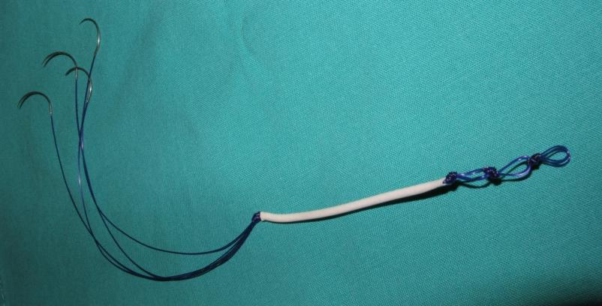
Device made from 4 strands of 0 – polydioxinone (PDO) circumscribed by porous polyurethane (PU) scaffold (White) implanted into sheep

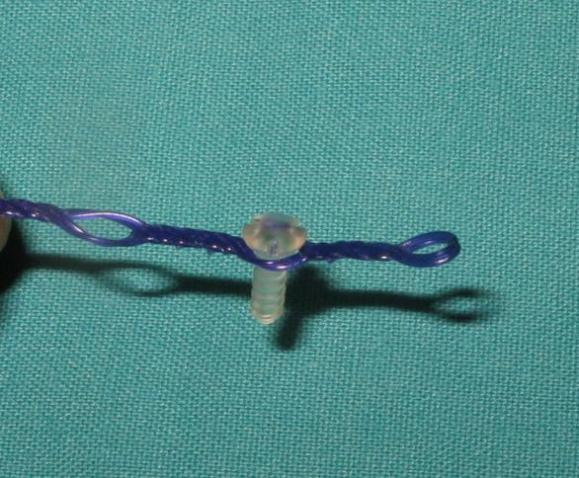
Improvement of anterior insertion portion of PDO/PU device. Buttonholes created by means of ultrasonic welding are spaced exactly 10mm apart to facilitate advancement of tongue base and secured by placement of screw into chin cortex. Screw is 2mmx 9mm PLA (polylactic acid absorbable within 8 months).
This improvement will be used in human model
Proof of biological tendon in sheep model
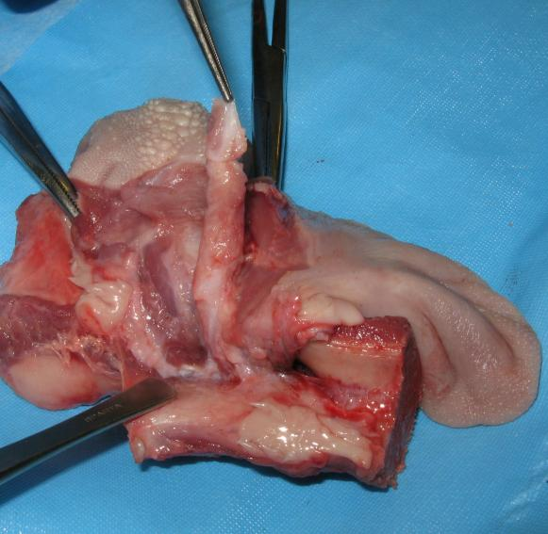
New Biological Tendon grown in sheep tongue 8 months explant. Note “natural” attachment to chin

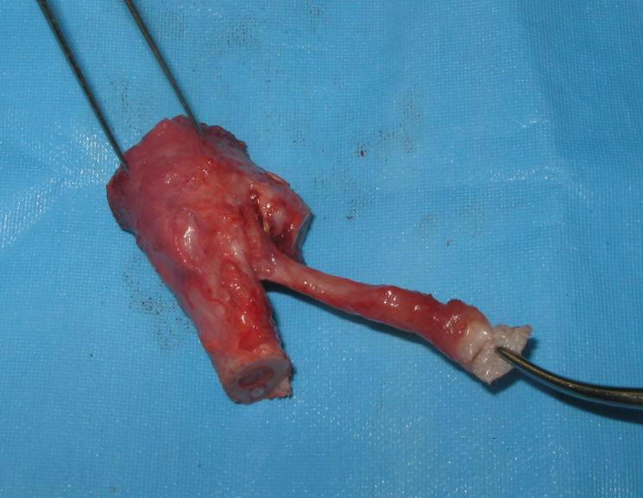
New Biological Tendon dissected free. Note the biological attachment of tendon to intrinsic muscle of tongue in sheep

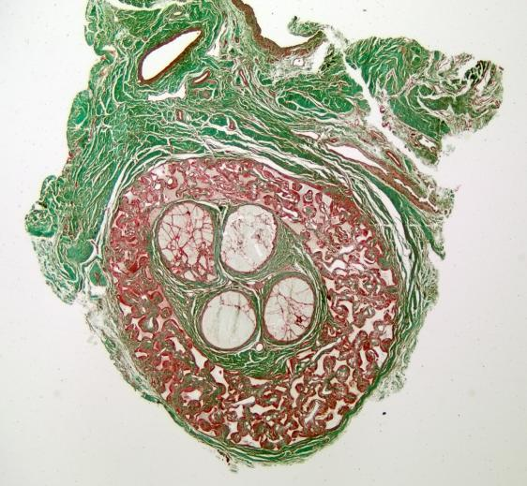
Histological photomicrograph showing cross section of device at 16 weeks explant in sheep with abundant collagen (green) ingrowth into polyurethane straw (red) of device

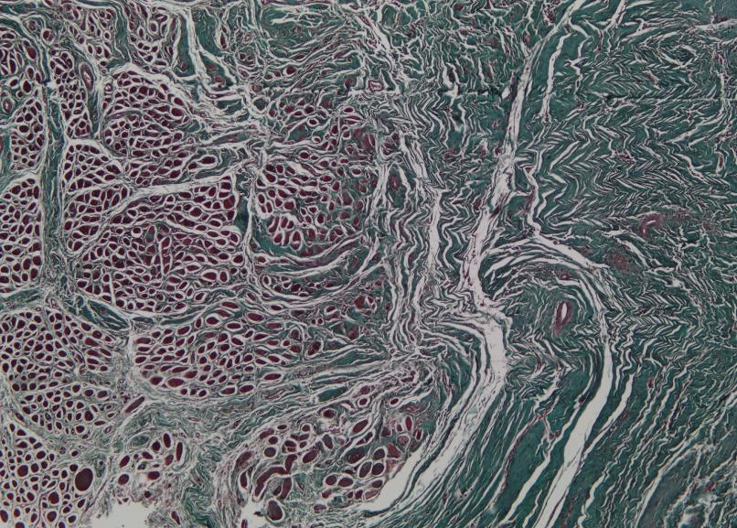
Histological photomicrograph showing Mature Collagen (mainly type 1) seen on right of slide (Green) merging biologically with intrinsic muscle of tongue in sheep at 32 weeks explant. Note complete disappearance of implanted device

APPENDIX 5

Implantation Technique [Figure numbers correspond to Patent document]
Initially the lower lip (51) is retracted and a vestibular incision (53) is carried out to incise the mucosa and the Mentalis Muscle of the chin as shown in Figure 8. The mentalis muscle is then stripped to expose the bony prominence of the chin (55) as shown in Figure 9. A fenestration or window (57) is the formed in the prominence (55) of the chin at the subapical level of the lower incisor teeth (59) as shown in Figures 10 and 11. The fenestration is created by an osteotomy of both the outer and inner cortices of the bone. A 701 bur is used to make the perforation in the bone which is then removed by means of an osteotome. It is recommended to remove each cortex separately.
Access to the floor of the mouth is thus achieved. Alternatively, a bone trephine bur measuring 10mm in diameter may also be used to create the fenestration access. Figure 11 illustrates the bicortical fenestration (57) to the floor of the mouth as seen from a lateral perspective. It is within this fenestration or bony defect that a fixation screw( 73) can be placed to provide anchorage to the implantable device.

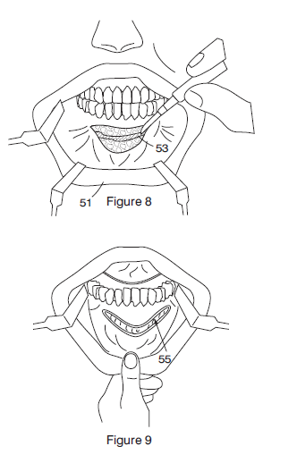

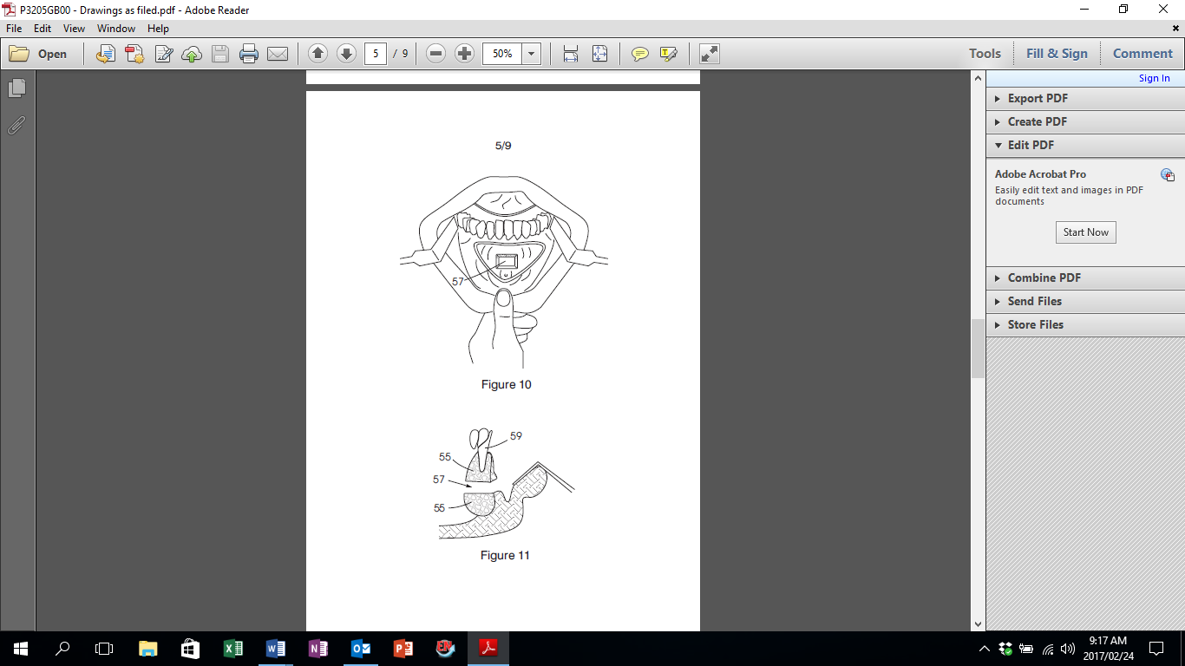
Two anchorage sutures are inserted deep into the intrinsic muscle of the tongue, one being anterior and the other posterior, respectively. This technique is illustrated in Figures 14 and 15. After the needles have been removed and discarded, the sutures are tensioned and tied together so that the two on the right side make a single knot (70) and the same is done for the two on the left side (Figure 15). In this way, the straw PU is well embedded into the base of the tongue.

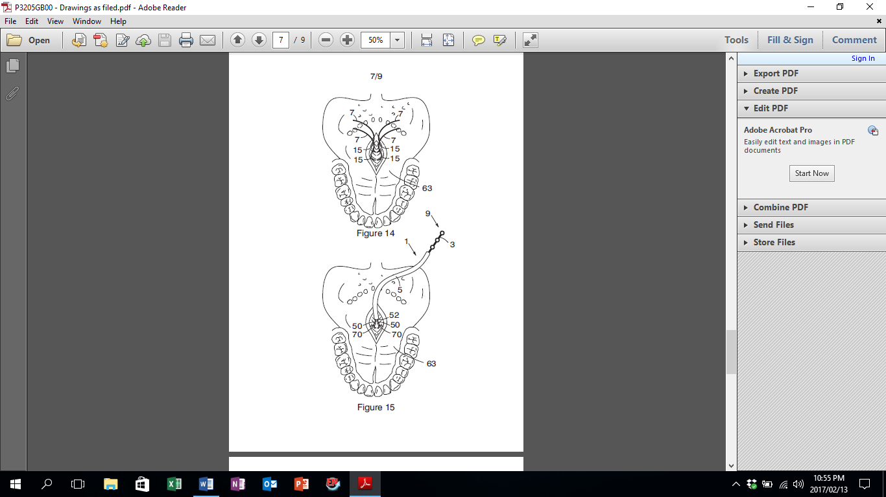

Figure 15 illustrates the knotted end of the tongue suspension device in the deep aspect of the tongue muscle before the push through into the floor of the mouth. By pulling anteriorly on the device, the validity and strength of the attachment to the tongue base is firstly tested clinically. Once this is satisfactory, then the push through/pull through method is employed.

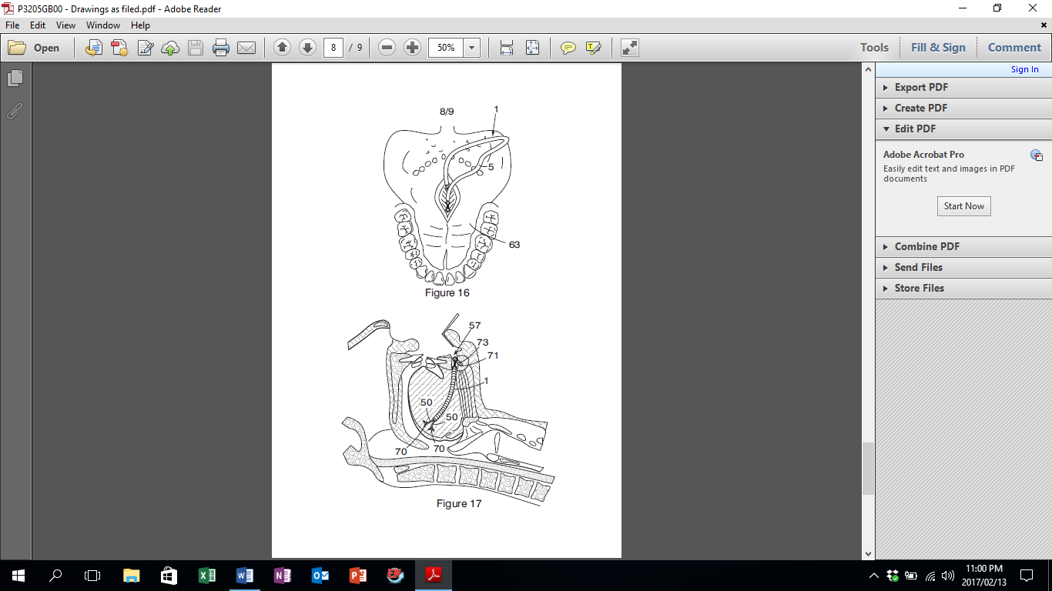

Figure 16: A curved, blunt artery forceps is used to engage one of the button holes and carry the front part of the tongue suspension device through the floor of the mouth towards the fenestration in the chin. The button hole section of the tongue suspension device is then engaged through the chin fenestration and pulled through gently until the base of the tongue makes a depression.
In addition, the 10mm spacing of the button holes simplifies the distance markings when the tongue needs to be advanced by 10mm, respectively. A 9mm by 2.0 mm hole is drilled into the medulla of the chin within the fenestration window and the same size Lactosorb ^{R} screw (73) is placed securing the chosen button hole. The bone that is removed is not replaced as new bone will eventually fill into the gap.

Figure 17 illustrates the final position of the embedded tongue suspension device. This device not only supports the tongue base from falling against the posterior pharyngeal wall during sleep, but also advances the tongue base so that the compliance of the oropharynx and hypopharynx is improved and secured, thereby making obstruction of the lower airway impossible. The Lactosorb screw is depicted by 73 and the PDO cords by 50 and the PU sheath by 1.
Ultimately, the tongue will now have a naturally induced biological ligament providing the check and protection that it lacks anatomically, yet at the same time, all physiological aspects of tongue muscular function, like speech, swallowing and chewing are not in any way adversely affected by the device which eventually disappears in its entirety.

APPENDIX 6

Calgary Sleep Apnoea Quality of Life Index (Interviewer)
This questionnaire has been designed to find out how you have been doing and feeling over the last 4 weeks. You will be questioned about the impact that sleep apnoea and/or snoring may have had on your daily activities, your emotional functioning, and your social interactions, and about any symptoms they might have caused.
A. Daily Functioning
I. Most important daily activity. With regard to performing your most important, usual daily activity (e.g., work, school, child care, housework, etc.) during the previous 4 weeks:
1. How much have you had to force yourself to do this activity? [yellow card]
2. How much of the time have you had to push yourself to remain alert while performing this activity? [yellow card]
3. How often have you adjusted your schedule to avoid this activity because you felt that you would be unable to remain alert while doing it? [yellow card]
4. How often do you use all of your energy to accomplish only this activity? [yellow card]
II. Secondary activities. With regard to activities other than your most important daily activity during the previous 4 weeks:
5. How much difficulty have you had finding the energy to exercise and/or do activities that you find relaxing (leisure activities)? [green card]
6. How much difficulty have you had finding the time for activities that you find relaxing? [green card]
7. How much difficulty have you had with your ability to do exercise and/or activities that you find relaxing? [green card]
8. How much difficulty have you had getting chores done around the place where you live? [green card]
III. General functioning. During the previous 4 weeks:
9. How much difficulty have you had with trying to remember things? [green card]
10. How much difficulty have you had with trying to concentrate? [green card]
11. How much of a problem have you had with having to fight to stay awake? [red card]

B. Social Interactions
The following questions pertain to how your relationship with your partner, other household members, relatives, and/or close friends have been during the previous 4 weeks. If you have not interacted with a partner, etc. in the previous 4 weeks, please try to work out how your relationship might have been with these people
. 1. How upset have you been about being told that your snoring was bothersome or irritating? [green card]
2. How upset have you been about having to (or possibly having to) sleep in separate bedrooms from your partner? [green card]
3. How upset have you been as a result of frequent conflicts or arguments? [green card]
4. How aware have you been of not wanting to talk to other people? [green card]
5. How much concern have you had about the need to make special sleeping arrangements if you were traveling and/or staying with someone? [green card]
6. How guilty have you felt about your relationship with family members or close personal friends? [green card]
7. How often have you looked for excuses for being tired? [yellow card]
8. How often have you experienced wanting to be left alone?
9. How often have you felt like not wanting to do things together with your partner, children, and/or friends? [yellow card]
10. How much of a problem have you felt there is with your relationship to the person who is closest to you? [red card]
11. How much of a problem have you had from not being involved in family activities? [red card]
12. How much of a problem have you had with inadequate and/or infrequent sexual intimacy? [red card]
13. How much of a problem have you had with a lack of interest in being around other people? [red card]

C. Emotional Functioning
With respect to how you have been feeling inside during the previous 4 weeks :
1. How often have you been feeling depressed, down, and/or hopeless? [yellow card]
2. How often have you been feeling anxious or fearful about what was wrong? [yellow card]
3. How often have you been feeling frustrated? [yellow card]
4. How often have you been feeling irritable and/or moody? [yellow card]
5. How often have you been feeling impatient? [yellow card]
6. How often have you been feeling that you are being unreasonable? [yellow card]
7. How often have you been getting easily upset? [yellow card]
8. How often have you experienced a tendency to become angry? [yellow card]
9. How often have you been feeling like you were unable to cope with everyday issues? [yellow card]
10. How concerned have you been about your weight? [green card]
11. How concerned have you been about heart problems (heart attacks or heart failure) and/or premature death? [green card]

D. Symptoms
Below is a list of symptoms that some people with sleep apnoea and/or who snore may experience. As each symptom is read please indicate whether it has been a problem or not (answer yes or no). Circle those symptoms that you have experienced during the previous 4 wk. Once the list is finished please write down additional symptoms in the blank spaces you may have had that are not included in the list below. Next select the five most important symptoms you have experienced. For each of the five symptoms please identify how much of a problem it has been. [red card]
1. Decreased energy
2. Excessive fatigue
3. Feeling that ordinary activities require an extra effort to perform or complete
4. Falling asleep at inappropriate times or places
5. Falling asleep if not stimulated or active
6. Difficulty with a dry or sore mouth/throat upon awakening
7. Waking up often (more than twice) during the night
8. Difficulty returning to sleep if you wake up in the night
9. Concern about the times you stop breathing at night
10. Waking up at night feeling like you were choking
11. Waking up in the morning with a headache
12. Waking up in the morning feeling unrefreshed and/or tired
13. Waking up more than once per night to urinate
14. A feeling that your sleep is restless
15. Difficulty staying awake while reading
16. Difficulty staying awake while trying to carry on a conversation
17. Difficulty staying awake while trying to watch something (concert, movie, TV)
18. Fighting the urge to fall asleep while driving
19. A reluctance or inability to drive for > 1 h
20. Concern regarding close calls while driving due to your inability to remain alert
21. Concern regarding your or other’s safety when you’re operating a motor vehicle or machinery
22. ______________________________________________________
23. ______________________________________________________
E. Treatment-related Symptoms
If you haven’t had some type of therapy for sleep apnea and/or snoring leave this section blank. Below is a list of symptoms that some people who have been treated for sleep apnea and/or snoring may experience. As each symptom is read please indicate whether it has been a problem or not (answer yes or no). Circle those symptoms that you have experienced during the previous 4 wk. Once the list is finished please write down any symptoms in the blank spaces you may have had that are not included in the list below. Next select the five most important symptoms you have experienced. For each of the five symptoms please identify how much of a problem it has been. [red card]
1. Runny nose
2. Stuffed or congested or blocked nose
3. Excessive dryness of the nose or throat passages, especially upon awakening
4. Soreness in the nose or throat passages
5. Headaches
6. Eye irritation
7. Ear pain
8. Waking up frequently during the night
9. Difficulty returning to sleep if you awaken
10. Air leakage from the nasal mask
11. Discomfort from the nasal mask
12. Marks or rash on your face
13. Complaints from your partner about the noise of the CPAP machine
14. Having fluid/food pass into your nose when you swallow
15. A change in how your voice sounds
16. Pain in the throat when swallowing
17. Pain or aching in your jaw joint or jaw muscles
18. Feeling self-conscious
19. Aching in your teeth that lasts at least an hour
20. Discomfort, aching, or tenderness of your gums
21. Hardship in being able to pay for the treatment
22. A sense of suffocation
23. Excessive salivation
24. Difficulty chewing in the morning
25. Difficulty chewing with your back teeth that persists most of the day
26. Movement of the teeth so that the upper and lower teeth no longer meet properly
27. ______________________________________________________
28. ______________________________________________________

F. Impact
Complete this section only if you have completed section E above.
I. Please think of the questions in Sections A, B, C, and D. Having been treated for your sleep apnea and/or snoring do you believe that overall there has been an improvement in your quality of life since you started treatment? If yes, how much of an impact on your quality of life has there been as reflected by the questions asked in Sections A, B, C, and D. Place a mark on the line.
Scale:
0—————————————————————————10
(no impact) (extremely large impact)

II. Please think of the symptoms that developed as a result of being treated for sleep apnoea and/or snoring that you highlighted in Section E.
How much of an impact on your quality of life have these symptoms had?
Scale:
0—————————————————————————10
(no impact) (extremely large impact)

Response Options
Yellow card
1. All the time
2. A large amount of the time
3. A moderate to large amount of the time
4. A moderate amount of the time
5. A small to moderate amount of the time
6. A small amount of the time
7. Not at all

Green card
1. A very large amount
2. A large amount
3. A moderate to large amount
4. A moderate amount
5. A small to moderate amount
6. A small amount
7. None

Red card
1. A very large problem
2. A large problem
3. A moderate to large problem
4. A moderate problem
5. A small to moderate problem
6. A small problem
7. No problem

A note about scoring.
To obtain mean scores for Domains A through D the total score of each domain should be divided by the total number of questions answered. When the SAQLI is administered after a therapeutic intervention, allowance has been made for the possibility that the treatment, even if it is “successful,” may have some independent negative consequences on a patient’s quality of life. The scores from Domain E (Treatment-related Symptoms), are dealt with in a manner different from that of the other four domains. First the scores require recoding (7 to 0, 6 to 1, 5 to 2, 4 to 3, 3 to 4, 2 to 5, and 1 to 6). For Domain E the mean recoded score is obtained by dividing the total score by 5 (regardless of how many symptoms were identified). Next, the mean value of the recoded scores needs to be weighted according to the impact of the treatment-related symptoms on quality of life in comparison with the impact of the improvement of Domains A through D. Weighting is accomplished by dividing the impact score for Domain E (a number from 0 to 10) by the impact score for Domains A through D (Section F of the SAQLI). If this quotient exceeds 1, the result should be reduced so that the weighting factor never exceeds 1. The mean recoded score from Domain E is multiplied by the weighting factor, and it is this product that should be subtracted from the sum of the mean scores from Domains A, B, C, and D. To obtain the final SAQLI score the sum of the mean domain scores A, B, C, and D is divided by 4. If Domain E has been used after a therapeutic intervention, the SAQLI score is obtained by summing the mean domain scores A, B, C, and D, subtracting the mean recoded Domain E score (that has been adjusted by the weighting factor described above) and dividing by 4.

W. WARD FLEMONS and MARLENE A. REIMER "Development of a Disease-specific Health-related Quality of Life Questionnaire for Sleep Apnea", American Journal of Respiratory and Critical Care Medicine, Vol. 158, No. 2 (1998), pp. 494-503.
doi: 10.1164/ajrccm.158.2.9712036

APPENDIX 7
SF· 36 Questions

1. In general, would you say your health is:

2. Compared to one year ago, how would you rate your health in general now?

3. The following items are about activities you might do during a tvplcal day. Does your
health now limit you in these activities? If so, how much?

a. Vigorous activities, such as running, lifting heavy objects, participating in strenuous
sports

b. Moderate activities, such as moving a table, pushing a vacuum cleaner, bowling, or

playing golf

c. Lifting or carrying groceries

d. Climbing several flights of stairs

e. Climbing one flight of stairs

f. Bending, kneeling, or stooping

g. Walking more than a mile

h. Walking several blocks

i. Walking one block

j. Bathing or dressing yourself

4. During the past 4 weeks, have you had any of the following problems with your work or
other regular daily activities as a result of your physical health?

a. Cut down the amount of time you spend on work or other activities.

b. Accomplished less than you would like

c. Were limited in the kind of work or other activities

d. Had difficulty performing the work or other activities (for example, it took extra
effort)

5. During the past 4 weeks, have you had any of the following problems with your work or
other regular daily activities as a result of any emotional problems (such as feeling
depressed of anxious)?

a. Cut down the amount of time you spent on work or other activities

b. Accomplished less than you would like

c. Didn't do work or other activities as carefully as usual

6. During the past 4 weeks, to what extent has your physical health or emotional problems
interfered with your normal social activities with family, friends, neighbours, or groups?

7. How much bodily pain have you had during the past 4 weeks?

8. During the past 4 weeks, how much did pain interfere with your normal work (including
both work outside the home and housework)?

9. These questions are about how you feel and how things have been with you during the
past 4 weeks. For each question, please give the one answer that comes closest to the
way you have been feeling. How much of the time during the past 4 weeks.

a. Did you feel full of pep?

b. Have you been a very nervous person?

c. Have you felt so down in the dumps that nothing could cheer you up ?

d. Have you felt calm and peaceful?

e. Did you have a lot of energy?

f. Have you felt downhearted and blue?

g. Did you feel worn out?

h. Have you been a happy person?

i. Did you feel tired?

10. During the past 4 weeks, how much of the time has your physical health or emotional
problems interfered with your social activities (like visiting with friends, relatives ect)?

11. How TRUE or FALSE is each of the following statements for you?

a. I seem to get sick a little easier than other people.

b. I am as healthy as anybody I know

c. I expect my health to get worse

d. My health Is excellent

SF - 36 Response Choices

1. Excellent, Very Good, Fair, Poor

2. Much better now than one year ago, Somewhat better now than one year ago, About
the same as one year ago, Somewhat worse now than one year ago, Much worse than
one year ago

3. Yes, Limited a lot, Yes, Limited a little, No, Not limited at all

4. a-d. Yes, No

5. a-c. Yes, No

6. Not at all, Slightly, Moderately, Quite a bit, Extremely

7. None, Very mild, Mild, Moderate, Severe, Very severe

8. Not at all, a little bit, Moderately, Quite a bit, Extremely

9. All of the time, Most of the time.A good bit of the time, Some of the time, A little of the
time, None of the time

10. All of the time, Most of the time, Some of the time, A little of the time, None of the time

11. Definitely true, Mostly true, Don't know, Mostly false, Definitely false.

APPENDIX 8:

SLEEP DISORDERED BREATHING

NAME ______________________ MR #________________ DOB _________________

Source: _______________________________ Date ____________________
Patient Identification number: _________________________

AGE | GENDER | HEIGHT  cm | WEIGHT  kg | BMI  kg/m² | Neck Circ.  inches | BP | WHR
  M | F
Snoring: intensity (0-3)_____ frequency (0-3)_____ Apneic episodes (0-3)____Daytime sleepiness(0-4)______

Co- Morbidities Meds:
Yes | No |  |  | Yes | No
 |  | Hypertension | Heart Failure
 |  | Obesity | Diabetes
 |  | Excessive daytime sleepiness | GERD
 |  | Coronary artery disease/MI | Asthma
 |  | Stroke | Parasomnias
 |  | Atrial fibrillation | #MVAs  (in past 10yrs)
 |  | Depression
 |  | Other:

NYHA Class _______(I-IV)
Alcohol _____ (glasses / night) Insomnia ______ Nocturia _____ x per night
Time to bed ________ Time out of bed ______ Total bed time_______hrs

Examination
Nose(0-4) _____ Uvula (0-4) _____
Mallampati (1-4) _____ Tonsils (0-4) ______
Endoscopy: Tongue base (1-4) _____ Epiglottis (0,1) _____
Lingula Tonsil (1-4) _____ SNB ______ degrees CT/ MRI ___________
Thyromental distance ______ cm ___________
___________
Pre Sleep Test Impression: Insomnia 780.52 SDB 780.57 OSA 327.23 EDS 327.8
Plan: _____________________________________________________________________

Physician Signature /PID_________________________Date___________________________

Sleep Test date__________ Total sleep time _______ AHI _______ AI ________
O desat Index ___________________ LSAT ________
CPAP 95TH pressure ________________ cm
APAP Mean pressure _______________ cm Mask _________________
DME _________________________________________________________
Compliance: Days / week ___________ Hrs/ day _____________

Post Sleep Test
Other therapies and follow-up

______________________ ______________
Physician Signature Date & Time

B Snoring Sleep Examination
Snoring | Apneic Episodes | Daytime Sleepiness
Intensity Frequency | 0 - None | 0 = Never
0 = None 0 = None | 1 = 1 or 2/night | 1 = Only after meals
1 = Mild/ bedroom 1 = Occasional 1-2 d/wk | 2 = 2-10 / night | 2 = Most days, but do not fall asleep
2 = Moderate / house 2 = Frequent  3-5 d/wk | 3 = 10 or more / night | 3 = occasionally fall asleep
3 = severe / yard 3 = Daily 6 or 7 d/wk |  | 4 = Regularly fall asleep

Upper Respiratory Tract Sleep Examination

Nose 0-4
Post-op perfectly straight
Straight with normal cartilage/bone at floor
<10% obstruction
10-50% obstruction worst side Lingual Tonsils 1-4
50-90 % obstruction worst side 1 None
90-100% obstruction worst side or 2 Small
obstruction nasal polyps. Allergic rhinitis- 3 Medium
add one. Total not to exceed 4. 4 Large

Mallampati 1-4
All of uvula and tonsils / pillars
Partial uvula and partial tonsils / pillars
Base of uvula
No uvula

Tonsil Grade

Tonsil 0-4 Adenoids 0-4
0 S/P tonsillectomy 0 Postop
1 Inside the pillars 1 <10 % obst
2 Outside the pillars, 2 10-50 %
<25% of airway
3 25% -<75% of airway 3 50-90%
4 75 % or more of airway 4 >90%

Uvula 0-4
Absent
U<50mm (5x10mm)
50 >U<112.5mm (7.5 x 15mm)
112.5 >U<200mm (10x20mm)
200>U

Tongue 1-4
(F.O.E.), patient sitting, mouth closed
1 Vallecula open
2 Vallecula filled with tongue base
3 Epiglottis pushed posteriorly
4 Epiglottis touching post pharyngeal wall
secondary to tongue base pressure

Larynx 0.1 (F.O.E.)
Normal
Any airway obstruction or deformed
Epiglottis, not covered above.

Depression: Yes = affirmative answer to #1 or #2
Over the past 2 weeks have you ever felt down, depressed or hopeless?
Over the past 2 weeks, have you felt little pressure or interest in doing things ? *

(Sensitivity 96%; Speciticity 57%) *

NYHA: New York Heart Association Class
Class I - Asymptomatic Class II - Symptomatic with moderate exertion
Class III - Symptomatic with little exertion Class IV - Symptomatic at rest

Waist Hip Ratio (WHR)
Acceptable unacceptable
 | Excellent | Good | Average | High | Extreme
Male | <0.85 | 0.85  0.9 | 0.9  0.95 | 0.95-  1 | >1
Female | <0.75 | 0.75-  0.8 | 0.8-  0.85 | 0.85-  0.9 | >0.9

APPENDIX 9

DISE: DRUG INDUCED SLEEP ENDOSCOPY

The VOTE Classification involves a qualitative assessment degree of airway narrowing, divided into the following:

None (typically with no vibration of the involved structure and less than 50% airway narrowing compared to dimensions during nonapnoeic state)

Partial (vibration, 50-75% narrowing)

Complete (obstruction, greater than 75% narrowing, and no airflow).

VOTE CLASSIFICATION (Kezirian et al 2012)(65)

REFERENCES
1. Epstein LJ, Kristo D, Strollo PJ, Jr., Friedman N, Malhotra A, Patil SP, et al. Clinical guideline for the evaluation, management and long-term care of obstructive sleep apnea in adults. J Clin Sleep Med. 2009;5(3):263-76.
2. Young T, Finn L, Peppard PE, Szklo-Coxe M, Austin D, Nieto FJ, et al. Sleep disordered breathing and mortality: eighteen-year follow-up of the Wisconsin sleep cohort. Sleep. 2008;31(8):1071-8.
3. Marin JM, Carrizo SJ, Vicente E, Agusti AG. Long-term cardiovascular outcomes in men with obstructive sleep apnoea-hypopnoea with or without treatment with continuous positive airway pressure: an observational study. Lancet. 2005;365(9464):1046-53.
4. Vgontzas AN, Bixler EO, Chrousos GP. Sleep apnea is a manifestation of the metabolic syndrome. Sleep medicine reviews. 2005;9(3):211-24.
5. Romero-Corral A, Caples SM, Lopez-Jimenez F, Somers VK. Interactions between obesity and obstructive sleep apnea: implications for treatment. CHEST Journal. 2010;137(3):711-9.
6. Van der Merwe T. Excellence in obesity management. house publication, Educational Grant: Johnson and Johnson Ethicon Endo-Surgery. 2006.
7. Organization WH. Obesity: preventing and managing the global epidemic. Report of a WHO Consultation presented at: the World Health Organization; June3-5, 1997; Geneva, Switzerland. Geneva, Switzerland: WHO. 1997.
8. Morrison JA, Friedman LA, Gray-McGuire C. Metabolic syndrome in childhood predicts adult cardiovascular disease 25 years later: the Princeton Lipid Research Clinics Follow-up Study. Pediatrics. 2007;120(2):340-5.
9. Rudnick EF, Walsh JS, Hampton MC, Mitchell RB. Prevalence and ethnicity of sleep-disordered breathing and obesity in children. Otolaryngology—Head and Neck Surgery. 2007;137(6):878-82.
10. Redline S, Storfer-Isser A, Rosen CL, Johnson NL, Kirchner HL, Emancipator J, et al. Association between metabolic syndrome and sleep-disordered breathing in adolescents. American journal of respiratory and critical care medicine. 2007;176(4):401-8.
11. Peppard PE, Young T, Palta M, Dempsey J, Skatrud J. Longitudinal study of moderate weight change and sleep-disordered breathing. Jama. 2000;284(23):3015-21.
12. Punjabi NM. The epidemiology of adult obstructive sleep apnea. Proceedings of the American Thoracic Society. 2008;5(2):136-43.
13. Shelton KE, Woodson H, Gay S, Suratt PM. Pharyngeal fat in obstructive sleep apnea. Am Rev Respir Dis. 1993;148(2):462-6.
14. Schwab RJ, Pasirstein M, Pierson R, Mackley A, Hachadoorian R, Arens R, et al. Identification of upper airway anatomic risk factors for obstructive sleep apnea with volumetric magnetic resonance imaging. American journal of respiratory and critical care medicine. 2003;168(5):522-30.
15. Malhotra A, White DP. Obstructive sleep apnoea. The lancet. 2002;360(9328):237-45.
16. Phillips BG, Kato M, Narkiewicz K, Choe I, Somers VK. Increases in leptin levels, sympathetic drive, and weight gain in obstructive sleep apnea. American Journal of Physiology-Heart and Circulatory Physiology. 2000;279(1):H234-H7.
17. Spiegel K, Tasali E, Penev P, Van Cauter E. Brief communication: sleep curtailment in healthy young men is associated with decreased leptin levels, elevated ghrelin levels, and increased hunger and appetite. Annals of internal medicine. 2004;141(11):846-50.
18. Vgontzas AN, Papanicolaou DA, Bixler EO, Hopper K, Lotsikas A, Lin H-M, et al. Sleep apnea and daytime sleepiness and fatigue: relation to visceral obesity, insulin resistance, and hypercytokinemia. The Journal of Clinical Endocrinology & Metabolism. 2000;85(3):1151-8.
19. Chervin RD, Murman DL, Malow BA, Totten V. Cost-utility of three approaches to the diagnosis of sleep apnea: polysomnography, home testing, and empirical therapy. Annals of internal medicine. 1999;130(6):496-505.
20. Collop NA, Anderson WM, Boehlecke B, Claman D, Goldberg R, Gottlieb DJ, et al. Clinical guidelines for the use of unattended portable monitors in the diagnosis of obstructive sleep apnea in adult patients. J Clin Sleep Med. 2007;3(7):737-47.
21. Lugaresi E, Plazzi G. Heavy snorer disease: from snoring to the sleep apnea syndrome–an overview. Respiration. 1997;64(Suppl. 1):11-4.
22. Guilleminault C, Stoohs R, Shiomi T, Kushida C, Schnittger I. Upper airway resistance syndrome, nocturnal blood pressure monitoring, and borderline hypertension. Chest. 1996;109(4):901-8.
23. <uw_qol_r_v4.pdf>.
24. Foster GD, Sanders MH, Millman R, Zammit G, Borradaile KE, Newman AB, et al. Obstructive sleep apnea among obese patients with type 2 diabetes. Diabetes care. 2009;32(6):1017-9.
25. Selim B, Won C, Yaggi HK. Cardiovascular consequences of sleep apnea. Clinics in chest medicine. 2010;31(2):203-20.
26. Hack M, Davies RJ, Mullins R, Choi SJ, Ramdassingh-Dow S, Jenkinson C, et al. Randomised prospective parallel trial of therapeutic versus subtherapeutic nasal continuous positive airway pressure on simulated steering performance in patients with obstructive sleep apnoea. Thorax. 2000;55(3):224-31.
27. Faccenda JF, Mackay TW, Boon NA, Douglas NJ. Randomized placebo-controlled trial of continuous positive airway pressure on blood pressure in the sleep apnea–hypopnea syndrome. American Journal of Respiratory and Critical Care Medicine. 2001;163(2):344-8.
28. Pepperell J, Ramdassingh-Dow S, Crosthwaite N. Ambulatory blood pressure following therapeutic and sub-therapeutic nasal CPAP for OSA: a randomised controlled parallel trial. Lancet. 2002;359:204-10.
29. Abramson Z, Susarla S, August M, Troulis M, Kaban L. Three-Dimensional Computed Tomographic Analysis of Airway Anatomy in Patients With Obstructive Sleep Apnea. Journal of oral and maxillofacial surgery : official journal of the American Association of Oral and Maxillofacial Surgeons. 2010;68(2):354-62.
30. Flemons W, Buysse D, Redline S, Pack A. The report of american academy of sleep medicine task force. Sleep related breathing disorders in adults: recommendations for syndrome definition and measurement techniques in clinical research. Sleep. 1999;22(5):667-89.
31. Hoy CJ, Vennelle M, Kingshott RN, Engleman HM, Douglas NJ. Can intensive support improve continuous positive airway pressure use in patients with the sleep apnea/hypopnea syndrome? American Journal of Respiratory and Critical Care Medicine. 1999;159(4):1096-100.
32. Hudgel DW, Fung C. A long-term randomized, cross-over comparison of auto-titrating and standard nasal continuous airway pressure. Sleep. 2000;23(5):645-8.
33. Stradling J, Barbour C, Pitson D, Davies R. Automatic nasal continuous positive airway pressure titration in the laboratory: patient outcomes. Thorax. 1997;52(1):72-5.
34. Fujita S, Conway W, Zorick F, Roth T. Surgical correction of anatomic abnormalities in obstructive sleep apnea syndrome: uvulopalatopharyngoplasty. Otolaryngology--Head and Neck Surgery. 1981;89(6):923-34.
35. Young T, Peppard PE, Gottlieb DJ. Epidemiology of obstructive sleep apnea: a population health perspective. American journal of respiratory and critical care medicine. 2002;165(9):1217-39.
36. Riley RW, Powell NB, Guilleminault C. Obstructive sleep apnea syndrome: a surgical protocol for dynamic upper airway reconstruction. Journal of oral and maxillofacial surgery. 1993;51(7):742-7.
37. Riley RW, Powell NB, Guilleminault C. Obstructive sleep apnea syndrome: a review of 306 consecutively treated surgical patients. Otolaryngology--Head and Neck Surgery. 1993;108(2):117-25.
38. Riley RW, Powell NB, Guilleminault C. Obstructive sleep apnea and the hyoid: a revised surgical procedure. Otolaryngology—Head and Neck Surgery. 1994;111(6):717-21.
39. Powell NB, Riley RW, Robinson A. Surgical management of obstructive sleep apnea syndrome. Clinics in chest medicine. 1998;19(1):77-86.
40. Powell NB, Riley RW, Troell RJ, Blumen MB, Guilleminault C. Radiofrequency volumetric reduction of the tongue: a porcine pilot study for the treatment of obstructive sleep apnea syndrome. Chest. 1997;111(5):1348-55.
41. Powell NB, Riley RW, Troell RJ, Li K, Blumen MB, Guilleminault C. Radiofrequency volumetric tissue reduction of the palate in subjects with sleep-disordered breathing. Chest. 1998;113(5):1163-74.
42. Sugerman HJ, Fairman RP, Sood RK, Engle K, Wolfe L, Kellum JM. Long-term effects of gastric surgery for treating respiratory insufficiency of obesity. The American journal of clinical nutrition. 1992;55(2):597S-601S.
43. Karason K, Lindroos AK, Stenlöf K, Sjöström L. Relief of cardiorespiratory symptoms and increased physical activity after surgically induced weight loss: results from the Swedish Obese Subjects study. Archives of internal medicine. 2000;160(12):1797-802.
44. Scheuller M, Weider D. Bariatric surgery for treatment of sleep apnea syndrome in 15 morbidly obese patients: long-term results. Otolaryngology--Head and Neck Surgery. 2001;125(4):299-302.
45. Bradley TD, Floras JS. Obstructive sleep apnoea and its cardiovascular consequences. The Lancet. 2009;373(9657):82-93.
46. Miller F. Role of the tongue base suspension suture with The Repose System bone screw in the multilevel surgical management of obstructive sleep apnea. Otolaryngology - Head and Neck Surgery. 2002;126(4):392-8.
47. Woodson BT, Steward DL, Mickelson S, Huntley T, Goldberg A. Multicenter study of a novel adjustable tongue-advancement device for obstructive sleep apnea. Otolaryngology--head and neck surgery : official journal of American Academy of Otolaryngology-Head and Neck Surgery. 2010;143(4):585-90.
48. Malhotra A, Loscalzo J. Sleep and cardiovascular disease: an overview. Progress in cardiovascular diseases. 2009;51(4):279.
49. Sullivan CE, Issa FG, Berthon-Jones M, Eves L. Reversal of obstructive sleep apnoea by continuous positive airway pressure applied through the nares. Lancet. 1981;1(8225):862-5.
50. Jenkinson C, Davies RJ, Mullins R, Stradling JR. Comparison of therapeutic and subtherapeutic nasal continuous positive airway pressure for obstructive sleep apnoea: a randomised prospective parallel trial. The Lancet. 1999;353(9170):2100-5.
51. Wolkove N, Baltzan M, Kamel H, Dabrusin R, Palayew M. Long-term compliance with continuous positive airway pressure in patients with obstructive sleep apnea. Canadian respiratory journal. 2008;15(7):365-9.
52. Van de Heyning PH, Badr MS, Baskin JZ, Cramer Bornemann MA, De Backer WA, Dotan Y, et al. Implanted upper airway stimulation device for obstructive sleep apnea. Laryngoscope. 2012;122(7):1626-33. doi: 10.002/lary.23301. Epub 2012 May 1.
53. Fernandez-Julian E, Munoz N, Achiques MT, Garcia-Perez MA, Orts M, Marco J. Randomized study comparing two tongue base surgeries for moderate to severe obstructive sleep apnea syndrome. Otolaryngology--head and neck surgery : official journal of American Academy of Otolaryngology-Head and Neck Surgery. 2009;140(6):917-23.
54. Fibbi A, Ameli F, Brocchetti F, Mignosi S, Cabano ME, Semino L. Tongue base suspension and radiofrequency volume reduction: a comparison between 2 techniques for the treatment of sleep-disordered breathing. American journal of otolaryngology. 2009;30(6):401-6.
55. Handler E, Hamans E, Goldberg AN, Mickelson S. Tongue suspension. The Laryngoscope. 2014;124(1):329-36.
56. Pavelec V, Hamans E, Stuck BA. A study of the new generation of the advance system tongue implants: Three‐and six‐month effects of tongue to mandible tethering for obstructive sleep apnea. The Laryngoscope. 2011;121(11):2487-93.
57. Thomas A. Preliminary findings from a prospective, randomized trial of two tongue-base surgeries for sleep-disordered breathing. Otolaryngology - Head and Neck Surgery. 2003;129(5):539-46.
58. Woodson BT, Derowe A, Hawke M, Wenig B, Ross EB, Katsantonis GP, et al. Pharyngeal suspension suture with Repose bone screw for obstructive sleep apnea. Otolaryngology -- Head and Neck Surgery. 2000;122(3):395-401.
59. Barnes M, Houston D, Worsnop CJ, Neill AM, Mykytyn IJ, Kay A, et al. A randomized controlled trial of continuous positive airway pressure in mild obstructive sleep apnea. American Journal of Respiratory and Critical Care Medicine. 2002;165(6):773-80.
60. Mitler MM, Gujavarty KS, Browman CP. Maintenance of wakefulness test: a polysomnographic technique for evaluating treatment efficacy in patients with excessive somnolence. Electroencephalography and clinical neurophysiology. 1982;53(6):658-61.
61. Johns MW. A new method for measuring daytime sleepiness: the Epworth sleepiness scale. Sleep. 1991;14(6):540-5.
62. Moser M. World Health Organization-International Society of Hypertension Guidelines for the Management of Hypertension-Do These Differ From the U.S. Recommendations? Which Guidelines Should the Practicing Physician Follow? Journal of clinical hypertension (Greenwich, Conn). 1999;1(1):48-54.
63. Ancoli-Israel S, Stepnowsky C, Dimsdale J, Marler M, Cohen-Zion M, Johnson S. The effect of race and sleep-disordered breathing on nocturnal BP “dipping”: analysis in an older population. Chest Journal. 2002;122(4):1148-55.
64. Vicente E, Marin JM, Carrizo S, Naya MJ. Tongue-base suspension in conjunction with uvulopalatopharyngoplasty for treatment of severe obstructive sleep apnea: long-term follow-up results. Laryngoscope. 2006;116(7):1223-7.

65. Kezirian EJ, Hohenhorst W, de Vries N, Drug-induced sleep endoscopy: the VOTE classification.
Eur Arch Otorhinolaryngol. 2011 Aug;268(8):1233-1236. doi: 10.1007/s00405-011-1633-8. Epub 2011 May 26.

