Picture | Description | Quantity | Room | Location
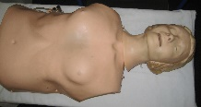 | Adult CPR | 8 | Surgical Room | S4
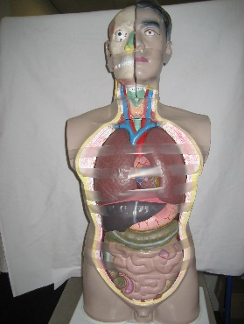 | Anatomical model | 1 | Surgical Room
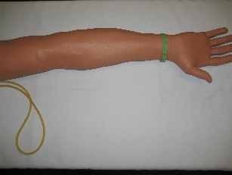 | Arterial stick arm | 8 | Surgical Room | S2
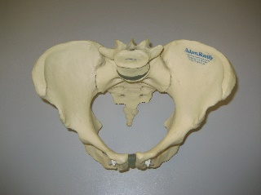 | Bony pelvis | 1 | Surgical Room | S3
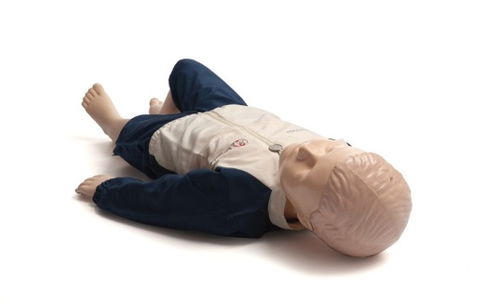 | Resusci Junior | 7 | Surgical Room | S4
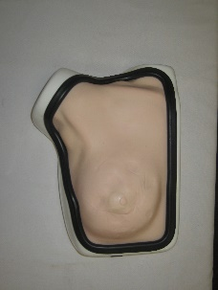 | Breast exam | 4 | Surgical Room | Skins need to be replaced!  S3
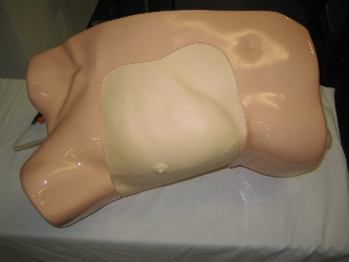 | Chest drain kit trainer | 2 | Surgical Room | S3
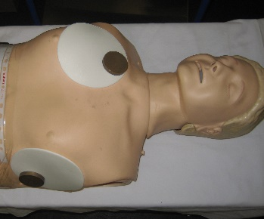 | Dry Defib Heart Sim (Redundant) | 1 | Surgical Room | S4
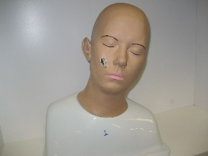 | Ear Diagnostic Trainer | 4 | Surgical Room | ON SHELVE
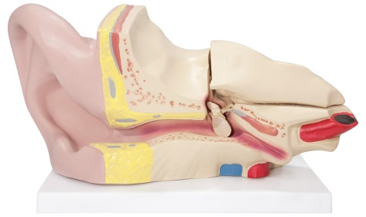 | Ear model | 1 | Surgical Room | ON SHELVE
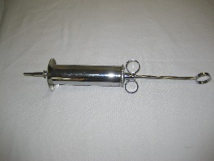 | Ear syringing | 1 | Surgical Room | BOX INFRONT
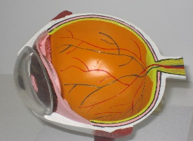 | Eye model | 1 | Surgical Room | ON SHELVE
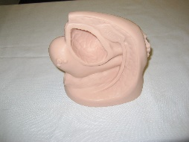 | Female catheterisation model | 1 | Surgical Room
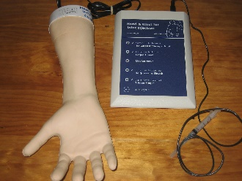 | Hand and wrist for injection | 2 | Surgical Room | S3
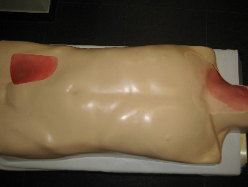 | IV Torso jugular and femoral | 2 | Surgical Room | PADS TO BE REPLACED S3
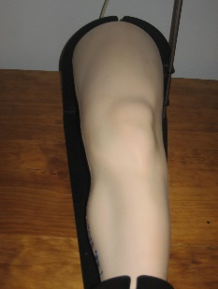 | Knee Aspiration | 2 | Surgical Room | S3
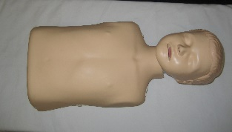 | Little Junior | 3 | Surgical Room | S4
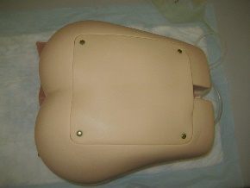 | Lumbar puncture adult | 2 | Surgical Room | S4
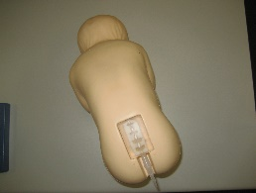 | Lumbar puncture infants | 2 | Surgical Room | S2
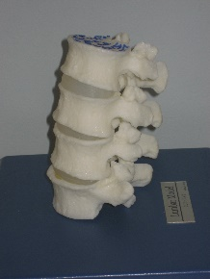 | Lumbar spine model | 2 | Surgical Room | S3
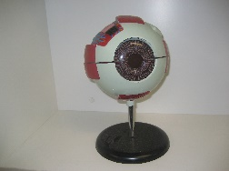 | Magnified eye model | 1 | Surgical Room | ON SHELVE
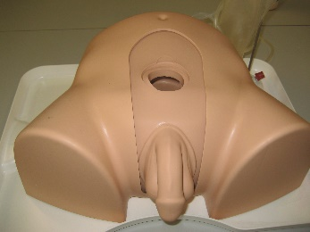 | Suprapubic Male | 1 | Surgical Room | Unit 1
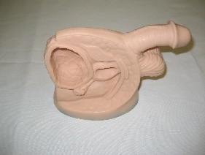 | Male catheterisation model | 1 | Surgical Room | Unit 5
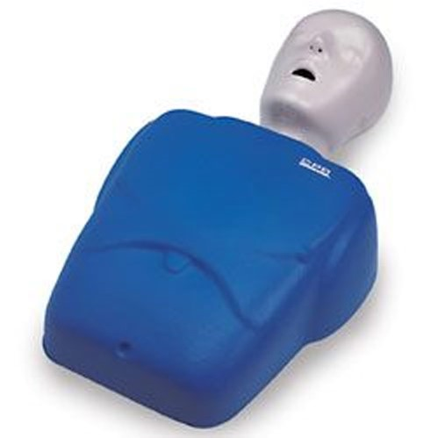 | Manikin Adult CPR Blue | 3 | Surgical  Room | Unit 5
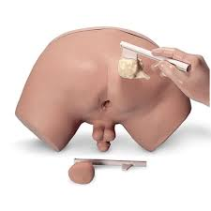 | Prostate Examination  Simulator | 2 | Surgical  Room | Unit 5
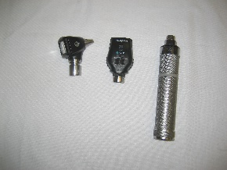 | Otoscope-Sets | 3 | Surgical Room | BOX INFRONT
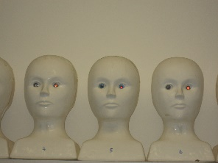 | Ophthalmology models_1 | 10 | Surgical Room | ON SHELVE
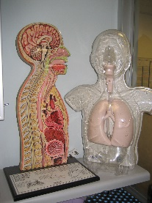 | Nasogastric Models | 2 | Surgical Room | ON SHELVE
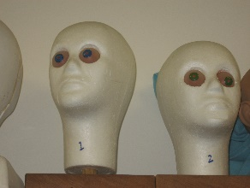 | Ophthalmology models_2 | 2 | Surgical Room | ON SHELVE
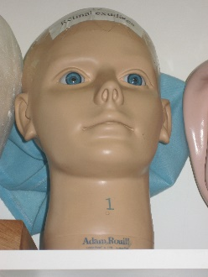 | Ophthalmology models_3 | 1 | Surgical Room | ON SHELVE
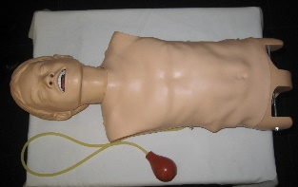 | Paediatric airway | 2 | Surgical Room | S4
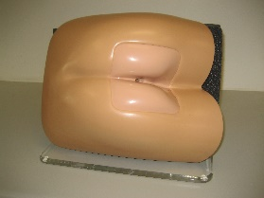 | Rectal exam | 2 | Surgical Room | Broken models S2
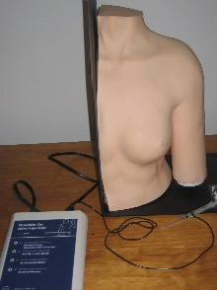 | Shoulder joint for injection | 2 | Surgical Room | S3
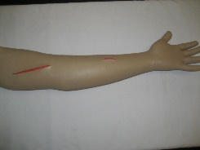 | Suture practice arm | 3 | Surgical Room | S3
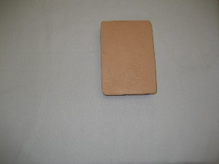 | Suturing pads | 8 | Surgical Room | S3
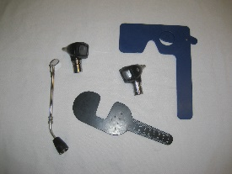 | Various ophthalmology | 1 | Surgical Room | BOX INFRONT
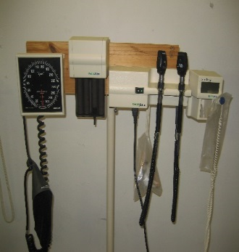 | Welch Allyn sets | 4 | Surgical Room | ON WALL
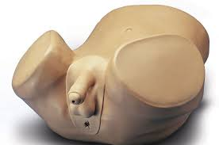 | prostate examination trainer | 1 | Surgical  Room | Unit 7
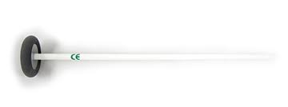 | Patella hammer | 1 | Surgical Room | BOX INFRONT
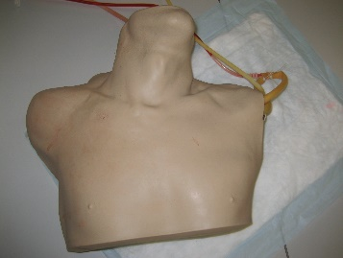 | CVP Simulator | 4 | General Room | 1-unit7  2-unit10  3-unit8  4-unit11
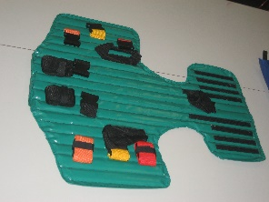 | E51 Equipment 092 |  | General Room | G2
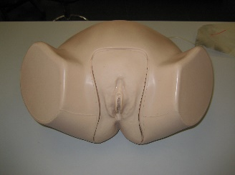 | Female catheterisation | 3 | General Room | Unit 1
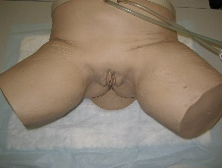 | Female catheterisation (Asian) | 1 | General Room
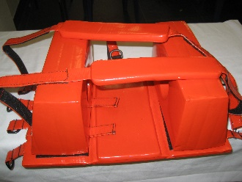 | Head blocks | 4 | General Room
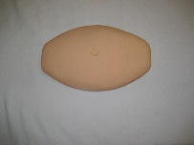 | Injection stomach | 2 | General Room
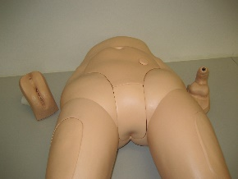 | Interchangeable catheterisation and enema trainer | 2 | General Room | Unit 15
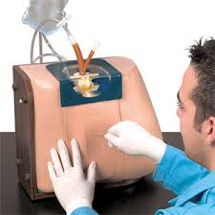 | Spinal Injection  Simulator | 2 | General Room
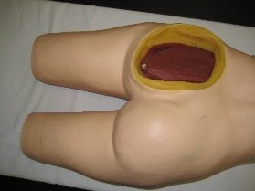 | Intra muscular injection | 3 | General Room
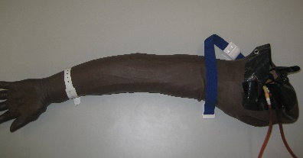 | IV Arm | 9 | General Room | Unit 7=2  Unit 8=2  Unit 10=2  Unit 11=2
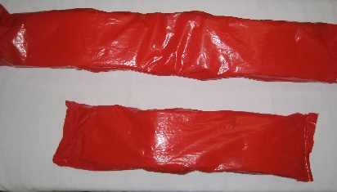 | Kramer splints long and short | 4+4=8 | General Room | G2
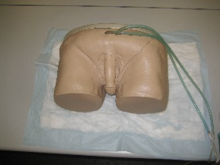 | Male catheterisation | 3-1=2  1 with Ea | General Room
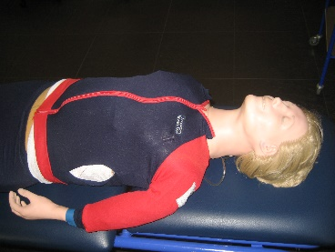 | Recording resusci Anne | 2 | General Room
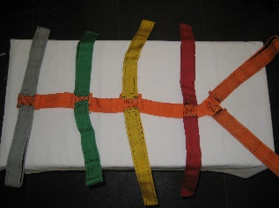 | Spider Harness | 3 | General Room | G1
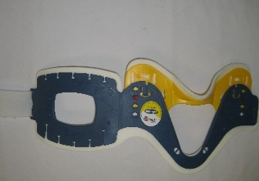 | Stiff neck collar Adult | 7 | General Room
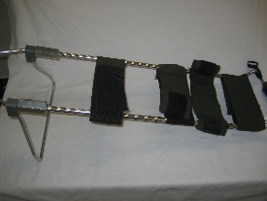 | Traction Splint | 3-1=2 | General Room | G1
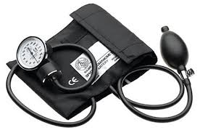 | Sphygmo  Manometer | 7 | General  Room
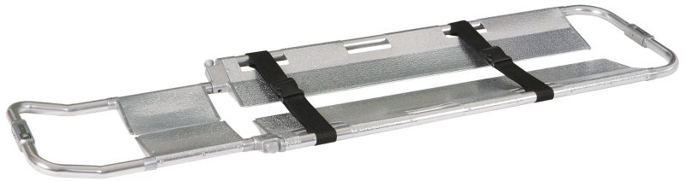 | Scoop | 2 | General Room | G1
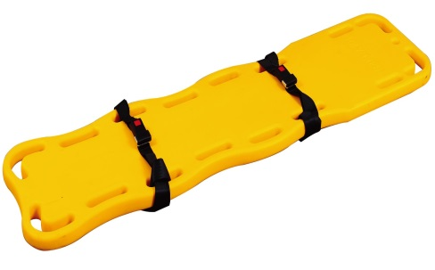 | Spine Board | 2 | General Room | G1
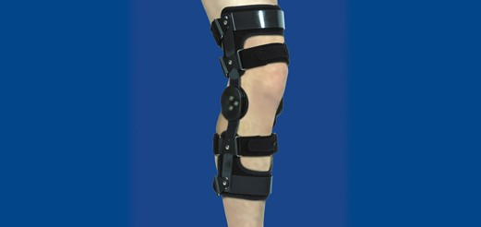 | Knee Splint | 1 | General Room
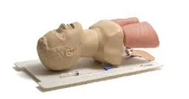 | Adult Airway manager | 9 | Casualty Room
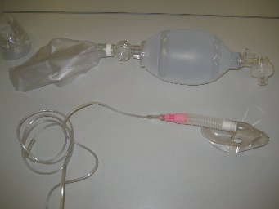 | Breathing |  | Casualty Room
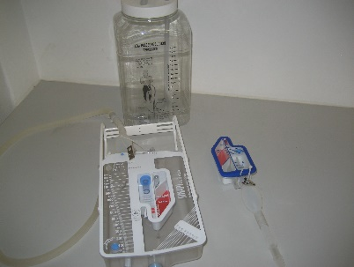 | Chest drain |  | Casualty Room
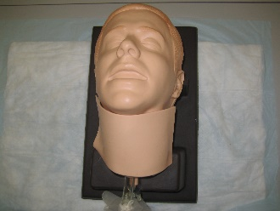 | Cricoid Stick Trainer | 3 | Casualty Room
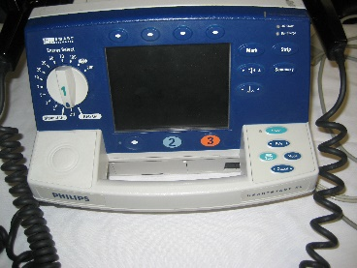 | Defib with pacing ability | 3  1x Pacing  2x Non Pacing | Casualty Room
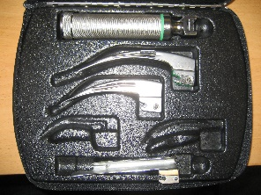 | Laryngoscope sets (adult) | 5 | Casualty Room
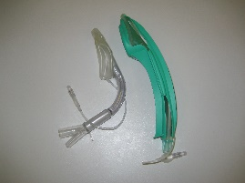 | LMA |  | Casualty Room
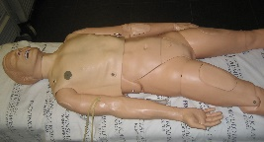 | 2 xMegacode Kelly  2 xSim Kelly | 4 | Casualty Room
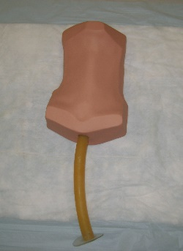 | Needle Cric | 2 | Casualty Room
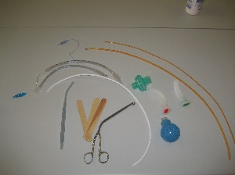 | Various Airway |  | Casualty Room
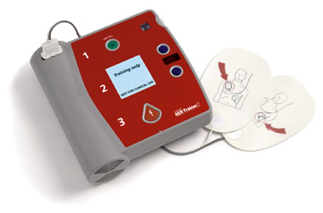 | AED Trainer | 4 | Casualty Room
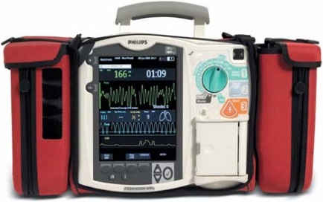 | Phillips Heart Start MRX | 2 | Casualty Room
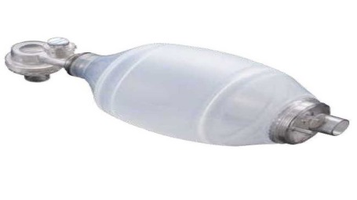 | Adult BVM’s | 10 | Casualty Room
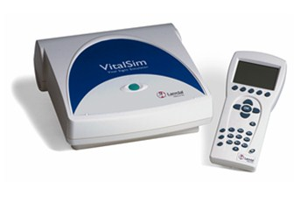 | VitalSim | 3 | Casualty Room
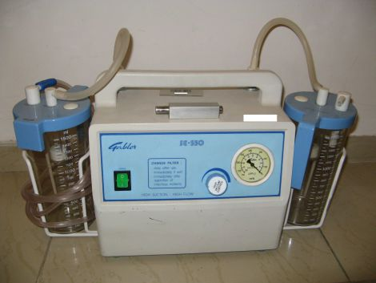 | Gabler Suction unit | 2 | Casualty Room
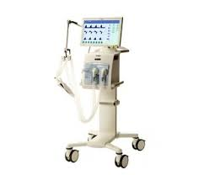 | Evita V300 Ventilator | 1 | Casualty Room | No Humidifier!!
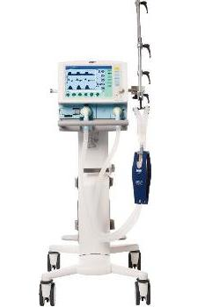 | Savina Ventilator | 1 | Casualty Room
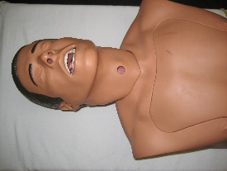 | Nasogastric model | 2 | Theatre Room
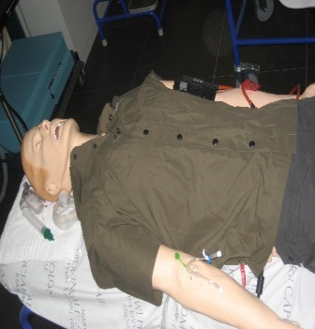 | Sim Man 3G | 1 | Theatre Room
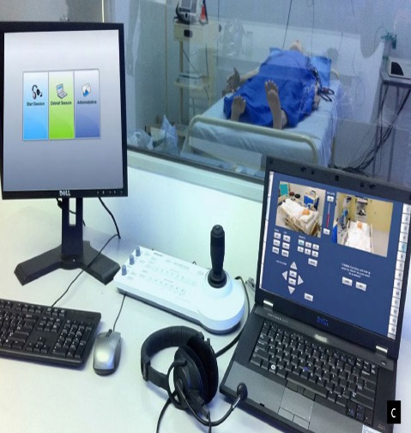 | Simulator  Monitor | 1 | Theatre  Room
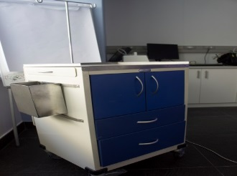 | Emergency Trolley | 4 | Theatre Room | 2 x old  2 x new
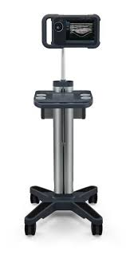 | -Nano Maxx Ultra Sound Main Unit  -Adult Cardiac, Linear and Abdominal Probe  -Universal Stand | 2 | Theatre  Room
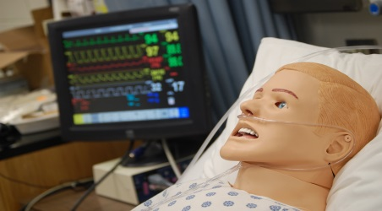 | Sim man | 1 | Theatre Room
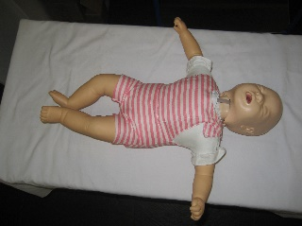 | Baby Anne | 3 | Mom & baby Room | Unit 3
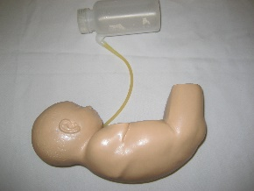 | Baby Stap | 2 | Mom & baby Room | Unit 1
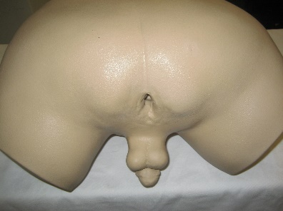 | Prostrate exam | 1 | Mom & Baby | Unit 5
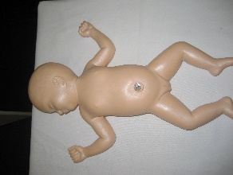 | Baby UMBI | 2 | Mom & baby Room | Unit 2
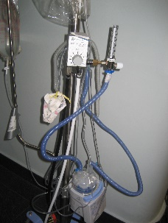 | Basic CPAP Neonatal | 1 | Mom & baby Room
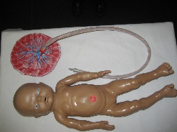 | Birthing simulator | 5 4xWhite  1xBroken brown | Mom & baby Room
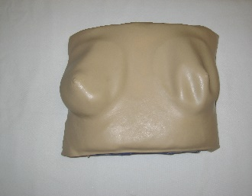 | Breast exam simulator | 1 | Mom & baby Room | Under the counter
 | Phototherapy light | 1 | Mom & baby Room
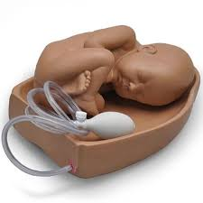 | palpation model for leopold | 1 | Mom and  Baby  Room
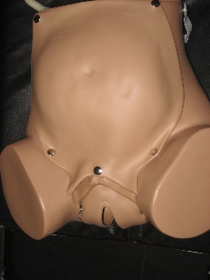 | Childbirth simulator | 7-2 to Somersethospital  =5 | Mom & baby Room | Unit 2
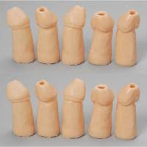 | Circumcision models  Young Adult (white) | 3 boxes | Red  Cross
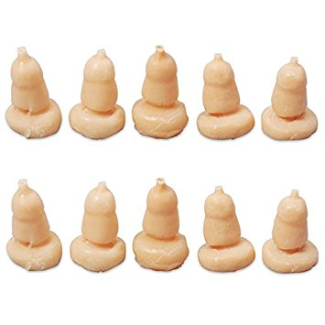 | Replacement Foreskin  Teen (White) | 3 boxes | Red  Cross
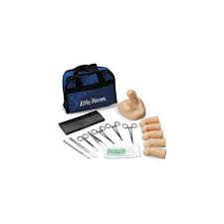 | Young Adult  Circumcision  Kit (White) | 4 | Red Cross
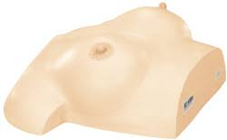 | Breast Massage  Model type II | 2 | Mom &  Baby  Room | Unit 2
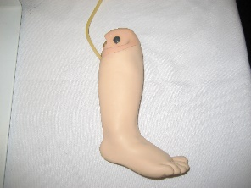 | Infant IO 1 | 10 | Mom & baby Room
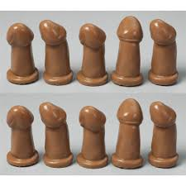 | Circumcision models  Young Adult (Dark) | 2 Boxes | Red  Cross
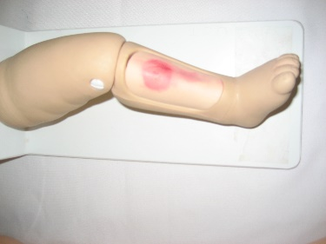 | Infant IO 2 | 1 | Mom & baby Room
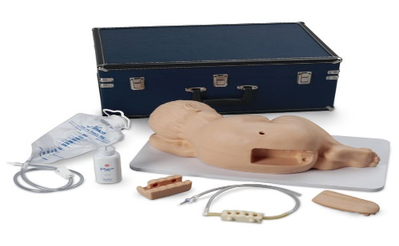 | paediatric lumbar puncture | 1 | Mom and Baby  Room | Unit 2
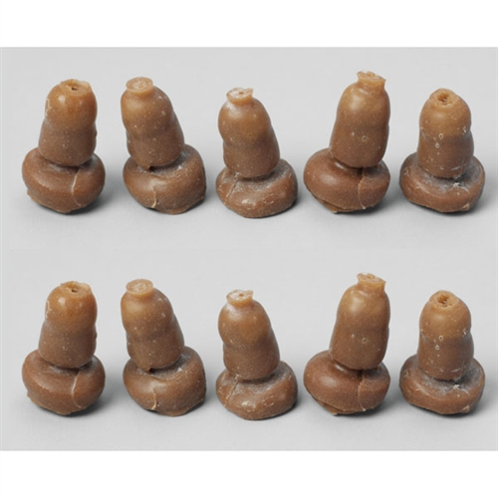 | Foreskin  Teen (Dark) | 2 | Red  Cross
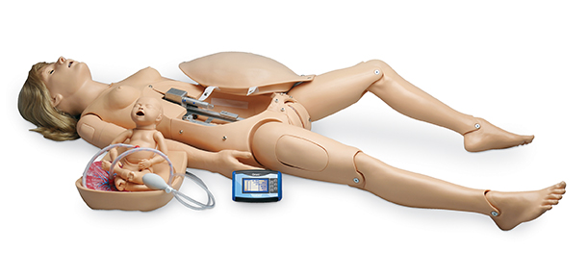 | Maternal Birthing  Simulator | 1 | Mowbray  Maternity  Hospital
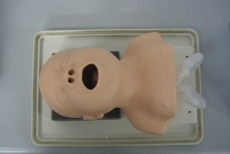 | Neonatal airway Laerdal | 2 | Mom & baby Room | Unit 2
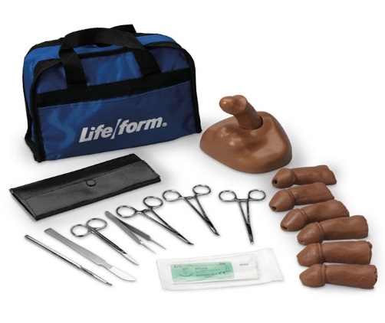 | Young Adult circumcision  Training Kit | 2 | Red  Cross
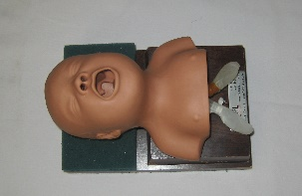 | Neonatal airway | 4 | Mom & baby Room | Unit 2
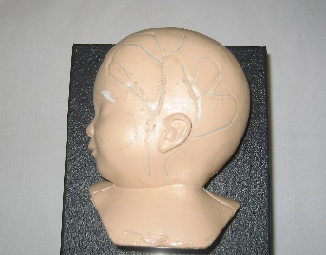 | Neonatal scalp cannulation | 1 | Mom & baby Room | Faulty Melted  Unit 1
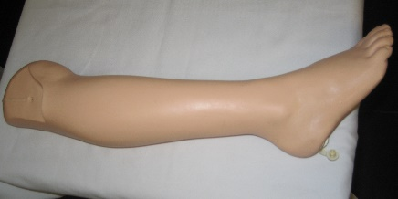 | Paediatric IO leg | 2 | Mom & baby Room
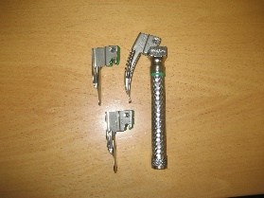 | Neonate paed laryngoscope | 6 | Mom & baby Room | Q Cart 2
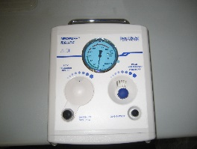 | Neopuff | 1 | Mom & baby Room
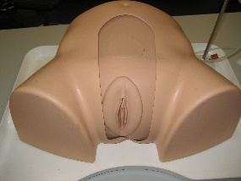 | Suprapubic female | 1 | Mom & Baby Room | Unit 1
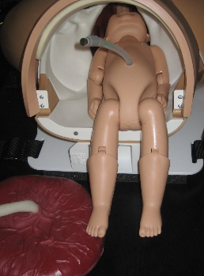 | PROMPT birthing simulator | 1 | Mom & baby Room
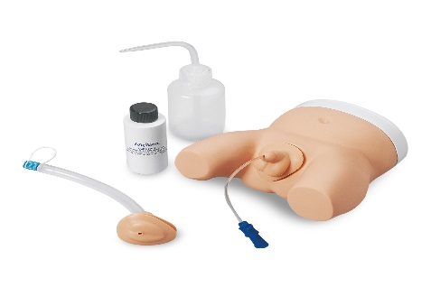 | Infant Male and Female Catheterization Trainer | 2 | Mom and Baby  Room | Unit 4
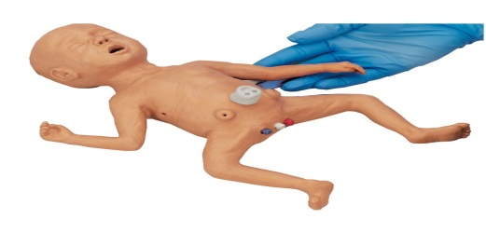 | Micro Preemie | 5 | Mom & baby Room | Unit 4
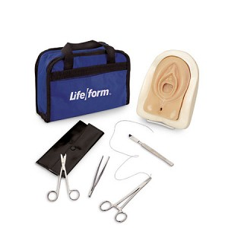 | Episiotomy & Perineal Laceration Trainer Kit | 7 | Mom & baby Room | Unit 4
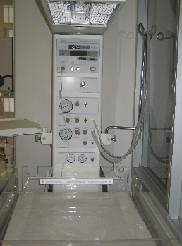 | Resuscitaire Air Shield | 1 | Mom & baby Room
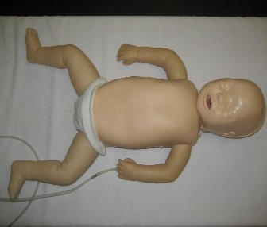 | CPR baby x5  CPR baby with IO leg x2 | 7 | Mom & baby Room | Unit 3
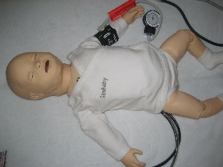 | Sim baby | 1 | Mom & baby Room | Red Cross Hospital
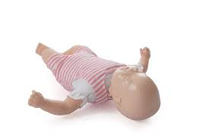 | Baby Anne | 3 | Mom & baby Room | Unit 3
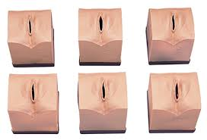 | Cervical Dialation Effacements Sims  LF01069U | 5-1  =4  1-Somerset Hospital | Mom & baby Room | Unit 1
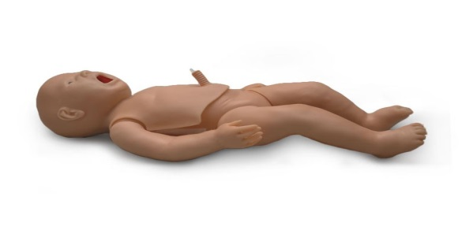 | Noelle Intubation, Resus, UMBI baby | 1 | Mom & baby Room | Unit 1
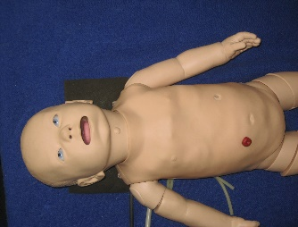 | Sim baby (Older version) | 1 | Mom & baby Room | G3
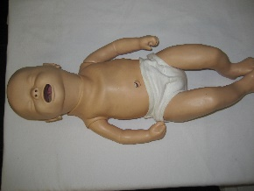 | Intubation Resusci baby | 11 | Mom & baby Room | Unit 3
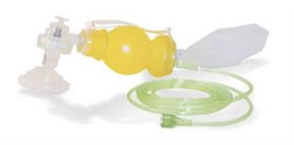 | Neonate BVM’s | 11 | Mom & baby Room | Q Cart 2
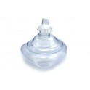 | Bvm Masks size: 00  01  2  3-4 | 19  33  6  28 | Mom & baby Room | Q Cart 2
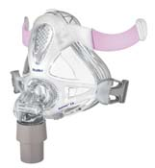 | Paediatric O₂ Masks | 18 | Mom & baby Room | Q Cart 2
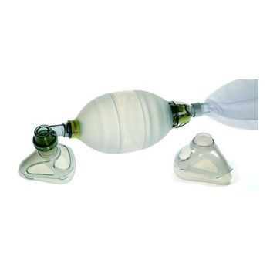 | Paediatric BVM’s | 12 | Mom & baby Room | Q Cart 2
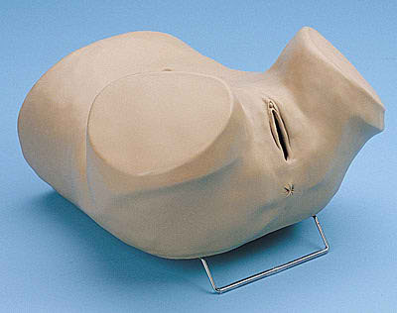 | Gynae Simulator | 5 | Mom & baby Room | Unit 4
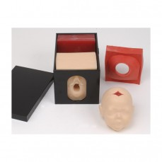 | Fetal Monitoring and Labour Process Set | 8-1  =7 | Mom & baby Room | Unit 3
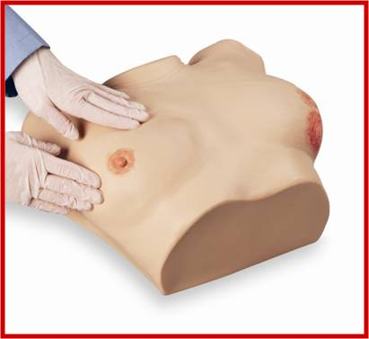 | Advanced Breast exam | 2 | Mom & baby Room | Under the counter
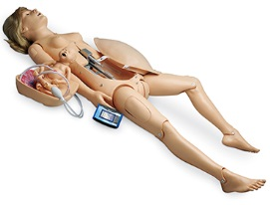 | Noelle Birthing Mom | 2 | Mom & baby Room
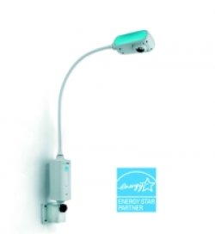 | Welch Allyn Gynae Lamp | 7 | Mom & baby Room
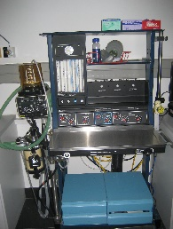 | Anaesthetic machine | 1 | Store Room
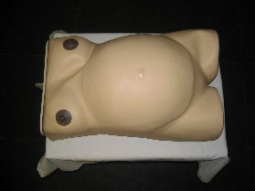 | Maternity model | 1 | Mom & baby Room | Unit 2
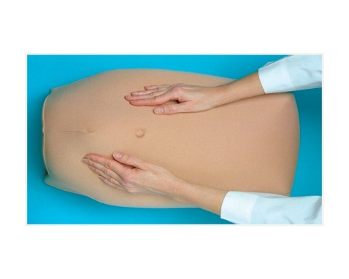 | Abdominal Palpation Model | 1 | Mom & baby Room | Under the counter
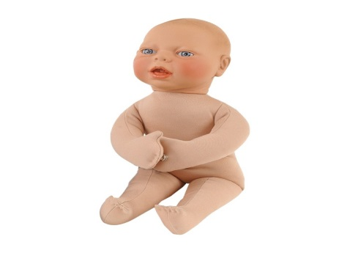 | Fetal Model | 1 | H-Floor Obs & Gynae
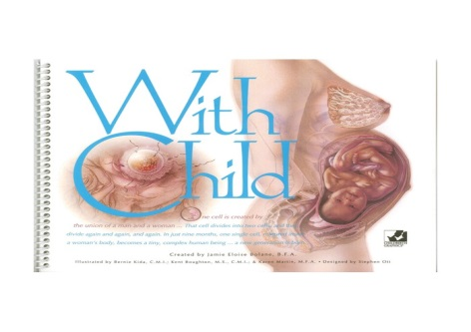 | With Child Large-Size Spiralbound Chart | 1 | Mom & baby Room
 | Birth Ball Comfort Positions Chart | 1 | Mom & baby Room
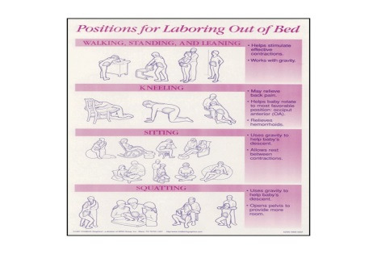 | Positions for Labouring Out of Bed Chart | 1 | Mom & baby Room
 | Breastfeeding Chart Collection, English | 1 | Mom & baby Room
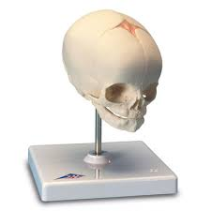 | Fetal Skull, on stand | 1 | Mom & baby Room
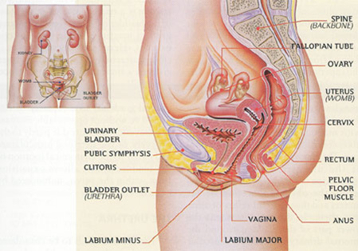 | The Female Pelvic Organs | 1 | Mom & baby Room
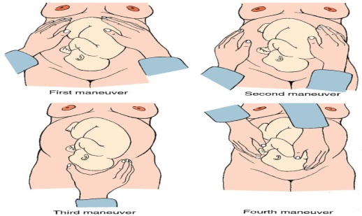 | Positions of Child Before Birth | 1 | Mom & baby Room
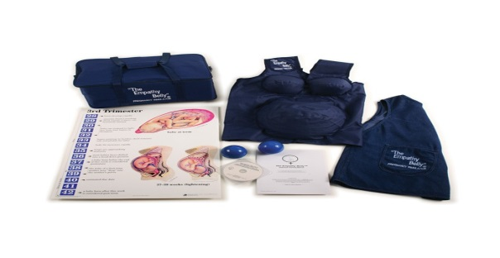 | Empathy Belly Pregnancy Simulator, Large | 1 | Mom & baby Room | Under the counter
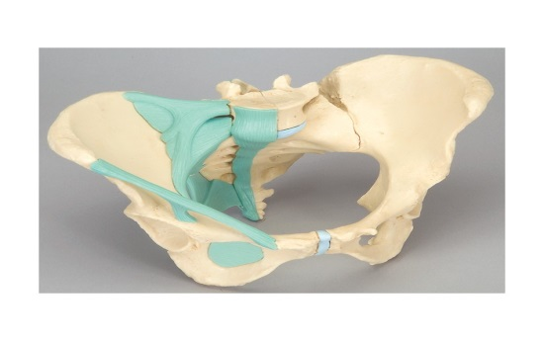 | Female Pelvic with ligaments | 1 | Mom & baby Room
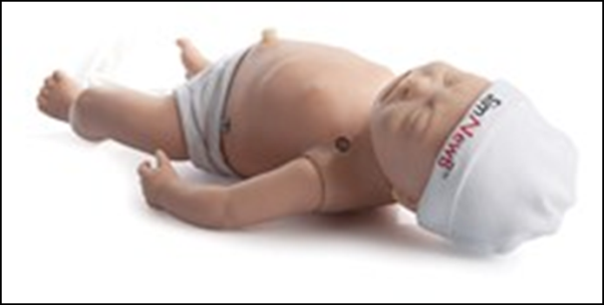 | SimNewB | 1 | Mom & baby Room | Drawer of the Air Shields Resuscitaire
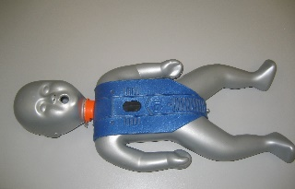 | Obsolete CPR |  | * | *
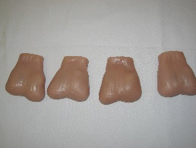 | Testicular self-examination models x4 | 1 | General Simulation Room | Unit 5
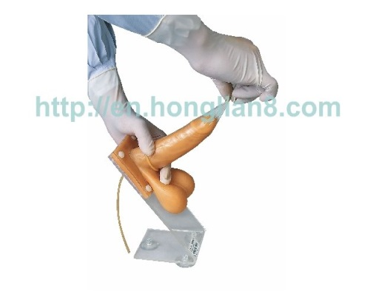 | Male Condom Model | 1 | General Simulation Room | Unit 5
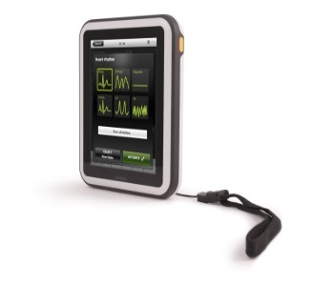 | Simpad  3 x Mega code Kelly  1 x SimNewB | 4 | Technical Assistant Office | E51
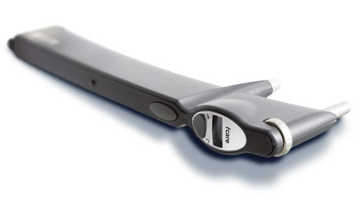 | iCare Tonometer | 1 | Technical Assistant Office | E51
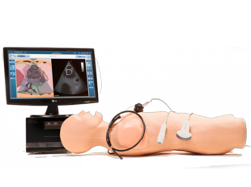 | Heartworks Vimedix Cardiac Echo Simulator | 1 | D23 | Anaesthetics  Department
 | Neonatal Intubation Trainer | 1 | Red Cross Children Hospital | Date Acquired: 27/05/2015
 | Infant Intubation Trainer | 1 | Red Cross Childrens Hospital | Date Acquirred:  27/05/2015
 | Child Birthing Simulator | 1 | Somerset  Hospital  s/n: PBR0312860

