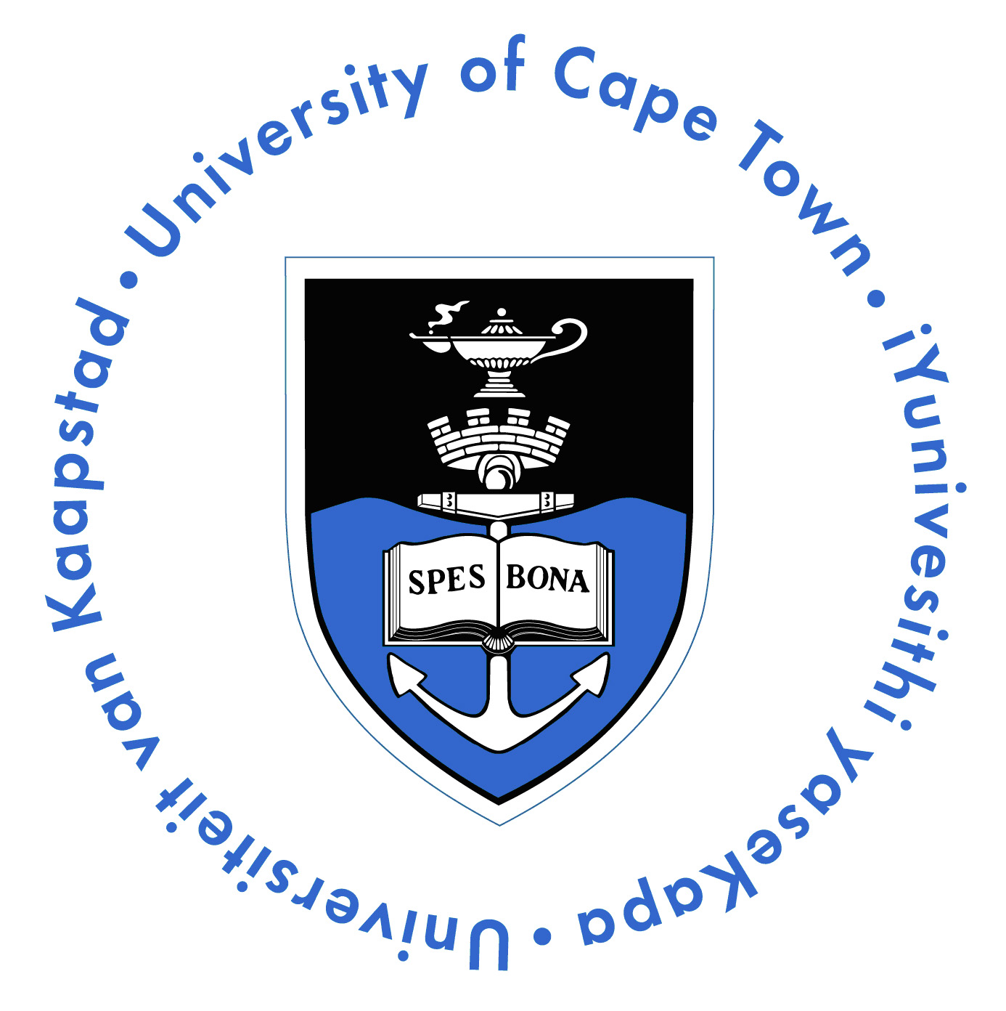
Department of Human Biology

Faculty of Health Sciences
University of Cape Town
Private Bag X3
Observatory 7935
South Africa
Phone: +27-21-406 6235
Fax: +27-21-448 7226

BODY DONATION PROGRAM

General Information, Conditions and Restrictions

Importance of Bequests

The Faculty of Health Sciences at the University of Cape Town acknowledges, with deep respect, the rare gift of whole body donation. These bequests are vital for the teaching of anatomy to medical, physiotherapy, occupational therapy and science students. Bequests may also be used to train professional for example surgeons in new techniques. It is for these reasons that the anatomy departments of Medical schools are legally empowered to receive bodies.

The Department is most grateful to persons who so generously bequeath their bodies for anatomical study. The contribution to the training of tomorrow’s doctors and other health care professionals is enormous.

Consent of relatives
It is important that all donors make sure that their families are aware of their plans and agree to the bequest. Once the bequest has been received by the Department we are not under any legal obligation to return it.

Residence
The Department can only accept bequests from the greater Cape Town area. Should a donor move to live outside this area or pass away whilst on vacation outside this area, their bequest will not be accepted. Donors who permanently change their residential address to outside of this area should inform the Department of Human Biology.

Costs paid by the Department of Human Biology
The Department pays the expenses for transporting the body from the place of death to the University and also the cremation costs.

Acceptance criteria
The Department endeavours to accept all bequests; however there are five limiting criteria at the time of death:

- The donor having a body size that exceeds our storage capabilities (e.g. not exceeding a weight of 90-100kgs).
- Having undergone extensive surgery close to the time of death.
- Having undergone a post mortem examination.
- If any organs (other than cornea) have been donated at time of death for transplant purposes.
- If the cause of death has been the result of major trauma.

If a bequest is not accepted the Department will not be liable for charges by the undertaker.

Dedication service
The Department holds an annual service for staff and students to honour the donors that have contributed to their education. This service is multidenominational and includes tributes from the students.

Instructions for next-of-kin
Avbob undertakers may be contacted at 021 593-8553 (This is a 24 hour line). If we accept a body, we have an arrangement for the above company to collect and deliver the body at our expense (in the Cape Town area only). If there are any problems or questions please contact the Department on 021 4066235.

PLEASE NOTE: In the absence of a doctor please consult the undertaker regarding the additional documentation.

Cremation
The anatomical examination of a donor’s body extends through at least a teaching year, so that a period of 18 months or longer normally elapses between the death of a donor and the final disposal of his or her remains. Sometimes the Department will retain some body parts for long term study and research. Following the completion of study, the remains are cremated, without a service and the ashes scattered at the Garden of Remembrance.

Return of Ashes
When requested, the Department is prepared to consider the return of ashes to the relatives of the deceased. However this does limit our ability to provide ongoing education for our trainee doctors as well as limiting some areas of research. The Department asks that donors and relatives please take this into consideration before requesting the return of ashes.

Having considered the above, should relatives wish to proceed with a request for return of ashes, they should do so, in writing before the body is removed by the undertakers.
Please note that ashes will only be kept for a maximum period of one year from the date of cremation.

