


Vula administration guide

  - Vula tests & quizzes
Table of Contents
Creating assessments using the Assessment Builder tool 3
Parts (sections) 3
Adding a part 4
Question pools 4
Adding a question pool 4
Question types 5
Multiple choice questions 5
Extended Matching Items (EMI) 8
Fill in the blank 11
Matching questions 13
Creating assessments using markup text (quick create) 14
MCQs from markup text 14
Draft assessment list 17
Publishing assessments 18

Creating assessments using the Assessment Builder tool

The Assessment Builder tool contains many sub-tools and options to enable you to create questions within Vula.

To get started with creating an assessment using the Assessment Builder tool:
- Click Tests & Quizzes in the menu bar.
- Click Add tab
- Enter the title of assessment in the text box provided.
- Select the Create using assessment builder radio button.
- Click Create.

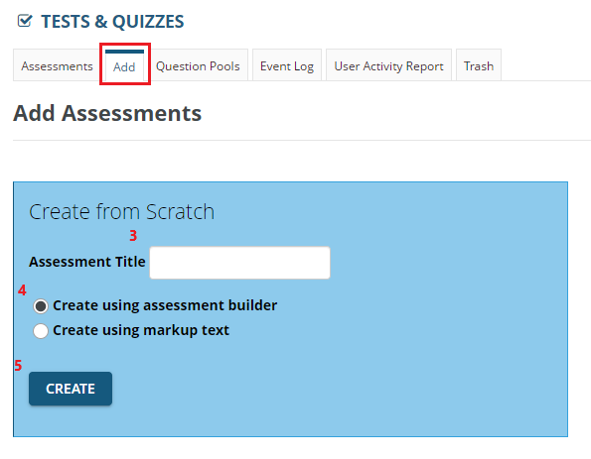
The system generates a new assessment with the title you gave it and opens the assessment in the Assessment Builder tool.
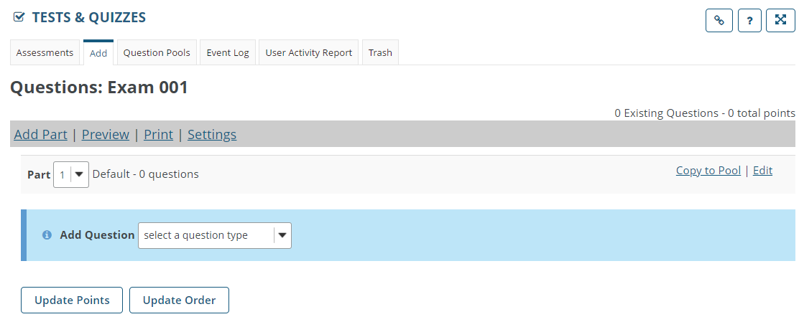
There are several components to creating assessment questions, which are covered in the sections below.

Parts (sections)
Parts are synonymous with sections within an assessment, and one assessment can contain many parts. Every time you create a new assessment, the system automatically generates a new Part called “Default”.
Parts are used to group questions about similar topics or material together. Assessments scores can also be displayed on a per-part basis.

Adding a part
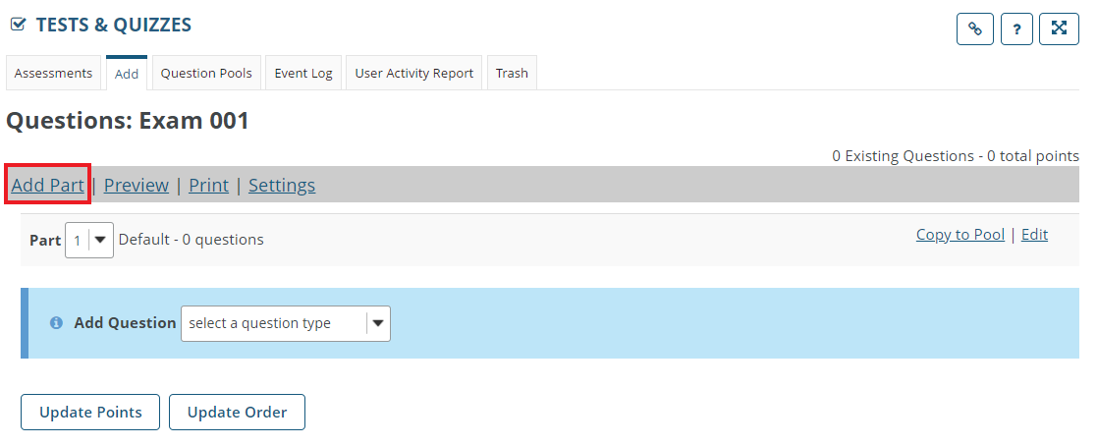

To add a new part:
- Click Add Part.
- Enter a title and add information.
- If you need to, add any attachments.
- Click Save.

Question pools
A question pool is a reusable set of questions that can appear in any give assessment. Question pools can be subdivided into subpools to organize questions by subject matter, section number, question type, or any other criteria desired. For example, an instructor can create a question pool called "Biology 105", and then create subpools called "Basic concepts", "Cell biology", and "Genetics". By default, the question pools you create will be accessible only to you in any course or project site for which you have permission to create assessments.

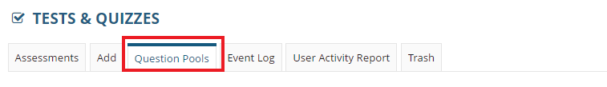

Adding a question pool
To Create a question pool:
- Click Question Pools.
- Click Add New Pool.
- Enter a name for the pool and describe it.
- Click Save.
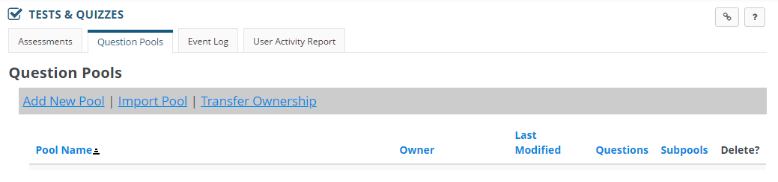

Question types

Multiple choice questions
Multiple choice questions (MCQs) offer students a selection of answers, where there is at least one correct option.
To create a new MCQ:
- Click the Add Question dropdown box and select Multiple Choice. The Add Question window appears, enabling you to add the new question.
- Enter a mark allocation in the Answer Point Value text box.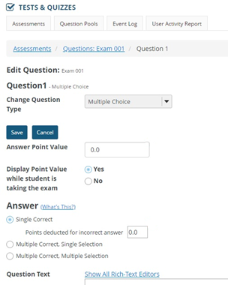
- The Answer section enables you to more finely specify the number of correct answers exist within the question. These answer types are:
  - Single Correct: For single correct questions, the student selects only one answer from a range. Negative marking can be applied to a single-correct question type. To do so, type in the amount of points to be deducted in the Points deducted for incorrect answer text box.
  - Multiple Correct, Single Selection: For this option, there is more than one correct option from the selection presented, and the student must choose one of them. It is advisable to indicate in the question that one answer should be selected.
  - Multiple Correct, Multiple Selection: This option enables you to specify that there are many correct options, and student is required to select more than one option. It is advisable to indicate in the question how many options the student must select.
- To be able to copy and paste your questions from another application such as Microsoft Word or Notepad, click Show All Rich-Text Editors.
  - If you are copying your questions from Notepad:
    - In Notepad, copy the text by selecting it and clicking Edit > Copy (or select the text and press Ctrl+C).
    - In Vula, click the Paste as plain text icon.
  - If you are copying from Microsoft Word:
    - In Word, copy the text by selecting it and clicking Edit > Copy (or select the text and press Ctrl+C).
    - In Vula, click the Paste icon (or press Ctrl+V)
- To add an image to the question, Click the Add Attachment icon. The Add attachment window displays.
  - Click Browse. The Windows file manager window displays.
  - Browse to the location of the image file (preferably in .jpg format).
  - Select the image.
  - Click the Open button.
  - Click Continue. The image appears in the question as an attachment.

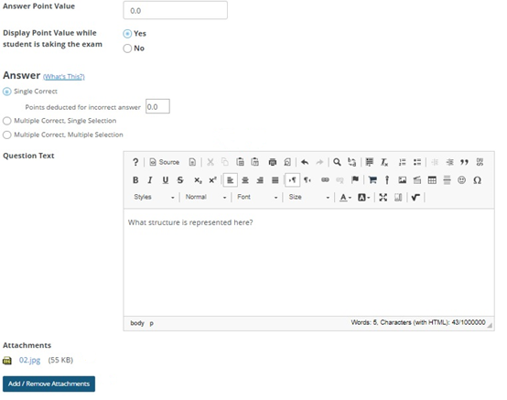
- You place all the answers to the question in the Answer text boxes, located below the question text box.
- To indicate a correct answer, click the Correct Answer radio button to the left of the relevant answer box.
- Optionally, enter feedback to let students know why a given option is correct or incorrect.
- To add more answer boxes, click the Insert Additional Answers dropdown box and select the number of additional answers required.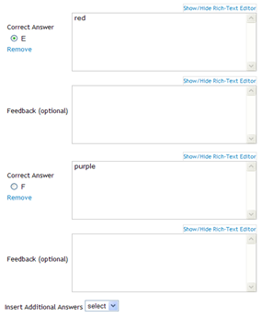
- There are several other options that enable you to refine the behaviour of each individual question:
  - Randomize Answers: The system enables you to randomise the order of the answers every time the question displays on screen. To enable this, select the Yes radio button beside Randomize Answers, or No to disable this behaviour.
- Require Rationale: If Yes is selected, the student is required to type in a rationale after selecting the correct option. Select No to disable this behaviour.
- Assign to Part: You can have the system re-assign the question to specific Part by selecting the relevant part from the Assign to Part dropdown list. If no parts have been created, this will not work.
- Assign to Question Pool: You can have the system automatically assign the question to a specific question pool by selecting the relevant pool from the Assign to Question Pool dropdown list. If you have created any parts, click the Select a pool name (optional), dropdown list and click select a pool.
- Correct/Incorrect Answer Feedback: You may optionally add further clarifying text to the answer in this text box.
- Click the Save button at the bottom of the page to save the question. 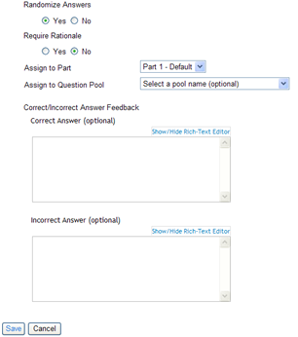

Extended Matching Items (EMI)

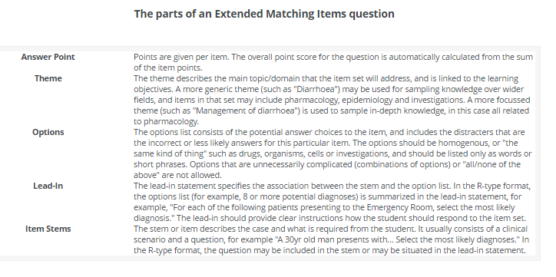

      - Select Extended Matching Items from the Add Question dropdown list.

There are three formats in which to display the Options list.
    - Simple text – for a list of items with no formatting
    - Simple text – for pasting options
    - Rich text / Attachments – for styled text, tables, labelled images
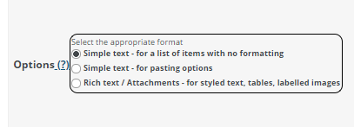
Simple text – for a list of items with no formatting
- Theme: type in the theme of the question
- Enter options individually: type in the options to the questions. At Add more options, select the number at the dropdown list, click Add more options.
- Lead-in: Add text for the Lead-in statement or use the default text
- Item Stems: Add text at the item stem.
- Correct Option Labels: Add text e.g. A or ABC
- Number of required answers: If more than 1 option is correct, indicate at the dropdown list, how many answers the student should enter.
- Item Points: shows the mark allocation for the item, automatically generated according to the number of required answers.
- Add Attachments: images in .jpeg or .png format can be added to each item.
- Add more items: If more items required, select the number at the dropdown list, click Add more options.
- Click Save to save the question.
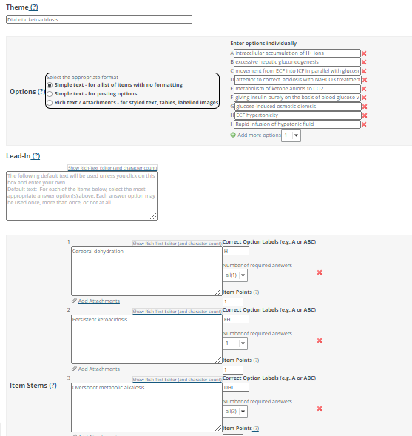

Simple text – for pasting options
- Theme: type in the theme of the question
- Paste a list (one option per line, no bullets): An alphabetic list will be generated.

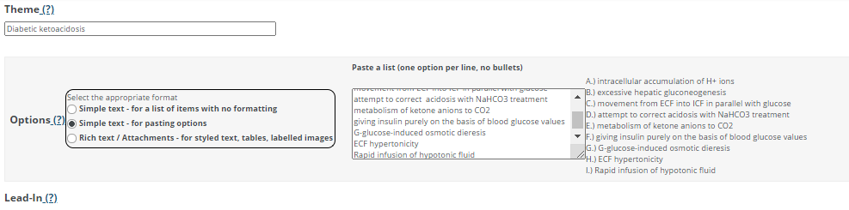

- Lead-in: Add text for the Lead-in statement or use the default text
- Item Stems: Add text at the item stem.
- Correct Option Labels: Add text e.g. A or ABC
- Number of required answers: If more than 1 option is correct, indicate at the dropdown list, how many answers the student should enter.
- Item Points: shows the mark allocation for the item, automatically generated according to the number of required answers.
- Add Attachments: images in .jpeg or .png format can be added to each item.
- Add more items: If more items required, select the number at the dropdown list, click Add more options.
- Click Save to save the question.

Rich text / Attachments – for styled text, tables, labelled images
- Theme: Enter the theme of the question
- Enter option text and/or Add Attachments below: List the options in an alphabetic list./ If adding an attachment in the form of an image, ensure that the image is labelled with alphabet, e.g. A,B,C. The labels are the answers to the items.
- Number of options in this question (e.g. A to G =7): click select, select number of options. Important to note, select the total number of options on the list or the total number of labels appearing on the image. If number of options incorrectly indicated, students will be restricted in their option choices for the question.
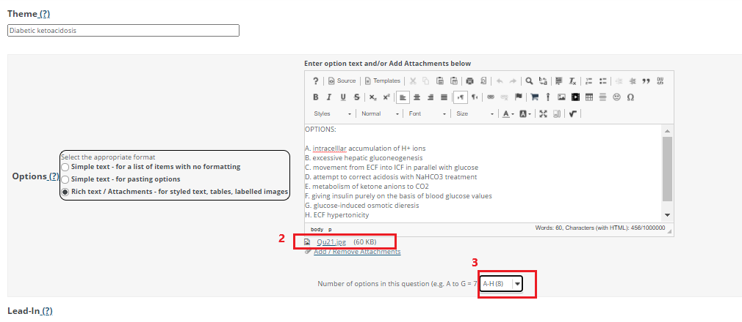

- Lead-in: Add text for the Lead-in statement or use the default text
- Item Stems: Add text at the item stem.
- Correct Option Labels: Add text e.g. A or ABC
- Number of required answers: If more than 1 option is correct, indicate at the dropdown list, how many answers the student should enter.
- Item Points: shows the mark allocation for the item, automatically generated according to the number of required answers.
- Add Attachments: images in .jpeg or .png format can be added to each item.
- Add more items: If more items required, select the number at the dropdown list, click Add more options.
- Click Save to save the question.

Fill in the blank
This question type presents users with a question and a text box in which they enter the answer; each user's answer is compared to a list of allowed answers. These questions take more care to craft because you need to consider all the alternate ways a student might answer a question, and an improperly phrased question could lead students to fill in something that, while technically correct, is evaluated as incorrect because it does not conform to the list of accepted answers.

To add new Fill in the blank question:
- On the Questions page, select Fill in the blank from the Add Question dropdown box.
- The Fill in the blank page has several options for customising the behaviour of the question:
  - Answer Point Value: Enter the mark allocation in the text box.
  - Show Rich-Text Editor: Click to display a more featureful text editor to enter the question text. The question must contain the following formatting for the system to properly evaluate where to insert blanks.
    - Place curly braces ({}) around words requiring a blank. For example: Roses are {red} and violets are {blue}.
    - Insert a pipe (|) between answer options that are synonyms. For example: {They are|They're} very happy.
    - Insert an asterisks (*) for one or more wildcard characters. For example: It's raining {c*} and {d*s}.
  - Case sensitive: Check this box if it is essential that the answer be case sensitive, for example, if the answer is an acronym or a proper noun.
  - Mutually exclusive: If this option is checked, questions that include multiple blank spaces with identical answer options must have unique answers. For example: The sides of a coin are {heads|tails} and {heads|tails}. Correct answer: heads, tails. Half correct answer: heads, heads.
  - Add Attachments: As with MCQs, the Add Attachments link enables you to add images to the question.
- When you have finished creating the question, click Save to return to the main page.

Example fill in the blank question
_______________________________________________________________________________
OPTIONS:

- intracellular accumulation of H+ ions
- excessive hepatic gluconeogenesis
- movement from ECF into ICF in parallel with glucose
- attempt to correct acidosis with NaHCO3 treatment
- metabolism of ketone anions to CO2
- giving insulin purely on the basis of blood glucose values
- G-glucose-induced osmotic dieresis
- ECF hypertonicity
- Rapid infusion of hypotonic fluid

Below is a list of clinical and/or biochemical findings encountered in diabetic ketoacidosis. Match each finding with its most obvious cause from the list of options above. Each option may be used once, several times or not at all. Type only the option number.

{8} | - Cerebral dehydration
{6} or {8} | - Persistent ketoacidosis
{4} and {8} and {9} | - Overshoot metabolic alkalosis
{7} | - Whole body dehydration
{3} | - Falling serum phosphate (Pi)
_______________________________________________________________________________

Tables in question text
To create the table as illustrated in the example above:
- Click Insert/Edit Table in the Rich Text Editor. Ensure that the cursor is positioned where the table must appear. In most cases, you want the table to display below the question text. The Table Properties dialog box appears.

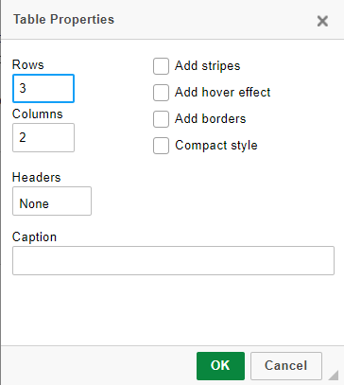

a. Rows: Specify the number of rows required.
b. Columns: Specify the number of columns required.
c. Headers: By clicking on "None" a list of options appears, viz. First Row, First Column, Both. The selected header format will be highlighted in the table.
d. Caption: Type in the caption to the table if required. The caption will appear right aligned above the table.
- Click OK to close the dialog box and confirm the table’s dimensions. The table appears in the Rich Text Editor text box.

Matching questions
Matching questions task students to match questions in one column with answers in another. To create a matching question:
- Select Matching from the Add Question dropdown list.
- Enter the mark allocation for the question in the Answer Point Value text box.
- As with other question types, type the question text into the Rich Text Editor text box.
- Type in the pairing items in the Choice and Match text boxes.
- Optionally, insert Correct Match Feedback and Incorrect Match Feedback to provide useful feedback to students on why their answers were right or wrong.
- Click Save Pairing.
- Repeat the above steps until all matching items are complete. 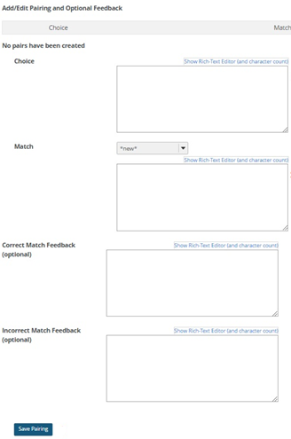
- Click Save to save the question.

Creating assessments using markup text (quick create)
Creating an assessment using markup text is another quick way of creating an assessment in the Tests & Quizzes tool. This method enables you to create your questions offline in the format described below, and then copy and paste them into a new assessment. Markup text is only compatible with the following types of questions:
- Multiple Choice
- Multiple Correct Answer
- Fill in the Blank
- Short Answer/Essay
- True/False

To start creating an assessment by using markup text:
- Click Tests & Quizzes in the menu bar.
- Click Add tab
- Enter the title of assessment in the text box provided.
- Select the Create using markup text radio button.
- Click Create.

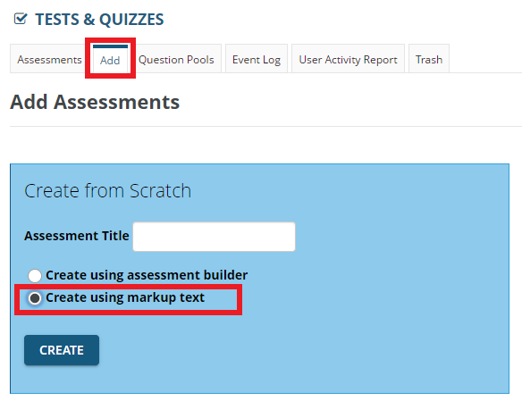
Each question type you insert has its own set of steps to follow for it to work properly.

MCQs from markup text
To create an MCQ in markup text:
In Windows, open Notepad by doing one of the following:
- Click Start > Windows Accessories > Notepad
- Click Start and type Notepad to search for the application.
- Press +R, type Notepad, and then click OK.

IMPORTANT: The correct format of the questions typed in Notepad is crucial! Please follow the format of the questions as indicated below.
- The correct format for a question is as follows:
  - question number. (mark+allocation points) question. Note the spaces after the full stop, between the mark allocation number and the word “points”, and after the close parentheses mark. For example: 1. (10 points) Who was the first president of the United States?
  - Line break.
  - a. answer option. Note the lowercase letter and the space after the full stop. For example: a. Jefferson
  - All subsequent answer options are on separate lines below using the format outlined in c. above.
  - Indicate the correct answer with an asterisk (*) before the lowercase letter. For example: *b. Washington
  - Leave a line break before starting a new question. See the figure below for an example.
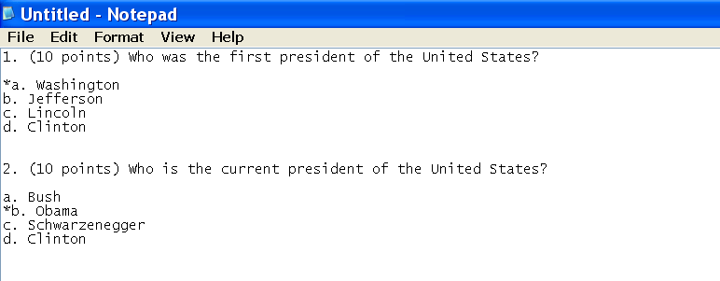

- When all questions and options are entered, copy all the text to the clipboard by clicking Edit > Select All > Edit > Copy or by entering the following keypresses in order: Ctrl+A, Ctrl+C.
- Switch back to the browser window with Vula.
- Place your cursor in the text box.
- Either right-click the mouse and select Paste or press Ctrl+V.
- Click Next.
- Verify that all questions are correct. If there are errors, Click Back. Correct the text in Notepad and follow from step 5 above.
- Click Create Assessment.

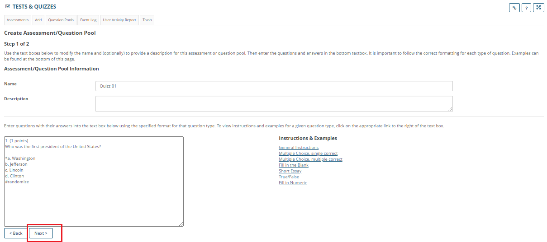

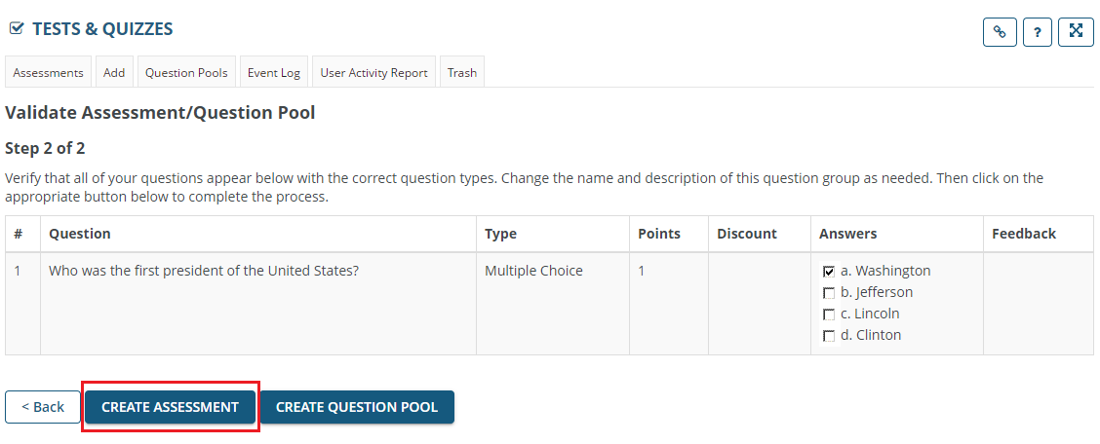

A new window displays, showing the Assessment List. The newly created assessment will be listed as draft following by the assessment title, e.g., Draft – Quizz 01

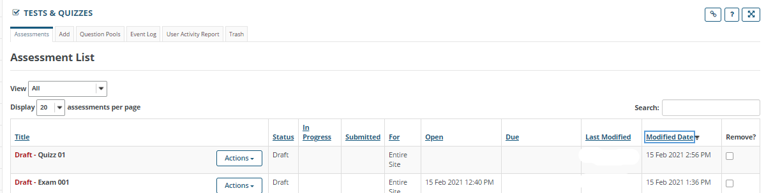

Draft assessment list

To Edit the assessment in the Draft assessment list: (This will allow you to edit questions before publishing the assessment)

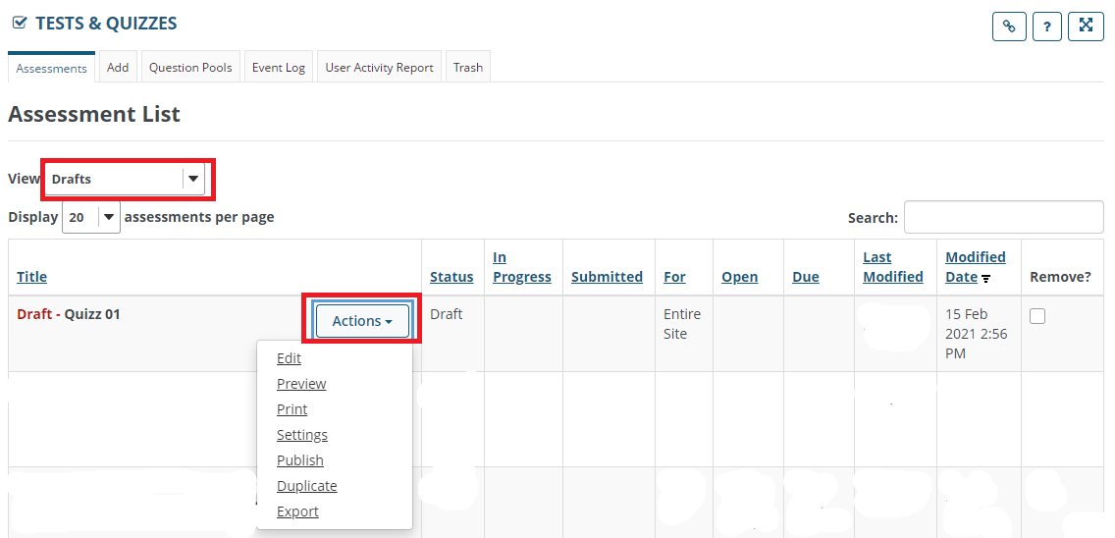

At Action drop down box,
      - Select Edit – will display all questions
      - Each question can be edited (refer to Section A.)
      - Click Save

To Preview the assessment in the Draft assessment list: (This will show a preview of the student view of the assessment)

At Action drop down box,
      - Select Preview
      - Click Begin Assessment (for student view of assessment)
      - Click Done, to exit the student view and return to draft assessment list

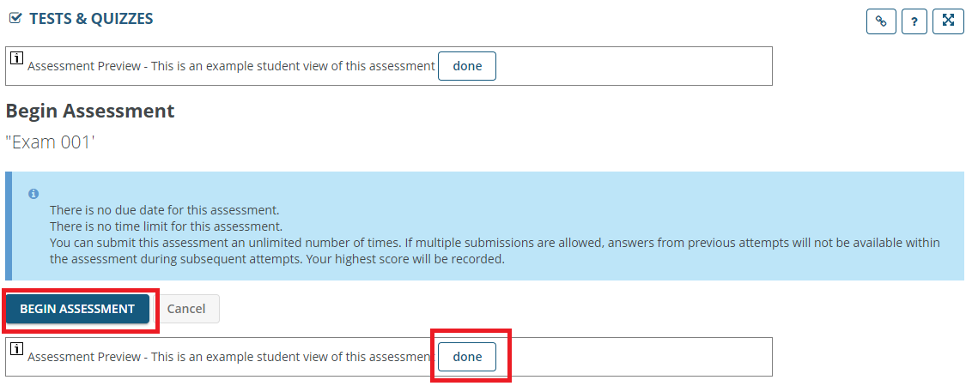

Publishing assessments

Students will not have access to an assessment until it has been published. By publishing an assessment, it is made accessible to students at a specified date and time.

In the Assessment List, search for the assessment in Drafts.

At Action drop down box,
      - Select Settings

A new window appears
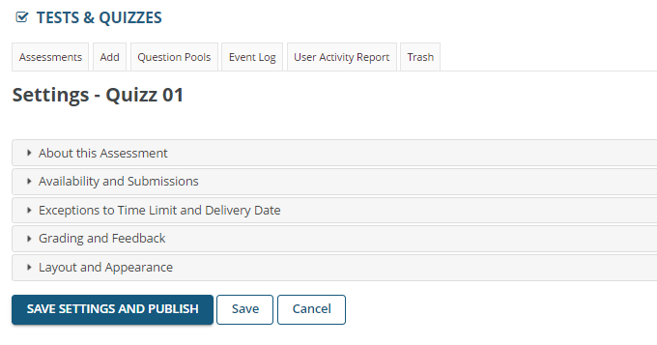

Expand About this Assessment

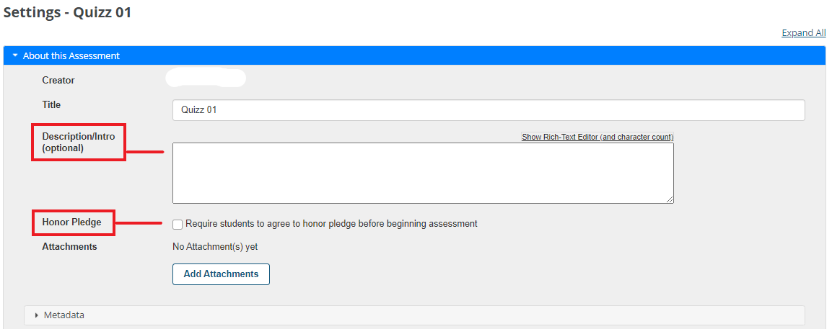

- Description/Intro (optional)
- Examples of description/instruction/detail of the assessment for students to read before beginning the assessment:
Switch off all cell phones
The test consists of 32 questions with single correct MCQs, multiple correct MCQs and matching questions
You cannot return to previous questions, make sure that you only click "Next" once you are ready to do so.
All items should be attempted.
There is no negative marking.

- Honor Pledge
- If you would like to add an honor pledge to an assessment, check the Add honor pledge box.

- When the honor pledge option is selected, students must agree to the statement that reads "Honor Pledge: I will neither give nor receive aid on this assessment." in order to begin their assessment.

Expand Availability and Submissions

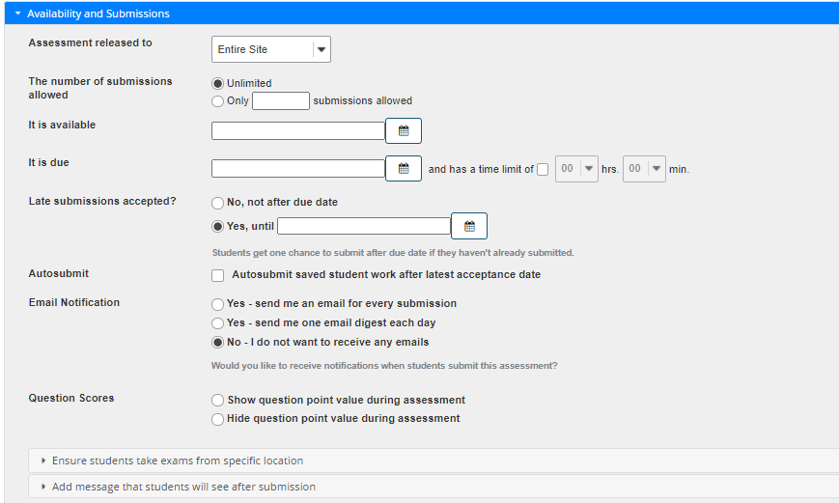

- Assessment released to
- Entire Site – the assessment will be accessible to all student participants on the site
- Selected groups - list of pre-populated groups (groups created in Group Manager) within the site. This option is used when only certain group/s of students from the entire class should gain access to the assessment
- Anonymous users - the assessment will be accessible to all student participants on the site. Lecturers/Markers will not have access to the student ID of submitted assessments. The student submission will display only as a submission code. Students will be given access to scores, sent directly to Gradebook on submission of the assessment.

- The number of submissions allowed
- Unlimited – the student will have access to the assessment to resubmit an unlimited number of times.
- Only _ submissions allowed – e.g., 1 (student allowed 1 submission only)

- It is available / It is due
- Click the calendar icon to specify the available date and time. The available date and time are when the assessment will be accessible to the student
- and has a time limit of – check the box to enter specific duration of the assessment,
e.g. 01 hrs 30 min
- Late submissions accepted? / No, not after due date / Yes, until
- No, not after due date – select this option if late submissions will not be accepted after the specified due date
- Yes, until – select this option, click calendar icon to enter date and time. Students get one chance to submit after due date if they haven't already submitted.

- Autosubmit
- Autosubmit saved student work after latest acceptance date – check the box to allow autosubmission of assessments
- Email Notification
- Select one of these options regarding receiving notifications when students submit the assessment?
  - Yes - send me an email for every submission
  - Yes - send me one email digest each day
  - No - I do not want to receive any emails
- Question Scores
- Select one of these options regarding the student view of the point value per question:
  - Show question point value during assessment
  - Hide question point value during assessment

- Ensure students take exams from specific location (expand)
- Allow only specified IP Addresses – as an added security measure the IP addresses of the computers in a location can be entered here. This will ensure that the assessment is only accessible on computers with the included IP addresses.
- Secondary Password - Assessment Password : enter a unique password. This password will give students access to the assessment.
  - If password is not entered, students will have access to the assessment as soon as the available date is reached.
- Require Locked Browser
  - None : this selection will allow students to view other websites and content during the assessment.
  - Respondus LockDown Browser : this selection will prohibit students from accessing other websites and content during the assessment. The computer on which the assessment is being done should have the Respondus Lockdown Browser software downloaded to allow access to the assessment.
- Exit Password (optional) – If exit password is entered, the student will enter this password when submitting the assessment. It will not allow submission if the password is not entered.

- Add message that students will see after submission (expand)
- Submission Message – students will receive a message on submission of the assessment. This is an optional step.
- Final Page URL – enter the URL of the assessment page. This is an optional step

Expand Exceptions to Time Limit and Delivery Date

Students who required extra time (in comparison to the set duration of the assessment) are included here. Students could be added individually or in a group.

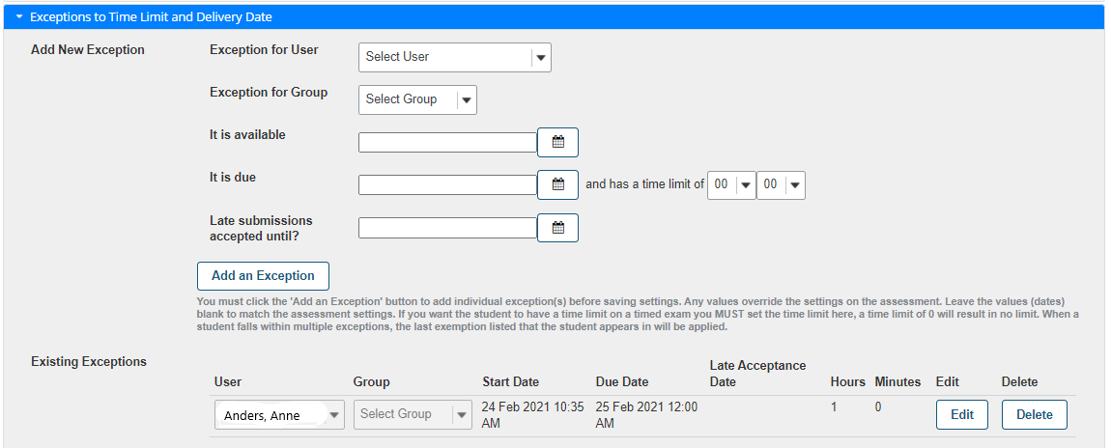

      - Exception for User
- Exception for User – enter student name or select from dropdown list
- It is available / It is due / late submissions until – these dates should match the entries as indicated at Availability & Submissions.
  - Note: the entries at Availability & Submissions should accommodate the extra time allocation.
- … and has a time limit of – enter the full duration of assessment which includes the extra time. E.g., if student is allocated 10 minutes extra time for a 1 hour assessment, enter 01 hour 10 minutes
- Add an Exception – click Add an Exception. This will secure the extra time for the user. The extra time details will be listed under “Existing Exceptions”.

      - Exception for Group
      - Exception for Group – create a group on Group Manager to include all students who required the same amount of extra time for the assessment. Enter the group name or select from dropdown list
- It is available / It is due / late submissions until – these dates should match the entries as indicated at Availability & Submissions.
  - Note: the entries at Availability & Submissions should accommodate the extra time allocation.
- … and has a time limit of – enter the full duration of assessment which includes the extra time. E.g., if group is allocated 15 minutes extra time for a 1 hour assessment, enter 01 hour 15 minutes
- Add an Exception – click Add an Exception. This will secure the extra time for the group. The extra time details will be listed under “Existing Exceptions”

Expand Grading & Feedback

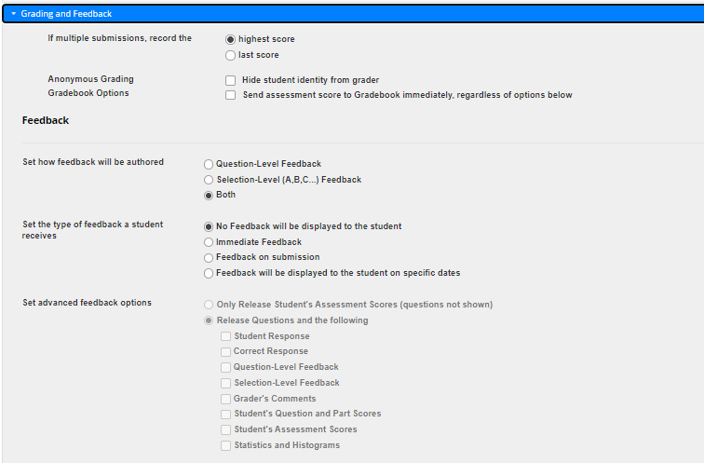

- Grading
- If multiple submissions, record the
  - Highest score
  - Last score
- Anonymous Grading
  - Hide student identity from grader - The graders’ downloaded scores after submission will not show student ID, instead a submission code will show. The student will also receive this submission code via email as proof of submission.

- Gradebook Options
  - Send assessment score to Gradebook immediately, regardless of options below – the student will view score sent directly to Gradebook after assessment submission

- Feedback
- Set how feedback will be authored
  - Question-Level Feedback – feedback to entire question
  - Selection-Level (A,B,C...) Feedback – feedback to the student’s response to the question (student selection of option/s)
  - Both – feedback to entire question and student response to question
- Set the type of feedback a student receives
  - No Feedback will be displayed to the student
  - Immediate Feedback
  - Feedback on submission
  - Feedback will be displayed to the student on specific dates

- Set advanced feedback options
  - Only Release Student's Assessment Scores (questions not shown)
  - Release Questions and the following – check all relevant boxes:
    - Student Response
    - Correct Response
    - Question-Level Feedback – note: if question feedback not entered, go to Edit question in Draft version of assessment to enter feedback
    - Selection-Level Feedback - note: if selection feedback not entered, go to Edit question in Draft version of assessment to enter feedback
    - Grader's Comments
    - Student's Question and Part Scores
    - Student's Assessment Scores
    - Statistics and Histograms

Expand Layout and Appearance

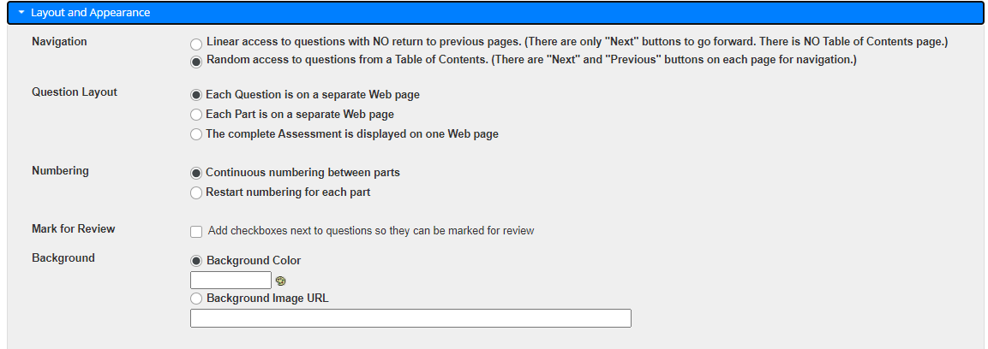

            - Navigation
- Linear access to questions with NO return to previous pages. (There are only "Next" buttons to go forward. There is NO Table of Contents page.)
- Random access to questions from a Table of Contents. (There are "Next" and "Previous" buttons on each page for navigation.)

            - Question Layout
- Each Question is on a separate Web page – students click “Next” to proceed to next question which automatically saves the answer to the question
- Each Part is on a separate Web page - students click “Next” to proceed to next part
- The complete Assessment is displayed on one Web page – students have to click save continuously to save answers on page

            - Numbering
- Continuous numbering between parts
- Restart numbering for each part
            - Mark for Review
- Add checkboxes next to questions so they can be marked for review - If this box is checked, it will allow students to flag questions to revisit later during the exam. This feature is not available in Linear access navigation.
            - Background – can be modified
- Background colour
- Background Image URL

Save Settings and Publish


Click Save – saves the selected settings. Note: the assessment will not be published for student availability.

Click SAVE SETTINGS AND PUBLISH – will save the selected settings, the assessment will be published and accessible to students on the set date and time.
A confirmation window of all settings appears
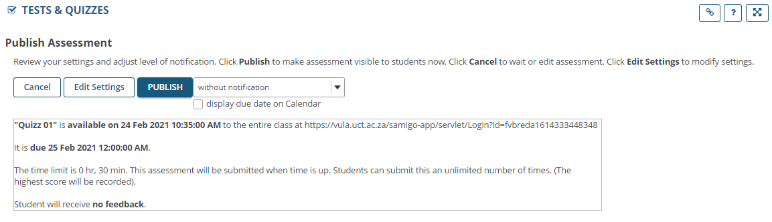
Click PUBLISH

When published, the assessment will be listed in the Assessment List as:
Drafts – the assessment can be edited
Published : Active / Inactive – the assessment is active between the set start and end time and accessible to students. After which it becomes Inactive and inaccessible to students. The assessment scores are downloaded from the Published Inactive assessment.
