1 December 2010

Dear Classmates,

“The MBChB Class of 1985 Bursary” and “To Return One Day”

For a number of years I have thought about what a positive influence we, as “The MBChB Class of 1985”, could exert if we worked collectively towards a common goal. With this in mind, I have had discussions with various members of our class including Mark Patrick, Pippa Hugo, John Stirling, Anne Pargiter and Tim Matthews about what this common goal should be and what we could do to achieve this.

The idea that gained the greatest support was that we as “The MBChB Class of 1985” work with UCT to create a Scholarship/Bursary to assist one or more students in gaining their MBChB degree at UCT.
The amount of money raised by our class would determine how generous the funding could be. In the first instance, I would suggest that we limit the amount to R5000 per person. However with sufficient funding we could create a prestigious perpetual bursary.

The administration of the “The MBChB Class of 1985 Bursary” would be managed by UCT with support of two members of our class.
Applicants would need to:
Demonstrate genuine need or hardship
Be South African citizens
Be registered for MBChB at UCT
Pass each year to get repeat funding

What the abovementioned class mates suggested was that we each consider donating the equivalent of one day’s salary to UCT with the view to funding “The Class of 1985 Bursary”. For many of you, this donation could be written off against tax and, having worked for about 6250 days in the last 25 years, “To Return One Day” is an achievable challenge that I hope you will consider joining us in contributing to.
At the 25th Class Reunion you will be asked to contribute to a “Medical School Class Campaign”. Please consider the ongoing benefit we could create by choosing to support “The MBChB Class of 1985 Bursary”.

I am sorry that I am unable to join you at the reunion. I am sure it would have been a pleasure to be there. Hope you all have a great time and feel free to contact me when you visit New Zealand.
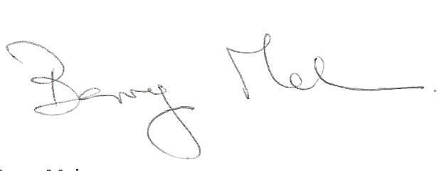

Barry Mahon
Clinical Leader Cardiothoracic Surgery
Wellington
New Zealand
Barry.Mahon@ccdhb.org.nz

