
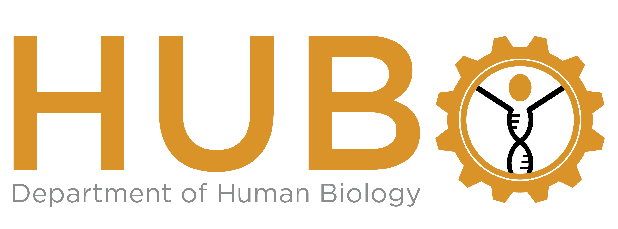

University of Cape Town
Anzio Road • Observatory
Cape Town 7925
South Africa

Phone: +27-21-406 6950
e-mail: BodyDonor-group@uct.ac.za

HUMAN BODY DONOR CONSENT FORM

& CONSENT FOR TISSUE & SAMPLE RETENTION

In accordance with the National Health Act [no. 61 of 2003]

Donor information (please print)
Title: (Mr/Mrs/Miss/Ms/Dr etc.) ..............Full Name........................................................

Residential address…………………………………………………………………………...

……………………………………………………………………………………………………

Postal code .............................Telephone Numbers …………….…………………………

I.D. number……………………………..E-mail address………..…………………………

☐ I wish to be listed as a body donor, in accordance with the National Health Act, to the Faculty of Health Sciences, University of Cape Town, for anatomical teaching, learning and research purposes.
☐ I have read the Body Donation Program - General information, Conditions and Restrictions.
☐ I understand that my body will be cremated after a period of approximately 18 months. The ashes may either be retained by my family or buried at the crematorium.
☐ I have discussed this with my next of kin and to the best of my knowledge they have no objection to this bequest.
☐I have not discussed this with my next of kin either because I do not wish to or because I have no immediate next of kin.

Please initial ALL of the following options to which you give your consent.

I am donating my body to the Department of Human Biology for the following activities:
☐ Anatomical education and dissection for medical, health and rehabilitation sciences and science students.
☐ Research studies and purposes covered by ethical permission.
☐ Research studies involving the analysis of my D.N.A. covered by ethical permission.
☐ Digital photographic images of my body excluding identifiable facial and other features, may be anonymously presented in student theses, and journal publications as defined by the Governance Committee.
☐ Digital photographic images of my body excluding identifiable facial and other features, may be placed anonymously in an electronic repository for research purposes as defined by the Governance Committee
☐ My demographic data (age, weight, sex, ethnicity, and nationality) may be used anonymously to improve the relevance of research. Covered by ethical or governance committee permission.

Donation Type
Option 1
☐ I consent to the retention, indefinitely, of any anonymised tissue, sample, or image thereof which may be of value for future teaching, learning and/or research. Types of research and teaching activities could include, but are not limited to, anatomical, biological, biological anthropological, genetics, forensic science, human variation, skeletal and plastination. No live cells will be taken and used as cell lines. I understand that my remains will be cremated after completion of any of the above teaching and research activities.
NOTE
For this option your medical history and demographic history can assist with research, therefore we request that you to disclose any relevant information on the next page.

OR
Option 2
☐ I consent to cremation after a period of 18-24 months without any tissue being retained by the department for teaching or research purposes. I consent to my ashes being buried at the relevant crematorium, unless my next-of-kin requests otherwise (see Note at the end of this form).

Signed at ………………………………………….... Time…………. Date: .....................

Signature: ...................................................

Witness (name): ....................................... (Signature): .......................................

Witness (name): ....................................... (Signature): .......................................
If a donor is already deceased, then an immediate next-of-kin (the spouse, partner, major child, parent, guardian, major brother, or major sister of that person) may donate the body or any specific tissue of that person to an institution and may complete and sign this form on their behalf.
Details of next of kin donating the deceased.

Name and Address

Title: (Mr, Mrs, Ms Etc.) …………Full name………………………………

Relationship to donor………………………………………………………...

Address…………………………………………………………………………

..........................................................postal code…………………….

Telephone Number ................................ Email address…………………………

MEDICAL HISTORY and DEMOGRAPHIC INFORMATION

If you would like to disclose any of your medical history and demographic information, this can be useful for training and research purposes. However, doing so is completely voluntary and any information disclosed will be treated confidentially.
Date of birth: …………….…………….
Gender: ……………..…………………
Race/Ancestry: ………………………..
Nationality………………………………
Surgery (type), Fracture/s (year), Smoker Y/N/ number of years, any other medical information.

Note: if your next of kin wishes to retain your ashes, they would need to inform the department in writing (e-mail) not later than 2 months after your donation. The next-of-kin will be contacted when the ashes are available for collection. Once the next of kin has been contacted they are requested to collect the ashes within a period of 3 months. If alternative arrangements have not been made, the department will have the ashes scattered at the crematorium after the 3-month period.

