Friday 4th April 2014 Wolfson Lecture Theatre

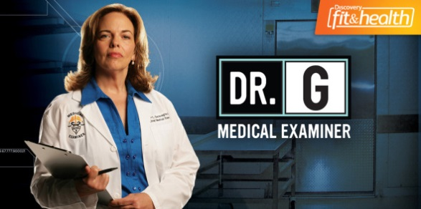
The Division of Forensic Pathology is pleased to present a short day of talks, with a special guest lecturer Dr Jan Garavaglia.
Dr Garavaglia is the Chief Medical Examiner for Orange and Osceola counties in Orlando, Florida. Garavaglia received her medical degree from the Saint Louis University School of Medicine and completed an internship in internal medicine and residency in anatomic/clinical pathology at Saint Louis University Hospitals. She also completed a fellowship in forensic pathology at the Dade County Medical Examiner's Office in Miami. She is board-certified in combined anatomic and clinical pathology and forensic pathology.

09h30 – 09h45 Welcome Prof Lorna J Martin
09h45 – 10h30 Introduction to SA Forensic Pathology Prof Lorna J Martin
10h30 – 11h30 The US system – why autopsies are Dr Jan Garavaglia
important
11h30 – 12h00 SUDA case studies Dr Gavin Kirk
12h00 – 12h30 Lodox in Forensic Pathology Dr Linda Liebenberg
12h30 – 13h15 Lunch – Attendees are invited to visit our Pathology Learning Centre http://www.digitalpathology.uct.ac.za/index.php
13h15 – 14h15 The origins of “Dr G Medical Examiner” TV Dr Jan Garavaglia
show
14h15 – 14h45 Henssge Normogram Dr Lene Burger
14h45 – 15h15 Maternal deaths Dr Celeste Herbst
15h15 – 15h45 A cluster of deaths at Valkenberg Hospital Dr Iekram Alli

Please RSVP to Ms June Mehl (june.mehl@uct.ac.za ; 021 406 6110) as places are limited and will be on a first come first served basis.

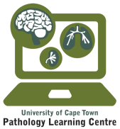
Tea and coffee will be available.

