 Forensic Day – 2019

“A basic guideline in Forensic Pathology and Science”

FOR Grade 10, 11 or 12 learners

*By*

*Michelle Perrins*

On the 30 August 2019, the Division of Forensic Medicine and Toxicology, UCT/ Forensic Pathology Service, hosted its 7th annual Forensic Day.

The fact that the field of Forensic Medicine/Pathology and Science is so vast, it is not possible to go through it all in a day.

However, we covered the basics that South African Universities offer, namely, Forensic Pathology and a Masters course in Biomedical Forensic Science which is offered at University of Cape Town. This course/program is multidisciplinary and combines coursework and research. Our website is quite informative so go to [www.forensicmedicine@uct.ac.za](http://www.forensicmedicine@uct.ac.za)

The day’s events covered Forensic Anthropology, Crime Scene, Histopathology, DNA, Toxicology and two South African Police Service units from the Police Forensic Laboratory, namely, Ballistics and Biology. These were hands-on activities for the learners to experience.

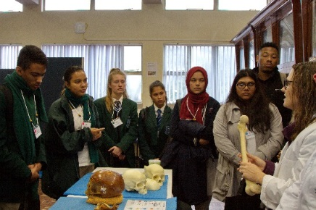 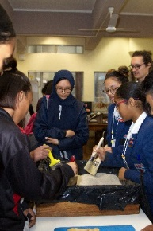 Forensic Anthropology

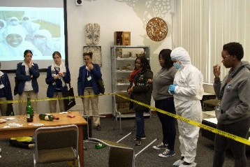 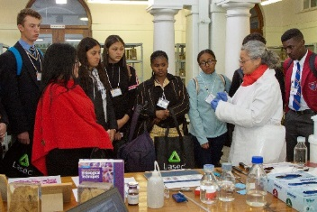 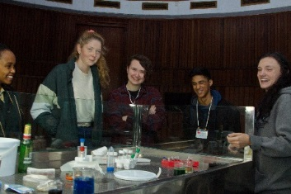

Crime scene Histopathology Toxicology

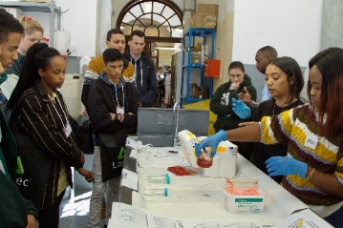 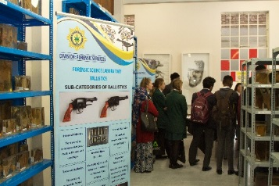 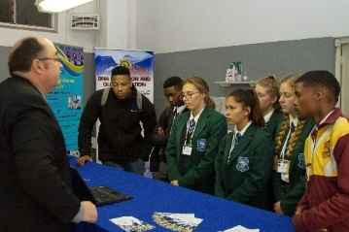

DNA Ballistics Biology

*Photographs by Melvin Lawrence*

There was also a display of a few Forensic related museum exhibits for the learners to peruse and answer the questions. This was an exercise to see how the learners applied their knowledge on Forensic related questions. The learner’s answers were placed into a box for a draw to take place before the September school holidays. Most of the entries showed that the learners had a fair knowledge about the Forensic related questions.

Out of 43 entries, four had 7 correct points out of 8. The draw took place on the 18 September 2019 and the winner was Sinesipho Tyopho from Spes Bona High.

At the closing of the day, a lucky draw took place where 5 learners went away with a prize each, namely, Mishka Krishnalall, Imaan Gameeldien, Ndinani Nkoduso, Sinesipho Tyopho and Emmah de Villiers. Congratulations to all.

I trust and hope that the learners went away with a good insight as to what the difference is between Forensic Pathology and Forensic Science, and to what is offered in following a career in Forensic Science. Varoius correspondance of the day was received from those that attended. This is always welcome, and we wish to continue in providing this opportunity as part of our social responsiveness and dialogue development.

I would like to thank

Lasec for sponsoring the day with their bags and pens.

Magna Analytical, SMM and CPS for sponsoring the refreshments.

The staff of Forensic Pathology Service/Division of Forensic Medicine and Toxicology, UCT

Forensic Anthropology, UCT

The Police Forensic Laboratory

The use of the facilities on Health Science campus, UCT